All these measurements are done using a differential probe at HO and SW:
1. Yes the frequency is stable at a no load condition. Sorry for the confusion earlier.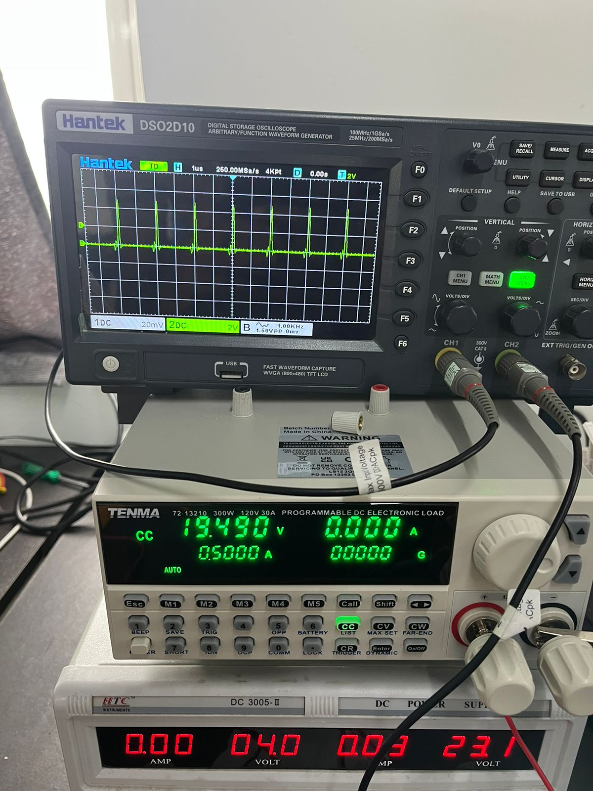
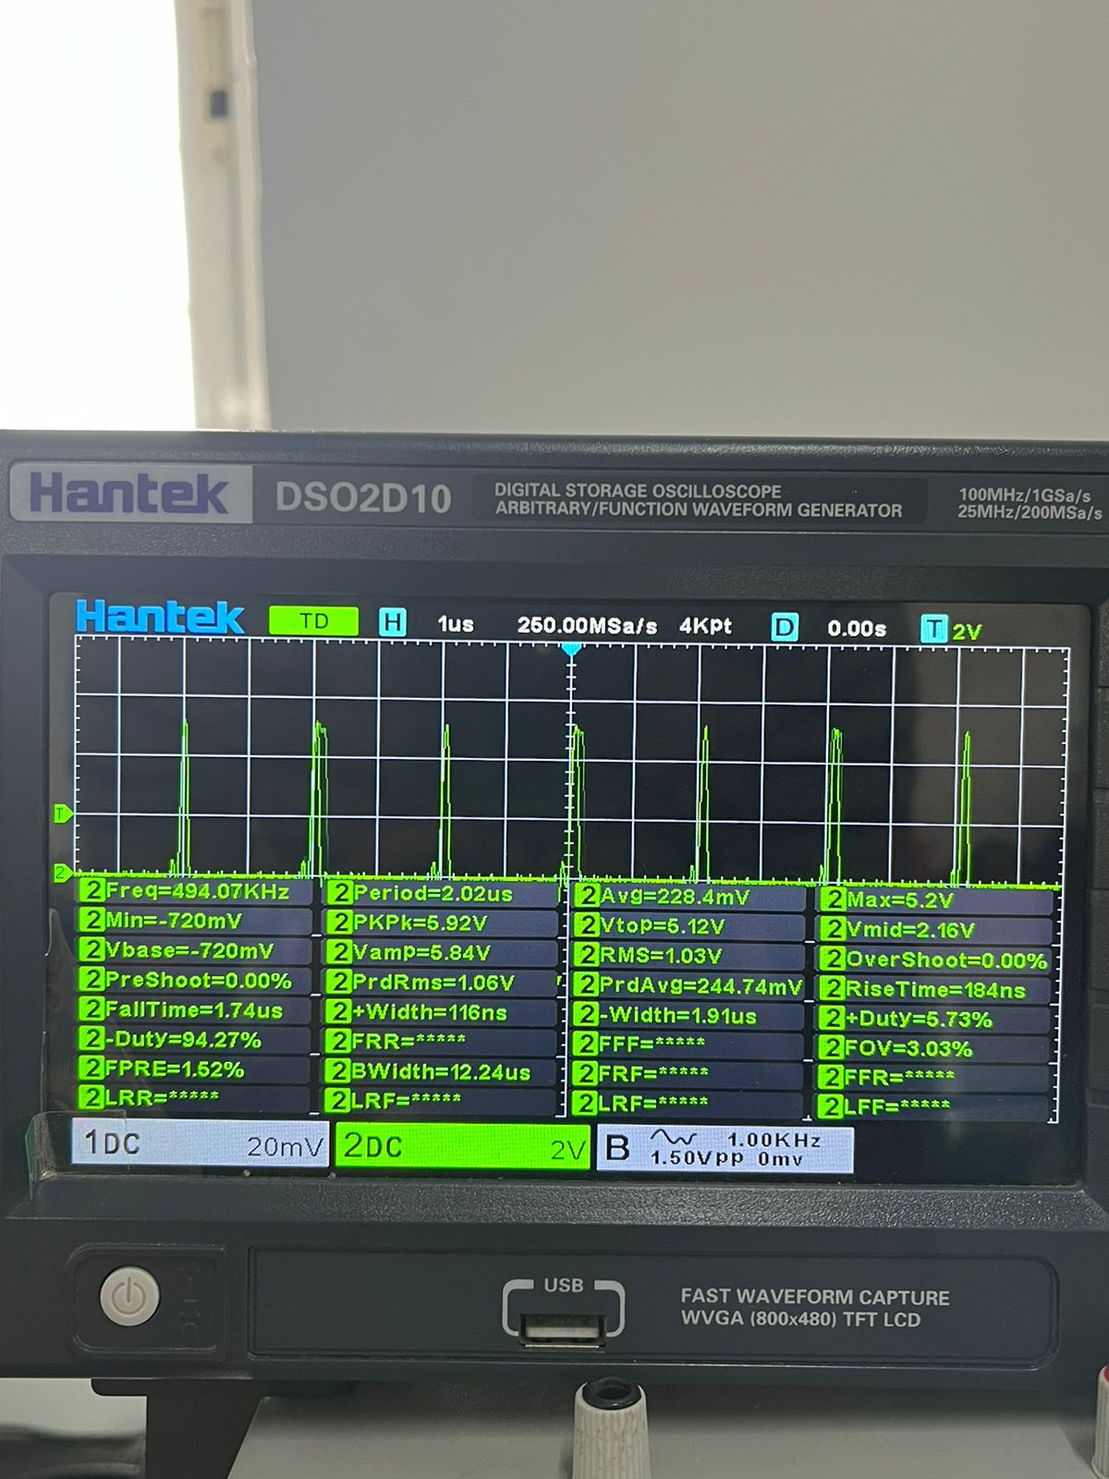

2.On a load of 0.5A and Vin:29.5V everything works fine. I get good regulation and also at the required frequency.
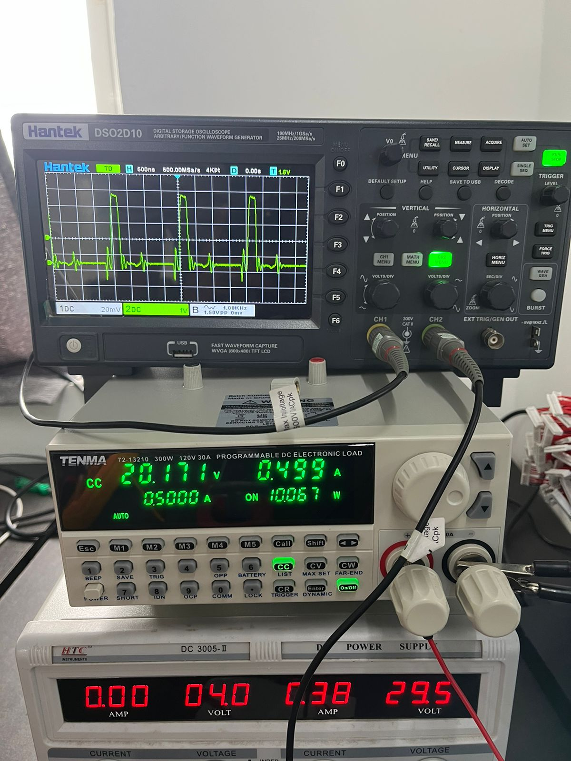
3.When the input voltage drops to 21.5V I do not understand why the regulation cannot be maintained?
