Thanks Damien.

To debug the issue further we have connected the battery monitor chip to [EV2300](http://www.ti.com/tool/EV2300).

I have installed [Bqstudio](http://www.ti.com/tool/Bqstudio" \o "Link to Tool Folder" \t "_blank) & was able to read the battery monitor data flash registers.

Also, the battery voltage, charge/discharge currents are shown up correctly.

But when I try to change any data flash registers, its not getting updated & I get the error "A read of data written failed comparison" as shown in below snapshot.

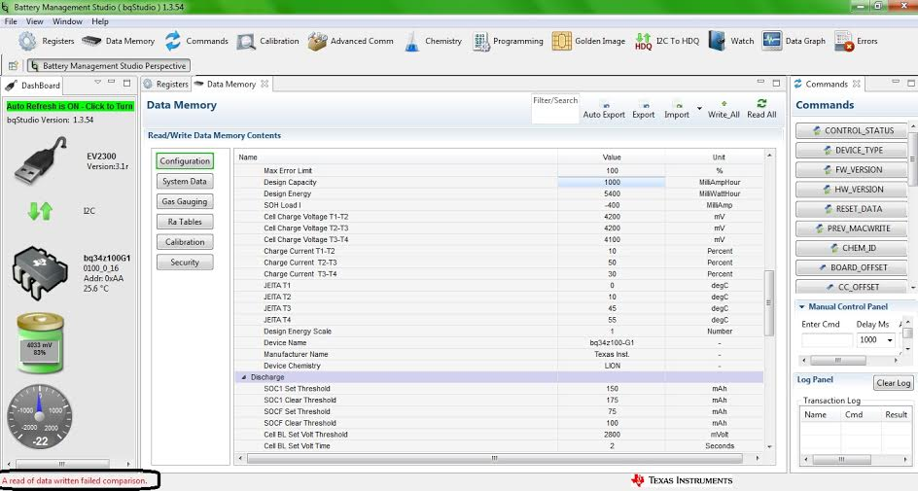

A "Write all" function to the data flash also fails with the below highlighted error.

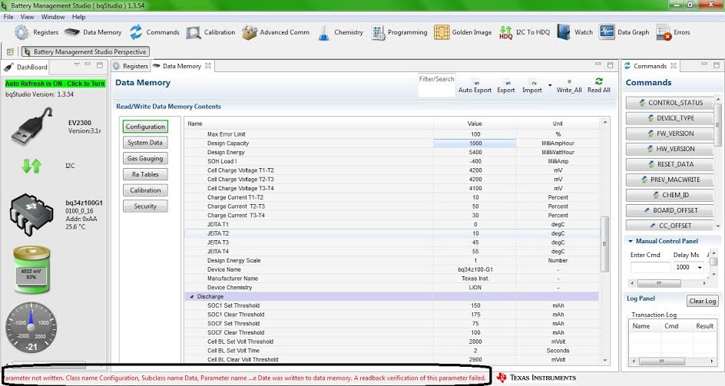

I have exported the data flash & attached the .gg file (Default\_Battery\_Monitor.gg).

To make sure that the issue is not related to Battery monitor firmware, I downloaded the latest firmware from TI website (v0\_16\_build\_17).

But if I import this file & try to program, I will not get any update from the [BqStudio](http://www.ti.com/tool/BqStudio" \o "Link to Tool Folder" \t "_blank).

Once I click on "Program" button, status shows "Programming - Priority sequence already in progress" as highlighted in below snapshot. But this status doesn't change even after waiting for 30 mins.

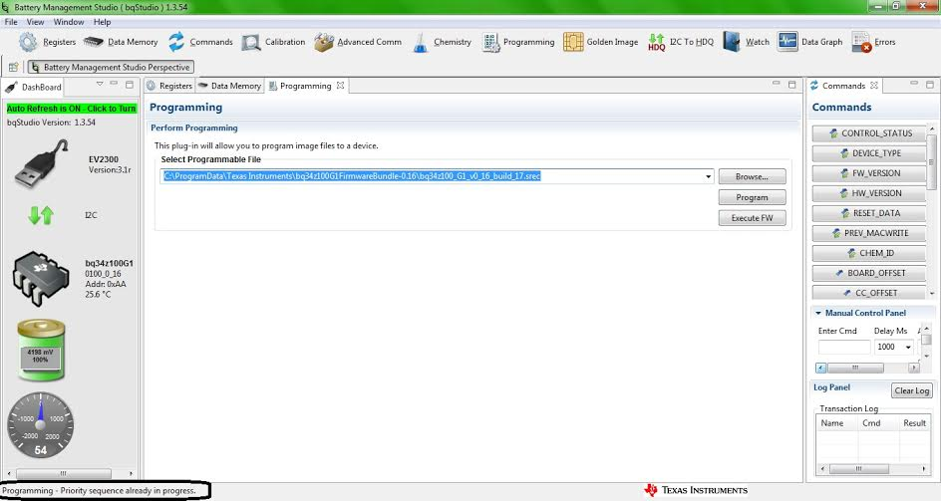

What can be the reason for this behavior ?

Looking forward to your valuable suggestions on how to proceed further.

|  |  |  |  |  |
| --- | --- | --- | --- | --- |
| \* Texas Instruments Data Flash File |  |  |  |  |
| \* File created Sat Jan 14 19:46:08 2017 |  |  |  |  |
| \* |  |  |  |  |
| \* Device Number 100 |  |  |  |  |
| \* Firmware Version 0.16 |  |  |  |  |
| \* Build Number not available |  |  |  |  |
| \* Order Number not available |  |  |  |  |
| \* |  |  |  |  |
| \* bqz Device Number 100 |  |  |  |  |
| \* bqz Firmware Version 0.16 |  |  |  |  |
| \* bqz Build Number 17 |  |  |  |  |
| \* |  |  |  |  |
| \* Field Order: Class name | Subclass name | Parameter name | Parameter Value | Display Units |
| Configuration | Safety | OT Chg | 55 | 1degC |
| Configuration | Safety | OT Chg Time | 2 | Seconds |
| Configuration | Safety | OT Chg Recovery | 50 | 1degC |
| Configuration | Safety | OT Dsg | 60 | 1degC |
| Configuration | Safety | OT Dsg Time | 2 | Seconds |
| Configuration | Safety | OT Dsg Recovery | 55 | 1degC |
| Configuration | Charge Inhibit Cfg | Chg Inhibit Temp Low | 0 | 1degC |
| Configuration | Charge Inhibit Cfg | Chg Inhibit Temp High | 45 | 1degC |
| Configuration | Charge Inhibit Cfg | Temp Hys | 5 | 1degC |
| Configuration | Charge | Suspend Low Temp | -5 | 1degC |
| Configuration | Charge | Suspend High Temp | 55 | 1degC |
| Configuration | Charge | Pb EFF Efficiency | 100 | % |
| Configuration | Charge | Pb Temp Comp | 24.96 | % |
| Configuration | Charge | Pb Drop Off Percent | 96 | % |
| Configuration | Charge | Pb Reduction Rate | 10 | % |
| Configuration | Charge Termination | Taper Current | 100 | mAmp |
| Configuration | Charge Termination | Min Taper Capacity | 25 | mAmpHr |
| Configuration | Charge Termination | Cell Taper Voltage | 100 | mVolt |
| Configuration | Charge Termination | Current Taper Window | 40 | Seconds |
| Configuration | Charge Termination | TCA Set % | 99 | Percent |
| Configuration | Charge Termination | TCA Clear % | 95 | Percent |
| Configuration | Charge Termination | FC Set % | 100 | Percent |
| Configuration | Charge Termination | FC Clear % | 98 | Percent |
| Configuration | Charge Termination | DODatEOC Delta T | 10 | 1degC |
| Configuration | Charge Termination | NiMH Delta Temp | 3 | 1degC |
| Configuration | Charge Termination | NiMH Delta Temp Time | 180 | Seconds |
| Configuration | Charge Termination | NiMH Hold Off  Time | 100 | Seconds |
| Configuration | Charge Termination | NiMH Hold Off Current | 240 | mAmp |
| Configuration | Charge Termination | NiMH Hold Off  Temp | 25 | 1degC |
| Configuration | Charge Termination | NiMH Cell Negative Delta Volt | 17 | mVolt |
| Configuration | Charge Termination | NiMH Cell Negative Delta Time | 16 | Seconds |
| Configuration | Charge Termination | NiMH Cell Neg Delta Qual Volt | 4200 | mVolt |
| Configuration | Data | Manufacture Date | 1/1/1980 | Day + Mo\*32 + (Yr -1980)\*256 |
| Configuration | Data | Serial Number | 1 | hex |
| Configuration | Data | Cycle Count | 0 | Count |
| Configuration | Data | CC Threshold | 900 | mAmpHr |
| Configuration | Data | Max Error Limit | 100 | % |
| Configuration | Data | Design Capacity | 1000 | MilliAmpHour |
| Configuration | Data | Design Energy | 5400 | MilliWattHour |
| Configuration | Data | SOH Load I | -400 | MilliAmp |
| Configuration | Data | Cell Charge Voltage T1-T2 | 4200 | mV |
| Configuration | Data | Cell Charge Voltage T2-T3 | 4200 | mV |
| Configuration | Data | Cell Charge Voltage T3-T4 | 4100 | mV |
| Configuration | Data | Charge Current T1-T2 | 10 | Percent |
| Configuration | Data | Charge Current  T2-T3 | 50 | Percent |
| Configuration | Data | Charge Current  T3-T4 | 30 | Percent |
| Configuration | Data | JEITA T1 | 0 | degC |
| Configuration | Data | JEITA T2 | 10 | degC |
| Configuration | Data | JEITA T3 | 45 | degC |
| Configuration | Data | JEITA T4 | 55 | degC |
| Configuration | Data | Design Energy Scale | 1 | Number |
| Configuration | Data | Device Name | [bq34z100-G1](http://www.ti.com/product/bq34z100-G1) | - |
| Configuration | Data | Manufacturer Name | Texas Inst. | - |
| Configuration | Data | Device Chemistry | LION | - |
| Configuration | Discharge | SOC1 Set Threshold | 150 | mAh |
| Configuration | Discharge | SOC1 Clear Threshold | 175 | mAh |
| Configuration | Discharge | SOCF Set Threshold | 75 | mAh |
| Configuration | Discharge | SOCF Clear Threshold | 100 | mAh |
| Configuration | Discharge | Cell BL Set Volt Threshold | 2800 | mVolt |
| Configuration | Discharge | Cell BL Set Volt Time | 2 | Seconds |
| Configuration | Discharge | Cell BL Clear Volt Threshold | 2900 | mVolt |
| Configuration | Discharge | Cell BH Set Volt Threshold | 4300 | mVolt |
| Configuration | Discharge | Cell BH Volt Time | 2 | Seconds |
| Configuration | Discharge | Cell BH  Clear Volt Threshold | 4200 | mVolt |
| Configuration | Discharge | Cycle Delta | 0.05 | % |
| Configuration | Manufacturer Data | Pack Lot Code | 0 | hex |
| Configuration | Manufacturer Data | PCB Lot Code | 0 | hex |
| Configuration | Manufacturer Data | Firmware Version | 0 | hex |
| Configuration | Manufacturer Data | Hardware Revision | 0 | hex |
| Configuration | Manufacturer Data | Cell Revision | 0 | hex |
| Configuration | Manufacturer Data | DF Config Version | 0 | hex |
| Configuration | Lifetime Data | Lifetime Max Temp | 30 | 1degC |
| Configuration | Lifetime Data | Lifetime Min Temp | 20 | 1degC |
| Configuration | Lifetime Data | Lifetime Max Chg Current | 0 | mAmp |
| Configuration | Lifetime Data | Lifetime Max Dsg Current | 0 | mA |
| Configuration | Lifetime Data | Lifetime Max Pack Voltage | 160 | 20mV |
| Configuration | Lifetime Data | Lifetime Min Pack Voltage | 175 | 20mV |
| Configuration | Lifetime Temp Samples | LT Flash Cnt | 0 | Count |
| Configuration | Registers | Pack Configuration | 41d9 | flags |
| Configuration | Registers | Pack Configuration B | af | flags |
| Configuration | Registers | Pack Configuration C | 37 | flags |
| Configuration | Registers | LED\_Comm Configuration | 0 | flags |
| Configuration | Registers | Alert Configuration | 0 | flags |
| Configuration | Registers | Number of series cell | 1 | num |
| Configuration | Lifetime Resolution | LT Temp Res | 1 | 1degC |
| Configuration | Lifetime Resolution | LT Cur Res | 100 | mA |
| Configuration | Lifetime Resolution | LT V Res | 1 | 20mV |
| Configuration | Lifetime Resolution | LT Update Time | 60 | Seconds |
| Configuration | LED Display | LED Hold Time | 4 | Num |
| Configuration | Power | Flash Update OK Cell Volt | 2800 | mVolt |
| Configuration | Power | Sleep Current | 10 | mAmp |
| Configuration | Power | FS Wait | 0 | Seconds |
| System Data | Manufacturer Info | Block A 0 | 0 | hex |
| System Data | Manufacturer Info | Block A 1 | 0 | hex |
| System Data | Manufacturer Info | Block A 2 | 0 | hex |
| System Data | Manufacturer Info | Block A 3 | 0 | hex |
| System Data | Manufacturer Info | Block A 4 | 0 | hex |
| System Data | Manufacturer Info | Block A 5 | 0 | hex |
| System Data | Manufacturer Info | Block A 6 | 0 | hex |
| System Data | Manufacturer Info | Block A 7 | 0 | hex |
| System Data | Manufacturer Info | Block A 8 | 0 | hex |
| System Data | Manufacturer Info | Block A 9 | 0 | hex |
| System Data | Manufacturer Info | Block A 10 | 0 | hex |
| System Data | Manufacturer Info | Block A 11 | 0 | hex |
| System Data | Manufacturer Info | Block A 12 | 0 | hex |
| System Data | Manufacturer Info | Block A 13 | 0 | hex |
| System Data | Manufacturer Info | Block A 14 | 0 | hex |
| System Data | Manufacturer Info | Block A 15 | 0 | hex |
| System Data | Manufacturer Info | Block A 16 | 0 | hex |
| System Data | Manufacturer Info | Block A 17 | 0 | hex |
| System Data | Manufacturer Info | Block A 18 | 0 | hex |
| System Data | Manufacturer Info | Block A 19 | 0 | hex |
| System Data | Manufacturer Info | Block A 20 | 0 | hex |
| System Data | Manufacturer Info | Block A 21 | 0 | hex |
| System Data | Manufacturer Info | Block A 22 | 0 | hex |
| System Data | Manufacturer Info | Block A 23 | 0 | hex |
| System Data | Manufacturer Info | Block A 24 | 0 | hex |
| System Data | Manufacturer Info | Block A 25 | 0 | hex |
| System Data | Manufacturer Info | Block A 26 | 0 | hex |
| System Data | Manufacturer Info | Block A 27 | 0 | hex |
| System Data | Manufacturer Info | Block A 28 | 0 | hex |
| System Data | Manufacturer Info | Block A 29 | 0 | hex |
| System Data | Manufacturer Info | Block A 30 | 0 | hex |
| System Data | Manufacturer Info | Block A 31 | 0 | hex |
| Gas Gauging | IT Cfg | Load Select | 1 | Number |
| Gas Gauging | IT Cfg | Load Mode | 0 | Number |
| Gas Gauging | IT Cfg | Res Current | 10 | mAmp |
| Gas Gauging | IT Cfg | Max Res Factor | 50 | num |
| Gas Gauging | IT Cfg | Min Res Factor | 1 | num |
| Gas Gauging | IT Cfg | Ra Filter | 500 | num |
| Gas Gauging | IT Cfg | Min PassedChg NiMH-LA 1st Qmax | 50 | % |
| Gas Gauging | IT Cfg | Maximum Qmax Change | 100 | % |
| Gas Gauging | IT Cfg | Cell Terminate Voltage | 3000 | mVolt |
| Gas Gauging | IT Cfg | Cell Term V Delta | 200 | mVolt |
| Gas Gauging | IT Cfg | ResRelax Time | 500 | Seconds |
| Gas Gauging | IT Cfg | User Rate-mA | 0 | MilliAmp |
| Gas Gauging | IT Cfg | User Rate-Pwr | 0 | mW/cW |
| Gas Gauging | IT Cfg | Reserve Cap-mAh | 0 | MilliAmpHour |
| Gas Gauging | IT Cfg | Reserve Energy | 0 | mWh/cWh |
| Gas Gauging | IT Cfg | Max Scale Back Grid | 4 | num |
| Gas Gauging | IT Cfg | Cell Min DeltaV | 0 | mVolt |
| Gas Gauging | IT Cfg | Ra Max Delta | 15 | % |
| Gas Gauging | IT Cfg | Design Resistance | 42 | mOhms |
| Gas Gauging | IT Cfg | Reference Grid | 4 | - |
| Gas Gauging | IT Cfg | Qmax Max Delta % | 10 | mAmpHour |
| Gas Gauging | IT Cfg | Max Res Scale | 32000 | Num |
| Gas Gauging | IT Cfg | Min Res Scale | 1 | Num |
| Gas Gauging | IT Cfg | Fast Scale Start SOC | 10 | % |
| Gas Gauging | IT Cfg | Charge Hys V Shift | 40 | mVolt |
| Gas Gauging | IT Cfg | Smooth Relax Time | 1000 | s |
| Gas Gauging | Current Thresholds | Dsg Current Threshold | 60 | mAmp |
| Gas Gauging | Current Thresholds | Chg Current Threshold | 75 | mAmp |
| Gas Gauging | Current Thresholds | Quit Current | 40 | mAmp |
| Gas Gauging | Current Thresholds | Dsg Relax Time | 60 | Seconds |
| Gas Gauging | Current Thresholds | Chg Relax Time | 60 | Seconds |
| Gas Gauging | Current Thresholds | Cell Max IR Correct | 400 | mV |
| Gas Gauging | State | Qmax Cell 0 | 1000 | mAmpHr |
| Gas Gauging | State | Cycle Count | 0 | num |
| Gas Gauging | State | Update Status | 0 | num |
| Gas Gauging | State | Cell V at Chg Term | 4200 | mVolt |
| Gas Gauging | State | Avg I Last Run | -299 | mAmp |
| Gas Gauging | State | Avg P Last Run | -1131 | MilliWattHour |
| Gas Gauging | State | Cell Delta Voltage | 2 | mVolt |
| Gas Gauging | State | T Rise | 20 | Num |
| Gas Gauging | State | T Time Constant | 1000 | Num |
| Ra Tables | Ra0 Table | Ra Flag | ff55 | Hex |
| Ra Tables | Ra0 Table | Ra 0 | 105 | Num |
| Ra Tables | Ra0 Table | Ra 1 | 100 | Num |
| Ra Tables | Ra0 Table | Ra 2 | 113 | Num |
| Ra Tables | Ra0 Table | Ra 3 | 143 | Num |
| Ra Tables | Ra0 Table | Ra 4 | 98 | Num |
| Ra Tables | Ra0 Table | Ra 5 | 97 | Num |
| Ra Tables | Ra0 Table | Ra 6 | 108 | Num |
| Ra Tables | Ra0 Table | Ra 7 | 89 | Num |
| Ra Tables | Ra0 Table | Ra 8 | 86 | Num |
| Ra Tables | Ra0 Table | Ra 9 | 85 | Num |
| Ra Tables | Ra0 Table | Ra 10 | 87 | Num |
| Ra Tables | Ra0 Table | Ra 11 | 90 | Num |
| Ra Tables | Ra0 Table | Ra 12 | 110 | Num |
| Ra Tables | Ra0 Table | Ra 13 | 647 | Num |
| Ra Tables | Ra0 Table | Ra 14 | 1500 | Num |
| Ra Tables | Ra0x Table | Ra Flag | ffff | Hex |
| Ra Tables | Ra0x Table | Ra 0 | 105 | Num |
| Ra Tables | Ra0x Table | Ra 1 | 100 | Num |
| Ra Tables | Ra0x Table | Ra 2 | 113 | Num |
| Ra Tables | Ra0x Table | Ra 3 | 143 | Num |
| Ra Tables | Ra0x Table | Ra 4 | 98 | Num |
| Ra Tables | Ra0x Table | Ra 5 | 97 | Num |
| Ra Tables | Ra0x Table | Ra 6 | 108 | Num |
| Ra Tables | Ra0x Table | Ra 7 | 89 | Num |
| Ra Tables | Ra0x Table | Ra 8 | 86 | Num |
| Ra Tables | Ra0x Table | Ra 9 | 85 | Num |
| Ra Tables | Ra0x Table | Ra 10 | 87 | Num |
| Ra Tables | Ra0x Table | Ra 11 | 90 | Num |
| Ra Tables | Ra0x Table | Ra 12 | 110 | Num |
| Ra Tables | Ra0x Table | Ra 13 | 647 | Num |
| Ra Tables | Ra0x Table | Ra 14 | 1500 | Num |
| Calibration | Data | CC Gain | 10.123 | mohm |
| Calibration | Data | CC Delta | 10.147 | mohm |
| Calibration | Data | CC Offset | -1200 | num |
| Calibration | Data | Board Offset | 0 | num |
| Calibration | Data | Int Temp Offset | 0 | degC |
| Calibration | Data | Ext Temp Offset | 0 | degC |
| Calibration | Data | Voltage Divider | 5000 | mVolt |
| Calibration | Current | Deadband | 5 | mAmp |
| Security | Codes | Sealed to Unsealed | 36720414 | hex |
| Security | Codes | Unsealed to Full | ffffffff | hex |
| Security | Codes | Authen Key3 | 1234567 | hex |
| Security | Codes | Authen Key2 | 89abcdef | hex |
| Security | Codes | Authen Key1 | fedcba98 | hex |
| Security | Codes | Authen Key0 | 76543210 | hex |

I am sorry i am not able to attach files and that is the reason i am pasting the complete file here.

Regards,

Avinash

