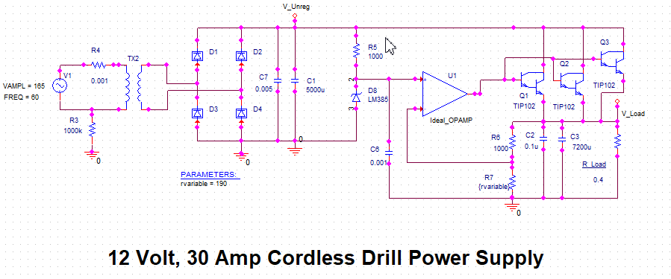

Linear Power Supply Circuit Using Ideal Op Amp and Three Parallel TIP102 Transistors

Load Resistor Modeled Using 12 Volts / 30 Amps

R_Load = 0.4 Ohm

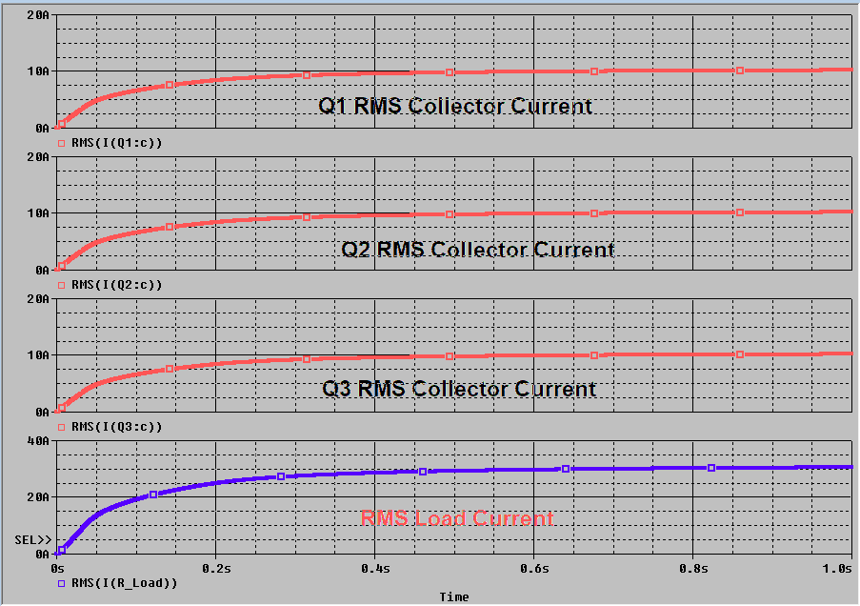

RMS Currents for Each Transistor Collector and the Total Load Current, I_R_Load

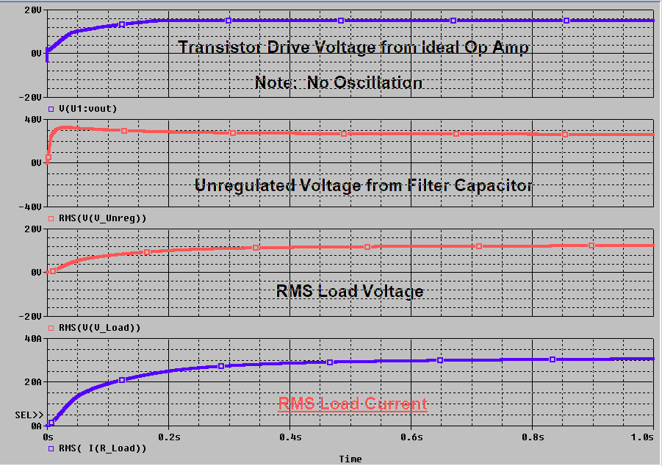

Modeled RMS Voltages and Currents from the Circuit

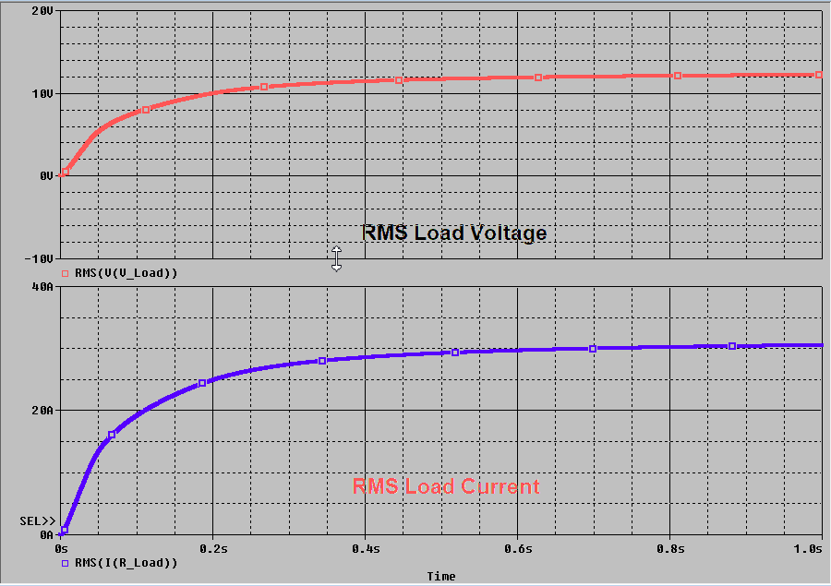

RMS Load Voltage and Current with Ideal Op Amp Driving the TIP102 Transistors