Distributor or Supplier information |  |  |  |  |  |  |  |  |  |  |  |  | Customer Information
Company: |  |  |  |  |  |  |  |  |  |  |  |  | Company: |  |  |  | PEGATRON
Contact: |  |  |  |  |  |  |  |  |  |  |  |  | Contact: |  |  |  | Small
Address: |  |  |  |  |  |  |  |  |  |  |  |  | Address: |  |  |  | No.150, Lide Rd., Beitou Dist., Taipei City 112, Taiwan (R.O.C.)
Phone: |  |  |  |  |  |  |  |  |  |  |  |  | Phone: |  |  |  | 886-9-88796657
E-Mail: |  |  |  |  |  |  |  |  |  |  |  |  | E-mail: |  |  |  | Small_Dwx@pegatroncorp.com
* indicates must be filled (without these information the job can be created)
*Level of Criticality for this return. (Any job listed as critical or major must complete the failure details section.)
__ | Critical |  |  |  |  |  | __ | Major |  |  |  |  |  |  |  |  |  | __ | Minor
Prevents product shipment |  |  |  |  |  |  | Elevated field reliability fallout to level of concern |  |  |  |  |  |  |  |  |  |  | Manufacturing is inconvenienced
Unacceptable field reliability |  |  |  |  |  |  | Major impact on throughput |  |  |  |  |  |  |  |  |  |  | Potential increase in field fallout but not to level of concern
Severely impacts throughput |  |  |  |  |  |  | Major issue with product performance |  |  |  |  |  |  |  |  |  |  | Minor issue with product performance
Shipping information
*Contact RCQE:
*Date sent : |  |  |  | 6/4 |  |  | Carrier : |  |  |  |  |  |  |  | Waybill# :
Customer return reference :
Product Details:
Customer P/N: |  |  |  |  |  | 0629-012W000 |  |  |  |  |  |  |  | * TI Part Number: |  |  |  |  |  |  |  | PTPS2121RUXR
* Lot Trace Code(s) of Failing Devices (marked on top of device): |  |  |  |  |  | 1006200CLB |  |  |  |  |  |  |  | Lot Trace Code(s) of Passing Devices (marked on top of device):
* Number of Failing Devices Sent to TI for analysis: |  |  |  |  |  | 2 |  |  |  |  |  |  |  | Number of Passing Devices Sent to TI for analysis
* Total Quantity of devices that have Failed: |  |  |  |  |  | 2 |  |  |  |  |  |  |  | *Total Quantity of Devices Tested: |  |  |  |  |  |  |  | 200
*Failure Rate (fail QTY / test QTY): |  |  |  |  |  | 2/200
Project Name: |  |  |  |  |  | ET5X8 and ET5X10
*Point of Failure:
Mass production |  |  |  |  |  |  |  |  |  |  | Prototype |  |  |  |  |  |  |  |  | Field Return |  |  | v
Incoming Test
In-Circuit Board Level Test (ICT)
Functional Board Level Test |  |  |  |  |  |  |  |  | V |  | 12V input and no power insert check
Burn-In/Reliability Testing Failure
(specify conditions at which failure occurred)
System Level Test
Other (Please Specify)
*Failure Description:
(Please provide as much detail as possible about the failure mode. Attach any photos and/or scope graphs.)
- Detail device failure symptom (Failure pin, failure data Vs TI datasheet, etc.)*
PTPS2121RUXR, the IN1 to OUT_1 and 2 can’t work normally.
- Schematic
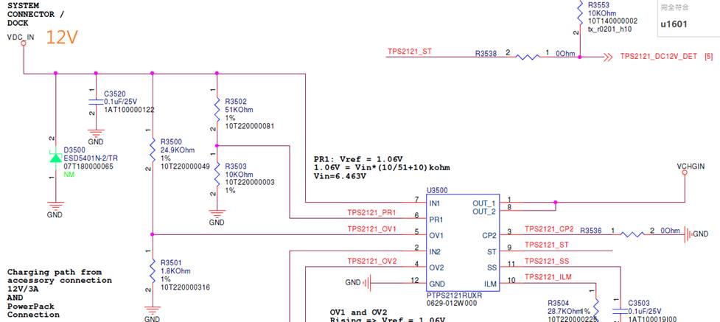
- IC photo
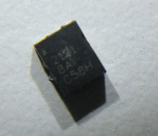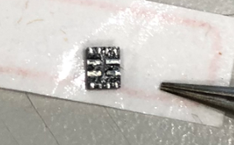

4.IC Impedance between good and fail
UNIT:Ohm
Chip 1:
 | PIN 1 | PIN 2 | PIN 3 | PIN 4 | PIN 5 | PIN 6
GOOD | 3.29M | 3.05M | 2.87M | 2.85M | 2.81M | 2.85M
DEFECT | 4.09K | 3.13M | 2.88M | 2.88M | 2.89M | 2.86M

 | PIN 7 | PIN 8 | PIN 9 | PIN 10 | PIN 11 | PIN 12
GOOD | 3.10M | 3.29M | 2.90M | 2.90M | 2.90M | 0
DEFECT | 3.17M | 4.08K | 2.87M | 2.88M | 2.87M | 0

Chip 2:
 | PIN 1 | PIN 2 | PIN 3 | PIN 4 | PIN 5 | PIN 6
GOOD | 3.29M | 3.05M | 2.87M | 2.85M | 2.81M | 2.85M
DEFECT | 0.60K | 350 | 227 | 2.85M | 2.85M | 2.85M

 | PIN 7 | PIN 8 | PIN 9 | PIN 10 | PIN 11 | PIN 12
GOOD | 3.10M | 3.29M | 2.90M | 2.90M | 2.90M | 0
DEFECT | 331 | 0.61K | 2.87M | 2.87M | 124 | 0

Ship Track Code (STC) from the TI Label on the bag, box, or reel from which the failing devices came (see example of label below). Send copy of label if possible: _________________________
Stick TI Label (as attached):
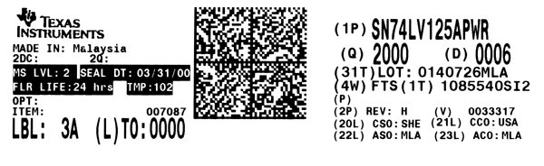
This is the Ship Track Code (STC) – the unique tracking number for each box, bag, or reel of TI devices.
Manufacturing Flow:
Please describe manufacturing flow to include any incoming testing, soldering, board electrical testing, etc.
Printing 1 -> Mounting1 -> Soldering1 -> Printing 2 -> Mounting2 -> Soldering2 -> ICT -> FCT
Is the failing device used in more than one location on the circuit board?
If yes, how many locations?
Which locations are causing the failure?
Is it just one location that is consistently causing the failures?
Is the design an old or new design?
Do failures occur at high temperature, low temperature or room temperature? Please specify temperature.
Does a competitor’s device work correctly all of the time? Please give details.

Reflow / Mounting Process:
What process is used to mount the failing devices to the circuit board (reflow, wave soldering, etc.)?
What are the reflow parameters used?
Is the device exposed to more than one type of solder process (reflow AND wave soldering)?
Is the circuit board double sided or single sided?
Comments:

Applications Related Questions:

What is the output load?
What is driving the input of the device?
Is there any unused input or output?
If so, what is the pin terminated to?
How far is the driver physically located from the receiver? (What is the length of the transmission line from the driver to the receiver?)
What is VCC set to?
What is the operating frequency?
What is the operating temperature?
Are pull-up or pull-down resistors used in the application?
If so, what are the values?
Is there any noise on the input or output? (Please provide soft copy for plots of the inputs and outputs waveforms.)
Are bypass capacitors added to all power pins? What value?

ESD Requirements for Handling Units:

The electronic industry has placed a growing emphasis on Quality and Reliability Assurance (QRA). Electro Static Discharge (ESD) damage to parts and assemblies can be minimized by adopting appropriate ESD handling procedures. EIA-625 (Requirements for Handling ESD Sensitive Devices) is a good specification to use as a reference.

- Handle Electrostatic Discharge Sensitive Devices (ESDS) only in an ESD protected area.

- Avoid electrostatic potential differences and electrostatic discharges at all cost.

- No electrostatic generating materials are allowed in ESD protected area or for packing ESD sensitive devices.

- Use only approved ESD protective packaging materials such as electrically conductive bags, hinged utility boxes, and adhesive grid tape to return parts to TI for analysis

Examples of appropriate ESD packaging material (always look for the ESD logo):

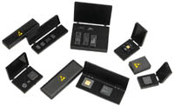
Electrically Conductive Bags Hinged Utility Boxes


Adhesive Grid Tape

Note: Units not returned in ESD protective packaging will NOT be analyzed.

Instructions for filling out this form
- Customer Contact Information: Please fill in completely. If multiple customers are involved, please provide information for all.

- Sending Date: Date units shipped to TI.

- Control No: Customer tracking number

- Product Details: Please fill in completely.
  - No of Samples Sent: Number of units being returned to TI.
  - Sample Size: How many failures has the customer seen for this problem?
  - Failure Rate: What is the failure rate observed?

- Point of Failure: Please explain where the problem was detected.
  - Incoming Test: Part inspection or test prior to assembling on a board.
  - Reliability Test: Special component-level or system-level reliability testing not done on all production systems built. Please describe exact reliability testing conditions, including voltages, temperatures, humidity).
  - Board: Board level testing → Prior to system integration.
  - Production Test: Standard module level testing for the assembled module. In many cases, this may be the same as System Level Testing.
  - Field Failure: Units that passed all production testing, shipped to customer’s customer and subsequently failed.
  - System Test: Total system test (may be the same as production test).

- Failure Description: Please completely define the failure and how it was verified at the customer site. Provide details on how it was being tested, what temperatures, output voltages measured, input voltages measured, schematic of circuit that the failure occurred in and all test conditions. Part of the verification process involves setting up the part on a lab bench and trying to exactly reproduce the customer’s situation that caused the failure. Lengthy delays occur when TI does not have this information and must request it after initial Automatic Test Equipment (ATE) testing. Please attach any data gathered in the testing done.

