Now I have tested with 10n connected to the dV/dt pin of e-fuse TPS259827.

With the capacitor the ramp-up time of the output voltage from the e-fuse is now appr 26ms (instead of 1.5-2ms without capacitor).  
The inrush current hardly measureable, it is ≈ 0mA.

But the problem with the failed start-up of the e-fuse remains. As before, the e-fuse succeeds to start-up (and keep the output voltage high) at the second attempt, 4.5 seconds later, ese osc pictures.

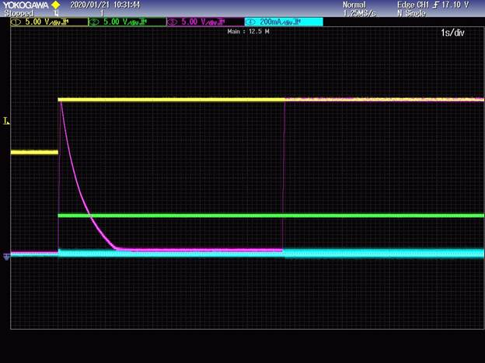

Ch1 (yellow): Input voltage VIN to the e-fuse (pins 123,16,E1)  
Ch2 (green): Enable signal to the 20V boost converter (the enable EN/UVLO to the e-fuse is this signal but delayed 1.5ms)  
Ch3 (red): Output voltage from e-fuse (pins 17-23)  
Ch4 (blue): Current thru e-fuse

In the zoom part of the picture below is shown the slow start-up of the e-fuse at the first attempt. The start-up time is appr 26ms.

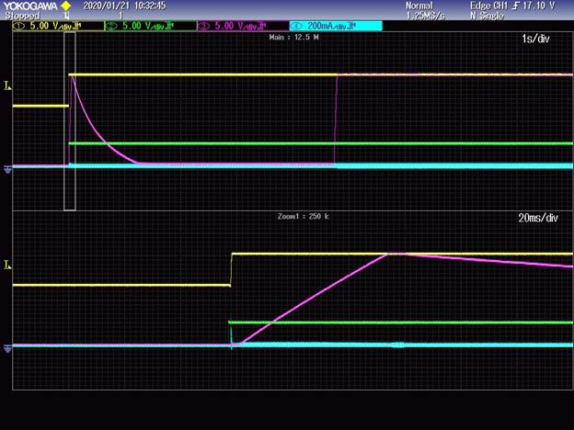

Ch1 (yellow): Input voltage VIN to the e-fuse (pins 123,16,E1)  
Ch2 (green): Enable signal to the 20V boost converter (the enable EN/UVLO to the e-fuse is this signal but delayed 1.5ms)  
Ch3 (red): Output voltage from e-fuse (pins 17-23)  
Ch4 (blue): Current thru e-fuse

In the zoom part of the picture below is shown the slow start-up of the e-fuse at the second attempt. The start-up time is the same as in the first attempt, appr 26ms.

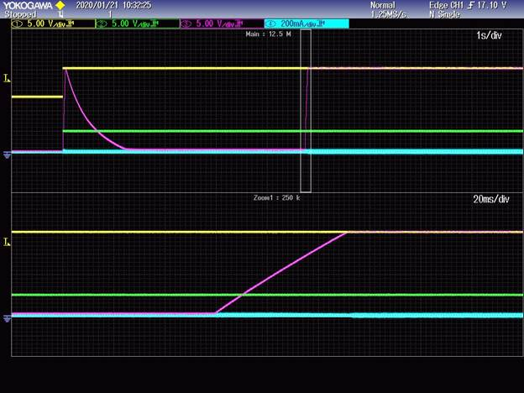

Ch1 (yellow): Input voltage VIN to the e-fuse (pins 123,16,E1)  
Ch2 (green): Enable signal to the 20V boost converter (the enable EN/UVLO to the e-fuse is this signal but delayed 1.5ms)  
Ch3 (red): Output voltage from e-fuse (pins 17-23)  
Ch4 (blue): Current thru e-fuse

I will continue to experiment with longer time intervals between the time point the input voltage to the e-fuse is ramped-up (from 13V to 20V) to the enable of the e-fuse.