Oscilloscope Screen Shots 2

1st September 2017

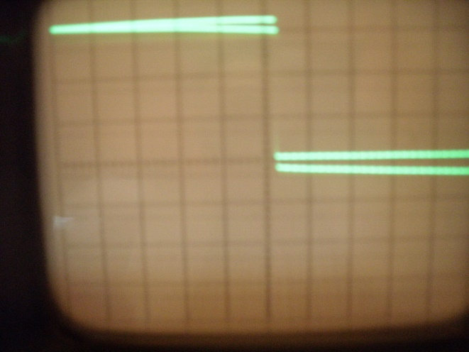

Pin 1. 10mS/cm; 2V/cm. Centre Line = 0V

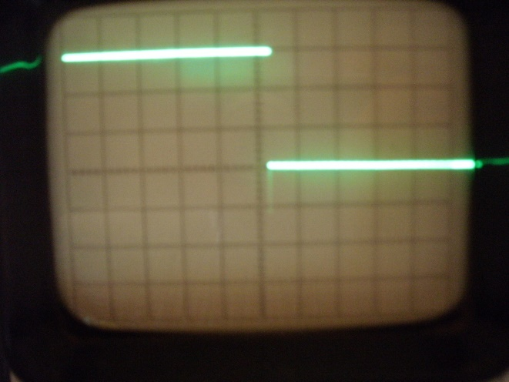

Pin 2. 10mS/cm; 0.2V/cm. Centre Line = 0V

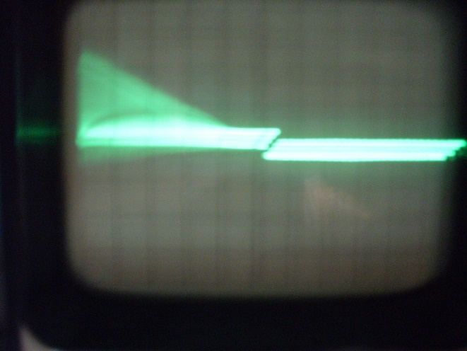

Pin 3. 10mS/cm; 50mV/cm. Centre Line = 0V

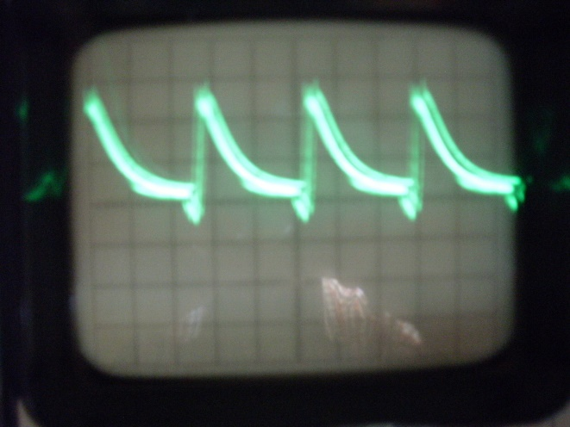

Pin 3. 10µS/cm; 50mV/cm. Centre Line = 0V

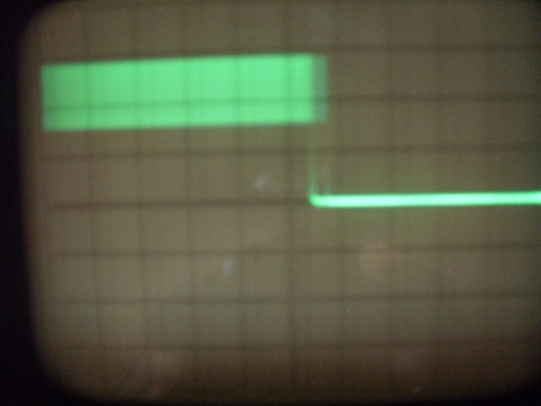

Pin 4. 10mS/cm; 1V/cm. Centre Line = 0V

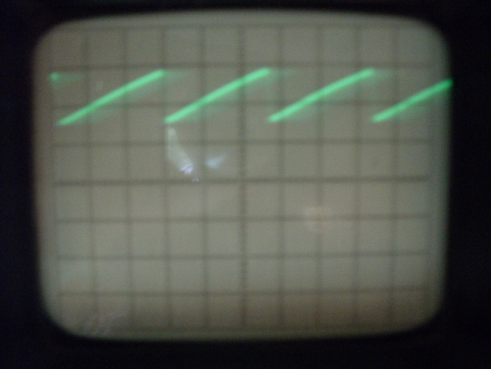

Pin 4. 10µS/cm; 1V/cm. Centre Line = 0V

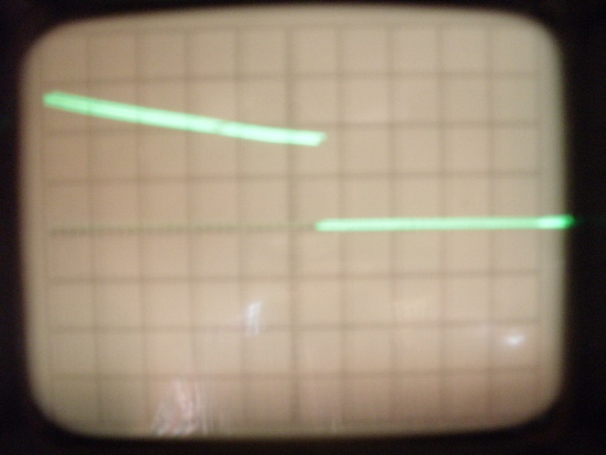

Pin 6. 10mS/cm; 5V/cm. Centre Line = 0V

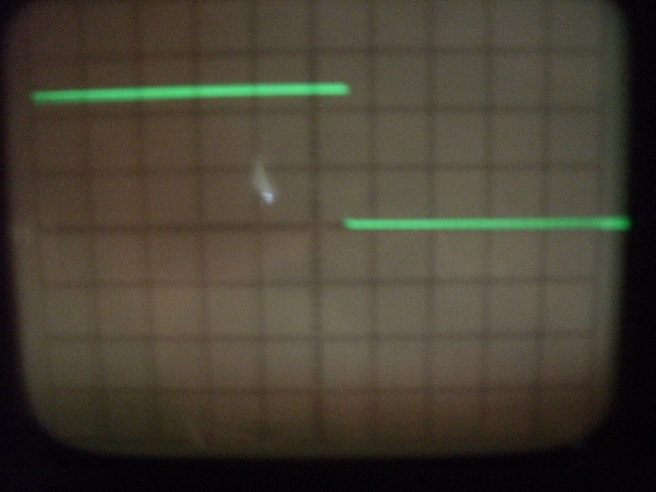

Pin 8. 10mS/cm; 2V/cm. Centre Line = 0V

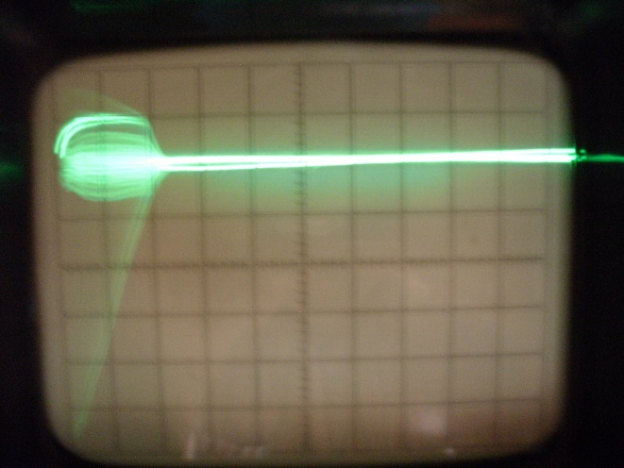

Transformer primary/TR1 collector

20mS/cm; 500V/cm (probe on x10)

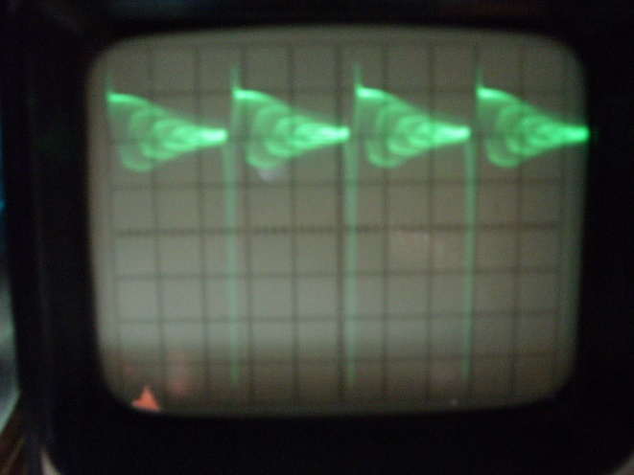

Transformer primary/TR1 collector

10µS/cm; 500V/cm (probe on x10)