**Oscilloscope Screen Shots. UC 3842 under fault conditions. 31st August 2017.**

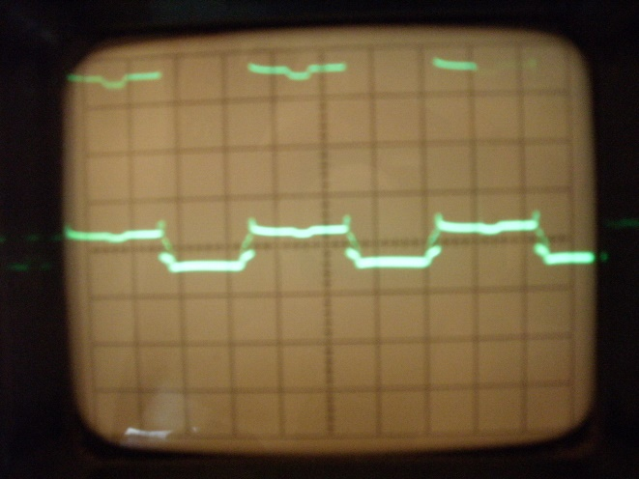

Pin 1. 2V/cm; 5mS/cm; centre line 0V

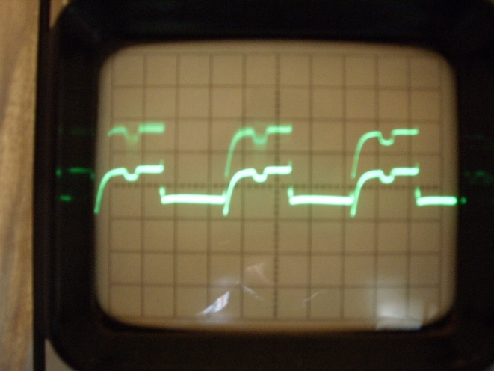

Pin 2. 2V/cm; 5mS/cm; centre line 0V

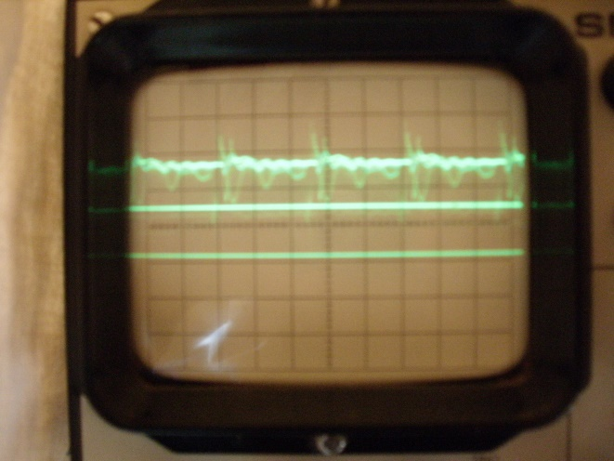

Pin 2. 0.5V/cm; 10µS/cm; centre line 0V

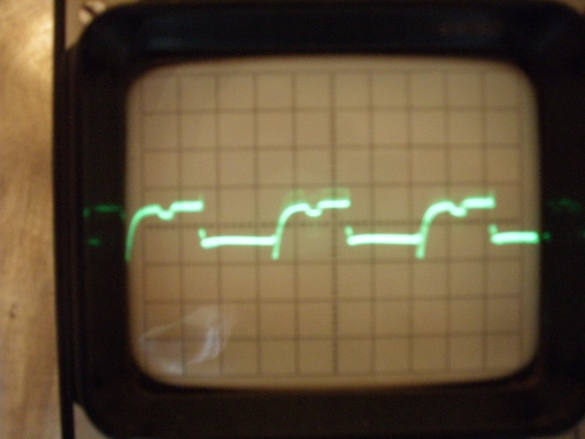

Pin 3. 0.5V/cm; 5mS/cm; centre line 0V

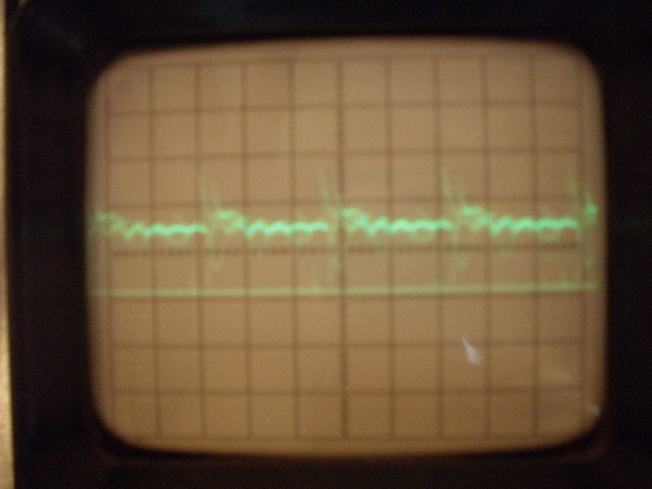

Pin 3. 0.5V/cm; 10µS/cm; centre line 0V

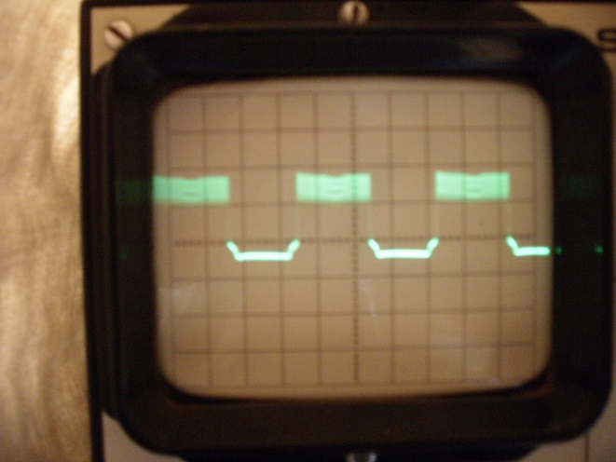

Pin 4. 2V/cm; 5mS/cm; centre line 0V

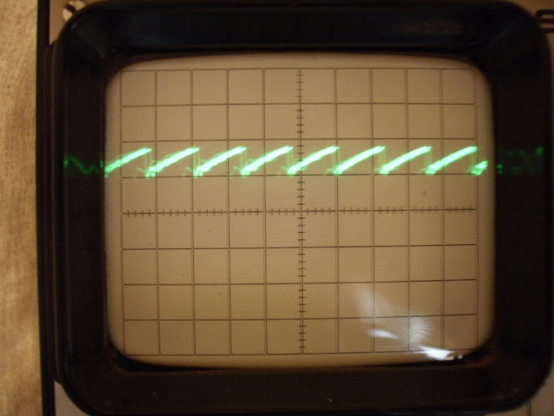

Pin 4. 2V/cm; 20µS/cm; centre line 0V

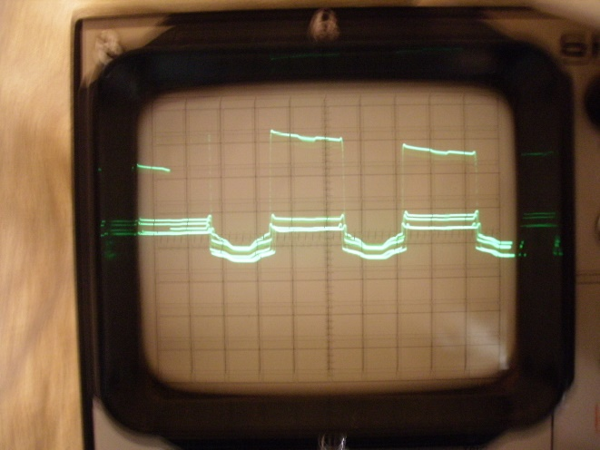

Pin 6. 5V/cm; 5mS/cm; centre line 0V

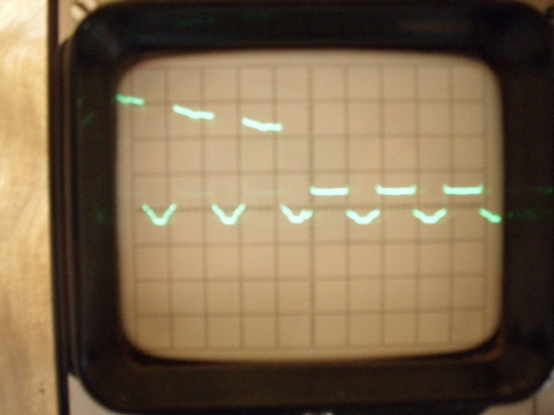

Pin 6. 5V/cm; 10mS/cm; centre line 0V

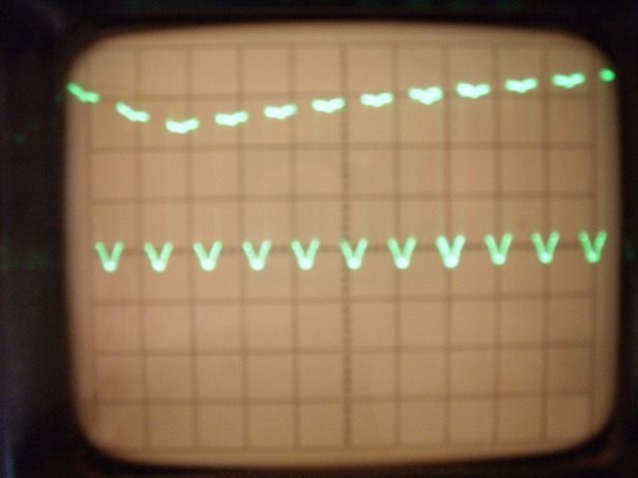

Pin 7. 5V/cm; 20mS/cm; centre line 0V

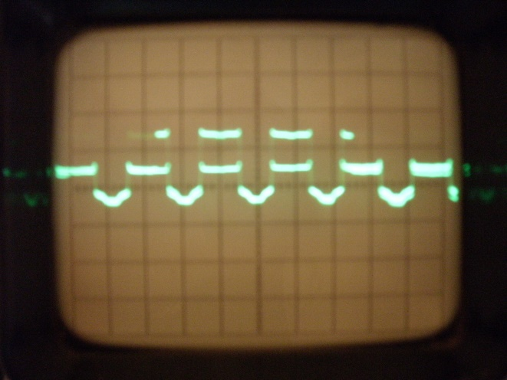

Pin 8. 5V/cm; 10mS/cm; centre line 0V