12500 TI Boulevard, MS 8640, Dallas, Texas 75243

PCN#20180329000
Qualify TI Mexico as an additional Assembly & Test site
for select PDIP devices
Change Notification / Sample Request

Date: $Date$
$To$ $Recipients_To$
$Cc$ $Recipients_Cc$

This is an announcement of a change to a device that is currently offered by Texas Instruments. The details of this change are on the following pages.

We request you acknowledge receipt of this notification within 30 days of the date of this notice. Lack of acknowledgement of this notice within 30 days constitutes acceptance of the change. If you require samples or additional data to support your evaluation, please request within 30 days.

The proposed first ship date is indicated on page 3 of this notification, unless customer agreement has been reached on an earlier implementation of the change.

This notice does not change the end-of-life status of any product. Should product affected be on a previously issued product withdrawal/discontinuance notice, this notification does not extend the life of that product or change the life time buy offering/discontinuance plan.

For questions regarding this notice, contact your local Field Sales Representative or the PCN Manager (PCN_ww_admin_team@list.ti.com).

Sincerely,

PCN Team
SC Business Services
$CRF_PCNNumber$
Attachment: 1

Products Affected:

The devices listed on this page are a subset of the complete list of affected devices. According to our records, these are the devices that you have purchased within the past twenty-four (24) months. The corresponding customer part number is also listed, if available.

$DeviceTable$

Technical details of this Product Change follow on the next page(s).

PCN Number: |  |  |  |  |  | 20180329000 |  |  |  |  |  |  |  | PCN Date: |  | April 16, 2018
Title: |  |  | Qualify TI Mexico as an additional Assembly & Test site for select PDIP devices
Customer Contact: |  |  |  | PCN Manager |  |  |  |  |  |  |  | Dept: | Quality Services
Proposed 1st Ship Date: |  |  |  |  |  |  |  | July 16, 2018 |  |  |  |  | Estimated Sample Availability: |  |  |  | Provided upon Request
Change Type:
 | Assembly Site |  |  |  |  |  |  |  |  |  | Design |  |  |  |  | Wafer Bump Site
 | Assembly Process |  |  |  |  |  |  |  |  |  | Data Sheet |  |  |  |  | Wafer Bump Material
 | Assembly Materials |  |  |  |  |  |  |  |  |  | Part number change |  |  |  |  | Wafer Bump Process
 | Mechanical Specification |  |  |  |  |  |  |  |  |  | Test Site |  |  |  |  | Wafer Fab Site
 | Packing/Shipping/Labeling |  |  |  |  |  |  |  |  |  | Test Process |  |  |  |  | Wafer Fab Materials
 |  |  |  |  |  |  |  |  |  |  |  |  |  |  |  | Wafer Fab Process
PCN Details
Description of Change:
Texas Instruments is pleased to announce the qualification of TI Mexico as an additional Assembly & Test site for the list of devices shown below. Material differences between sites are as follows.

Assembly Site | Assembly Site Origin | Assembly Country Code | Assembly City
Carsem | CRS | MYS | Jelapang
TI Mexico | MEX | MEX | Aguascalientes

Material Differences:
 | Carsem | TI Mexico
Mount compound | 434165 | 4147858
Mold compound | 435006 | 4211880
Lead finish | NiPdAu | NiPdAu

Marking Differences:

 | Carsem | TI Mexico
Group 1 Device | 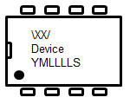  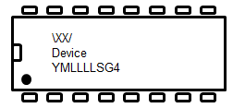 | 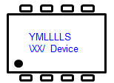  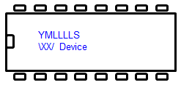
Group 2 Device | 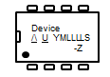  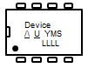  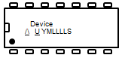  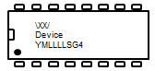  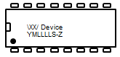  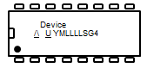 | 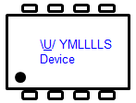  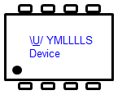  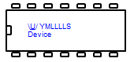  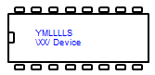  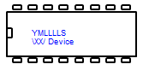  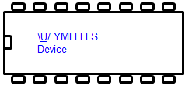
Group 3 Device | 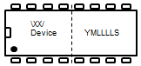 | 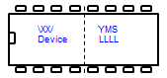

Test coverage, insertions, conditions will remain consistent with current testing and verified with test MQ.
Reason for Change:
Continuity of Supply. Carsem will shut down PDIP packages by Dec2018.
Anticipated impact on Fit, Form, Function, Quality or Reliability (positive / negative):
None
Anticipated impact on Material Declaration
 |  | No Impact to the Material Declaration |  |  |  |  |  |  | Material Declarations or Product Content reports are driven from production data and will be available following the production release. Upon production release the revised reports can be obtained from the TI Eco-Info website. There is no impact to the material meeting current regulatory compliance requirements with this PCN change.
Changes to product identification resulting from this PCN:
Assembly Site
Carsem | Assembly Site Origin (22L) | ASO: CRS
TI Mexico | Assembly Site Origin (22L) | ASO: MEX

Sample product shipping label (not actual product label)
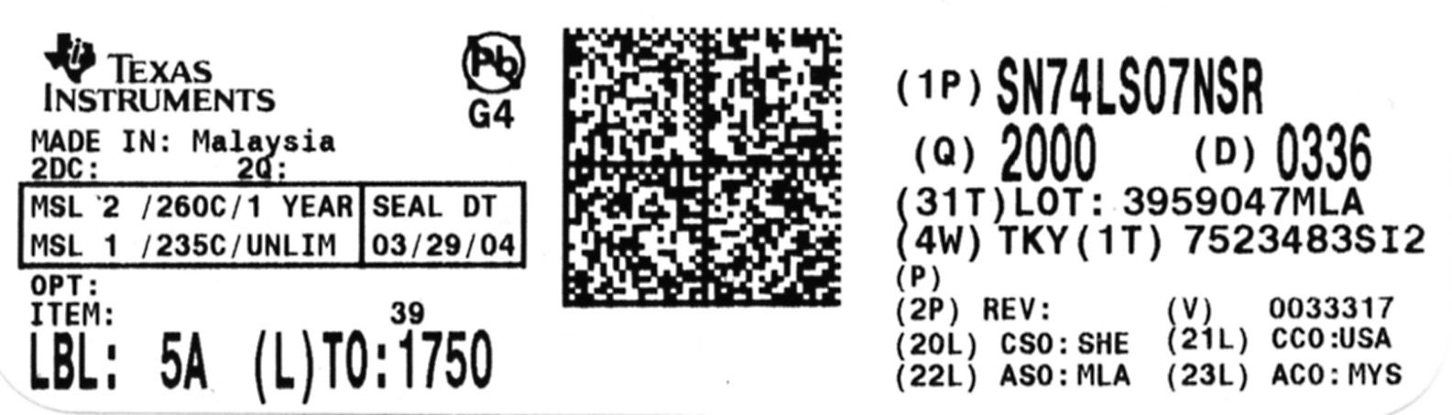
Product Affected : Group 1
BQ2004EPNG4 | UC2825NG4 | UC3770ANG4 | UC2525ANG4
BQ2004PNG4 | UC2527ANG4 | UC3770BNG4 | UC3823ANG4
DAC714P | UC2610NG4 | UC2842ANG4 | UC3823NG4
DAC714PG4 | UC2705NG4 | UC2842NG4 | UC3824NG4
DAC716PG4 | UC2707NG4 | UC2843ANG4 | UC3825ANG4
DAC716PK | UC3843ANG4 | UC2843NG4 | UC3825NG4
DAC7800KPG4 | UC3843NG4 | UC2844ANG4 | UC3854NG4
DAC7800LPG4 | UC3844ANG4 | UC3842ANG4 | UC3856NG4
INA101HP | UC3844NG4 | OPA2244PA | UC3861NG4
INA101HPG4 | UC3845ANG4 | OPA2244PAG4 | UC3867NG4
INA105KP | UC3845NG4 | OPA2337PA | UC3901NG4
INA105KPG4 | UC3852NG4 | OPA2337PAG4 | UC3902NG4
INA121P | UC3853NG4 | OPA2705PA | UC3906NG4
INA121PA | UC3854ANG4 | OPA2705PAG4 | UC3907NG4
INA121PAG4 | UC3854BNG4 | OPA340PA | UC39432NG4
INA121PG4 | UC2844NG4 | OPA340PAG4 | UCC25701NG4
INA125P | UC2845ANG4 | OPA344PA | UCC25702NG4
INA125PA | UC2845NG4 | OPA344PAG4 | UCC2806NG4
INA125PAG4 | UC2846NG4 | OPA347PA | UCC2810NG4
INA125PG4 | UC2853NG4 | OPA347PAG4 | UCC2817ANG4
INA2134PA | UC2854ANG4 | OPA4137P | UCC2818ANG4
INA2134PAG4 | UC2854BNG4 | OPA4137PA | UCC2818NG4
INA2137PA | UC2854NG4 | OPA4137PAG4 | UCC35701NG4
INA2137PAG4 | UC2856NG4 | OPA703PA | UCC3806NG4
MPC508AP | UC2901NG4 | OPA703PAG4 | UCC3817ANG4
MPC508APG4 | UC2906NG4 | OPA705PA | UCC3817NG4
MPC509AP | UC2907NG4 | PGA202KP | UCC3818ANG4
MPC509APG4 | UC29432NG4 | PGA202KPG4 | UCC3818NG4
MPY634KP | UC3524ANG4 | PGA203KP | VFC320BPG4
MPY634KPG4 | UC3525ANG4 | PGA203KPG4 | VFC320CPG4
OPA2137P | UC3525BNG4 | PGA2310PA | VFC32KP
OPA2137PA | UC3527ANG4 | PGA2310PAG4 | VFC32KPG4
OPA2137PAG4 | UC3610NG4 | PGA2311P | XTR101AP
OPA2137PG4 | UC3705NG4 | PGA2311PA | XTR101APG4
UC2708NG4 | UC3706NG4 | PGA2311PAG4 | XTR105P
UC2709NG4 | UC3707NG4 | PGA2311PG4 | XTR105PA
UC2710NG4 | UC3708NG4 | SN0708100P | XTR105PAG4
UC28025NG4 | UC3709NG4 | UAF42AP | XTR105PG4
UC2825ANG4 | UC3710NG4 | UAF42APG4 | XTR110KP
UC2825BNG4 | UC3717ANG4 | UC2524ANG4 | XTR110KPG4

Product Affected : Group 2
BQ2004EPN | UC2844N | UC3717AN | UC3907N
BQ2004HPN | UC2845AN | UC3770AN | UC39432N
BQ2004PN | UC2845N | UC3770BN | UC80851N
DAC716P | UC2846N | UC3823AN | UC81185N
DAC716PB | UC2852N | UC3823N | UC81186N
UC2524AN | UC2853N | UC3824N | UC81500AN
UC2525AN | UC2854AN | UC3825AN | UC81501AN
UC2525BN | UC2854BN | UC3825BN | UC81502AN
UC2527AN | UC2854N | UC3825N | UC81521P
UC2610N | UC2856N | UC3842AN | UC81522P
UC2705N | UC2901N | UC3842N | UCC25701N
UC2706N | UC2902N | UC3843AN | UCC25702N
UC2707N | UC2906N | UC3843N | UCC2806N
UC2708N | UC2907N | UC3844AN | UCC2810N
UC2709N | UC29432N | UC3844N | UCC2817AN
UC2710N | UC3524AN | UC3845AN | UCC2817N
UC28025N | UC3525AN | UC3845N | UCC2818AN
UC2823AN | UC3525BN | UC3852N | UCC2818N
UC2823N | UC3527AN | UC3853N | UCC35701N
UC2824N | UC3610N | UC3854AN | UCC35702N
UC2825AN | UC3611N | UC3854BN | UCC3806N
UC2825BN | UC3705N | UC3854N | UCC3810N
UC2825N | UC3706N | UC3856N | UCC3817AN
UC2842AN | UC3707N | UC3861N | UCC3817N
UC2842N | UC3708N | UC3867N | UCC3818AN
UC2843AN | UC3708NE | UC3901N | UCC3818N
UC2843N | UC3709N | UC3902N
UC2844AN | UC3710N | UC3906N

Product Affected : Group 3
DAC7800KP | DAC7800LP | VFC320BP | VFC320CP

Qualification Report
PDIP 8/14/16 PIN OFFLOAD TO FMX Devices without Die Overcoat Polyimide
Approve Date 20-Mar-2018

Product Attributes
Attributes | Qual Device: PGA2310PA | QBS Package Reference:  L293DNE | QBS Package Reference:  LT1013CP | QBS Package Reference:  MSP430F2013IN | QBS Package Reference:  NE5532P | QBS Package Reference:  SN74HC595N | QBS Package Reference:  SN74HCT540N
Assembly Site | FMX | FMX | FMX | MLA | FMX | MLA | MLA
Package Family | PDIP | PDIP | PDIP | PDIP | PDIP | PDIP | PDIP
Flammability Rating | UL 94 V-0 | UL 94 V-0 | UL 94 V0 | UL 94 V-0 | UL 94 V-0 | UL 94 V-0 | UL 94 V-0
Wafer Fab Supplier | SFAB | SFAB | SFAB | TSMC-10 | SFAB | SFAB | SFAB
Wafer Fab Process | BCMOS | JI1 | JI1 | TSMC EMB FLASH | JI1 | 74HC | 74HC-NONEPI

Attributes | QBS Package Reference:  SN74LS03N | QBS Package Reference:  TLC339IN | QBS Package Reference:  TPA3122D2N | QBS Package Reference:  TPS2041P | QBS Package Reference:  TS12A4514P | QBS Package Reference:  UCC37322P
Assembly Site | MLA | FMX | MLA | FMX | FMX | FMX
Package Family | PDIP | PDIP | PDIP | PDIP | PDIP | PDIP
Flammability Rating | UL 94 V-0 | UL 94 V-0 | UL 94 V-0 | UL 94 V-0 | UL 94 V-0 | UL 94 V-0
Wafer Fab Supplier | SFAB | DFAB | UMC FAB8AB | DFAB | DFAB | DFAB
Wafer Fab Process | JI1 | LINCMOS_5/5 | LBC5X | LBC3S | LBC3S | LBC3S
- QBS: Qual By Similarity
- Qual Device PGA2310PA is qualified at Not Classified

Qualification Results
Data Displayed as: Number of lots / Total sample size / Total failed
Type | Test Name / Condition | Duration | Qual Device: PGA2310PA | QBS Package Reference:  L293DNE | QBS Package Reference:  LT1013CP | QBS Package Reference:  MSP430F2013IN | QBS Package Reference:  NE5532P | QBS Package Reference:  SN74HC595N | QBS Package Reference:  SN74HCT540N
AC | Autoclave 121C | 96 Hours | 3/231/0 | 3/231/0 | - | 3/231/0 | - | 3/225/0 | 3/231/0
ED | Electrical Characterization | Per Datasheet Parameters | - | - | - | - | - | Pass | -
FLAM | Flammability (UL 94V-0) | - | - | - | - | - | - | - | 3/15/0
HAST | Biased HAST, 130C/85%RH | 96 Hours | - | - | - | - | 3/231/0 | - | -
HTOL | Life Test, 150C | 300 Hours | - | - | - | - | 3/231/0 | - | -
HTSL | High Temp. Storage Bake, 170C | 420 Hours | 3/231/0 | 3/231/0 | - | 3/231/0 | - | 3/231/0 | 3/231/0
LI | Lead Fatigue | Leads | - | 3/66/0 | - | 3/45/0 | 3/66/0 | 3/45/0 | 3/45/0
LI | Lead Pull to Destruction | Leads | - | 3/144/0 | - | 3/126/0 | 3/72/0 | 3/144/0 | 3/180/0
MQ | Manufacturability (Assembly) | (per mfg. Site specification) | Pass | Pass | Pass | Pass | Pass | Pass | Pass
PKG | Lead Finish Adhesion | Leads | - | 3/45/0 | - | 3/45/0 | 3/45/0 | 3/45/0 | 2/30/0
SD | Solderability | 8 Hours Steam Age | - | 3/66/0 | - | 3/66/0 | 3/66/0 | 3/66/0 | 3/66/0
TC | Temperature Cycle, -65/150C | 500 Cycles | 3/231/0 | 3/225/0 | 3/231/0 | 3/231/0 | - | 3/231/0 | 3/231/0

Type | Test Name / Condition | Duration | QBS Package Reference:  SN74LS03N | QBS Package Reference:  TLC339IN | QBS Package Reference:  TPA3122D2N | QBS Package Reference:  TPS2041P | QBS Package Reference:  TS12A4514P | QBS Package Reference:  UCC37322P
AC | Autoclave 121C | 96 Hours | 3/231/0 | 3/231/0 | 3/231/0 | - | 1/77/0 | 3/231/0
ED | Electrical Characterization | Per Datasheet Parameters | - | - | - | - | - | -
FLAM | Flammability (UL 94V-0) | - | - | - | - | - | - | 3/15/0
HAST | Biased HAST, 130C/85%RH | 96 Hours | - | - | - | - | - | -
HTOL | Life Test, 150C | 300 Hours | - | - | - | - | - | -
HTSL | High Temp. Storage Bake, 170C | 420 Hours | 3/231/0 | 3/231/0 | 3/231/0 | - | 1/77/0 | 3/231/0
LI | Lead Fatigue | Leads | 3/45/0 | 3/45/0 | 3/45/0 | - | - | 3/45/0
LI | Lead Pull to Destruction | Leads | 3/126/0 | 3/126/0 | 3/180/0 | - | - | 3/70/0
MQ | Manufacturability (Assembly) | (per mfg. Site specification) | Pass | Pass | Pass | Pass | Pass | Pass
PKG | Lead Finish Adhesion | Leads | 3/45/0 | 3/45/0 | 3/45/0 | - | - | 3/45/0
SD | Solderability | 8 Hours Steam Age | 3/66/0 | 3/66/0 | 3/66/0 | - | - | 3/66/0
TC | Temperature Cycle, -65/150C | 500 Cycles | 3/231/0 | 3/231/0 | 3/231/0 | 3/231/0 | 1/77/0 | 3/231/0
- Preconditioning was performed for Autoclave, Unbiased HAST, THB/Biased HAST, Temperature Cycle, Thermal Shock, and HTSL, as applicable
- The following are equivalent HTOL options based on an activation energy of 0.7eV : 125C/1k Hours, 140C/480 Hours, 150C/300 Hours, and 155C/240 Hours
- The following are equivalent HTSL options based on an activation energy of 0.7eV : 150C/1k Hours, and 170C/420 Hours
- The following are equivalent Temp Cycle options per JESD47 : -55C/125C/700 Cycles and -65C/150C/500 Cycles
Quality and Environmental data is available at TI's external Web site: http://www.ti.com/
Green/Pb-free Status:
Qualified Pb-Free(SMT) and Green

THIS INFORMATION RELATING TO QUALITY AND RELIABILITY IS PROVIDED "AS IS." Product information detailed in this report may not accurately reflect TI's current product materials, processes and testing used in the construction of the TI products. Customers are solely responsible to conduct sufficient engineering and additional qualification testing to determine whether a device is suitable for use in their applications. Using TI products outside limits stated in TI’s datasheet may void TI's warranty. See TI's Terms of Sale at "http://www.ti.com/lsds/ti/legal/termsofsale.page"

For questions regarding this notice, e-mails can be sent to the regional contacts shown below or your local Field Sales Representative.
Location | E-Mail
USA | PCNAmericasContact@list.ti.com
Europe | PCNEuropeContact@list.ti.com
Asia Pacific | PCNAsiaContact@list.ti.com
Japan | PCNJapanContact@list.ti.com

