PFC DESIGN FOR 8KW OUTPUT POWER USING UCC28180
CIRCUIT DIAGRAM:
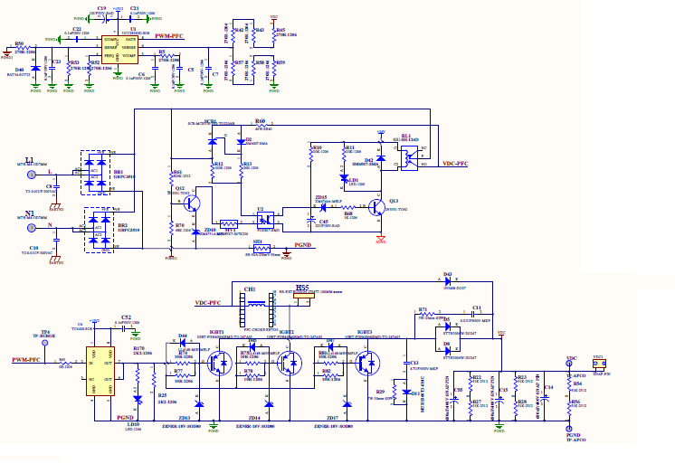

PFC DESIGN FOR 8KW OUTPUT POWER USING UCC28180
Bill of material:
ITEM | DESCRIPTION | UOM | QTY | CKT REFERENCE
10 | SURFACE MOUNT SMALL SIGNAL FAST SWITCHING GLASS CASE SILICON DIODE, TYPE-LL4148, PACKAGE: MINIMELF SOD-80, ORDER CODE- LL 4148-GS08, MAKE: VISHAY/ FAIRCHILD | NOS | 3 | D44,D45,D47
20 | CHIP RESISTOR, 100K OHMS, +/-1%, 0.25W, 100PPM/DEGREE CEL, SIZE-1206, MAKE-YAGEO(RC1206FR-07100KL) OR MAKE- WATTS(WCR-18) | NOS | 1 | R42...
30 | CHIP RESISTOR, 2.2K OHMS,+/-1%, 100PPM/C,0.25W, SIZE-1206, MAKE-YAGEO(RC1206FR-072K2L), WATTS(WCR-18) | NOS | 1 | R170...
40 | CHIP RESISTOR, 4.7K OHMS,+/-1%, 100 PPM/DEGREE CEL., 0.25W, SIZE-1206, MAKE-YAGEO(RC1206FR-074K7L), WATTS(WCR-18) | NOS | 1 | R25...
50 | CHIP RESISTOR, 20 OHMS,+/-1%, 100 PPM/DEGREE CEL, 0.25W, SIZE-1206, MAKE-YAGEO(RC1206FR-0710RL), WATTS(WCR-18) | NOS | 6 | R74,R75,R81,R77,R78,R82
60 | IGBT SINGLE TRANSISTOR, 40 A, 2.4 V, 483 W, 1.2 kV, TO-247, MAKE: FUJI SEMICONDUCTOR PART NO. :FGW40N120WD; | NOS | 3 | IGBT1,IGBT2,IGBT3
70 | ZENER DIODE, 18V ,PACKAGE -SOD-80, PART NO- TZM5248B,MAKE- VISHAY OR PART NO- BZV55-18B,MAKE- NXP SEMICONDUCTORS | NOS | 3 | ZD13,ZD14,ZD15
80 | CHIP LED (0.5 MM HEIGHT),PACKAGE : 1206 , RED COLOUR,PART NO : 15-215/R6C-AM2P1VY/2T MAKE : EVERLIGHT ELECTRONICS CO., LTD. | NOS | 1 | LD10...
90 | ULTRAFAST RECTIFIERS DIODE 600 V/3A, PART NO : MURS360T3 PACKAGE : SMC (CASE 403) MAKE : ON SEMI , ELEMENT 14 ORDERING NO: 1459153 OR EQUIVALENT. | NOS | 1 | D11...
100 | METALLIZED POLYPROPYLENE FLIM CAPACITORS,MKP TYPE,4.7NF,+/-10%,630V,MAKE : EPCOS ORDER CODE : B32621A6472+ (BODY SIZE = 13MM(L) X 4MM(W) X 9MM(H), PITCH = 10MM) | NOS | 2 | C13,C11...
110 | WIRE WOUND RESISTOR , 22 OHMS, +/-5% , +/-100 PPM, 7W TYPE : SIFP 7 MAKE:CERMET (BODY = 25L x 8.5D) . | NOS | 1 | R29...
120 | STTH3006W TURBO 2 ULTRAFAST HIGH VOLTAGE RECTIFIER DIODE,600V/30A, PACKAGE : DO-247, PART NO : STTH3006W, MAKE :ST | NOS | 2 | D5,D8
130 | CURRENT SENSE RESISTOR 50A, 250mV AS PER DRAWING NO: | NOS | 1 | SH
140 | CERAMIC MULTILAYER CHIP CAPACITORS,100NF,+/10%,50V,SIZE:1206,TYPE: X7R, MAKE:YAGEO(ORDERING CODE: 12062R104K9B20D)ORMAKE: AVX(ORDERING CODE:12065C104KAT2A) OR MAKE: VISHAY(ORDERING CODE:1206Y104KXAAC).OR MAKE: KEMET, PART NO: C1206C104K5RAC | NOS | 1 | C52
150 | MINIATURE ALUMINIUM ELECTROLYTIC CAPACITOR,SNAP IN TYPE,680uF,+/-20%,450V,105 DEGREE CEL,MAKE:KENDEIL, PART NO:K054506810PMOE060 (BODY SIZE =35Dx60H) | NOS | 3 | C55, C14, C15...
160 | CHIP RESISTOR, 51K OHM,+/-1%,1W,100PPM/?c,SIZE-2512,MAKE-YAGEO(RC2512) OR MAKE-WATTS(WCR-24) | NOS | 6 | R23,R22,R28,R27,R54,R56

PFC DESIGN FOR 8KW OUTPUT POWER USING UCC28180
Bill OF MATERIAL:
ITEM | DESCRIPTION | UOM | QTY | CKT REFERENCE
170 | CHIP RESISTOR, 200 OHMS,+/-1%,0.25W, 100PPM /DEGREE CEL., SIZE-1206, MAKE-YAGEO(RC 1206FR-07200RL) / WATTS(WCR-18) | nos | 1 | R50,R53
180 | SS210 , SCHOTTKY BARRIER DIODE, 100V/2A , PACKAGE : SMB, MOLDED PLASTIC, MAKE : VISHAY , HY ELECTRONICS , PART NO : SS210, ELEMENT 14 ORDRERING NO: 1843484 | nos | 1 | D40
190 | SURFACE MOUNT CAPACITOR(SMD),6.8NF/ 50V, NPO, PACKAGE-1206, MAKE-VISHAY SEMICONDUCTOR | nos | 1 | C22
200 | SURFACE MOUNT CAPACITOR(SMD),2.2NF/ 50V, NPO, PACKAGE-1206, MAKE-VISHAY SEMICONDUCTOR | nos | 1 | C23
210 | CHIP RESISTOR, 47K OHMS, +/-1%, 0.25W, 100PPM/DEGREE CEL, SIZE-1206, MAKE-YAGEO(RC1206FR-0747KL) OR MAKE- WATTS(WCR-18) | nos | 1 | R52
220 | CERAMIC MULTILAYER CHIP CAPACITOR, 0.1UF, +/-5%, 50V, SIZE-1206, TYPE-X7R, MAKE-YAGEO(ORDERING CODE-CC1206KRX7R9BB104) OR MAKE--VISHAY ORDERING CODE-VJ1206Y104KXACW1BC) | nos | 1 | C21
230 | CERAMIC MULTILAYER CHIP CAPACITOR,1.8UF ,+/-10%,50V,SIZE-1206,TYPE-X7R,MAKE -YAGEO(ORDERING CODE-12062R824K9B20D) | nos | 1 | C6
240 | CERAMIC MULTILAYER CHIP CAPACITOR,820 PF (0.82NF) ,+/-10%,50V,SIZE-1206,TYPE-X7R,MAKE -YAGEO(ORDERING CODE-12062R821K9B20D) | nos | 1 | C7
250 | CHIP RESISTOR, 5.6K OHMS, +/-1%, 0.25W, 100PPM/DEGREE CEL, SIZE-1206, MAKE-YAGEO(RC1206) OR MAKE- WATTS(WCR-18) | nos | 1 | R5
260 | CERAMIC MULTILAYER CHIP CAPACITOR 6.8UF,+/-10%,50V,SIZE-1206,TYPE-X7R,MAKE-KEMET (ORDERING CODE-C1206C685J5RACTU) | nos | 1 | C5
270 | CHIP RESISTOR, 470KOHMS, +/-1%, 0.25W, 100 PPM/DEGREE CEL, SIZE-1206, MAKE-YAGEO(RC 1206FR-07470KL) / WATTS(WCR-18) | nos | 1 | R45
280 | CHIP RESISTOR, 430KOHMS, +/-1%, 0.25W, 100 PPM/DEGREE CEL, SIZE-1206, MAKE-YAGEO(RC 1206FR-07430KL) / WATTS(WCR-18) | nos | 1 | R43
290 | CHIP RESISTOR, 12K OHMS,+/-1%, 100PPM/DEG. C, 0.25W, SIZE-1206, MAKE-YAGEO(RC1206FR-0712KL), WATTS(WCR-18) | nos | 1 | R57
300 | CHIP RESISTOR, 680 OHMS,+/-1%, 100PPM/?C, 0.25W, SIZE-1206, MAKE-YAGEO(RC1206), WATTS(WCR-18) | nos | 1 | R58
310 | CHIP RESISTOR, 0R OHMS, +/-1%, 0.25W, 100PPM/?C, SIZE-1206, MAKE-YAGEO(RC1206FR-070RL) OR MAKE- WATTS(WCR-18) | nos | 1 | R59
320 | CHIP RESISTOR, 0R OHMS, +/-1%, 0.25W, 100PPM/?C, SIZE-1206, MAKE-YAGEO(RC1206FR-070RL) OR MAKE- WATTS(WCR-18) | NOS | 1 | R63
330 | WIRE WOUND RESISTOR , 10 OHMS, +/-5% , +/-100 PPM, 7W TYPE : SIFP 7 MAKE:CERMET (BODY = 25L x 8.5D) . | nos | 1 | R71

PFC DESIGN FOR 8KW OUTPUT POWER USING UCC28180
WAVEFORM:
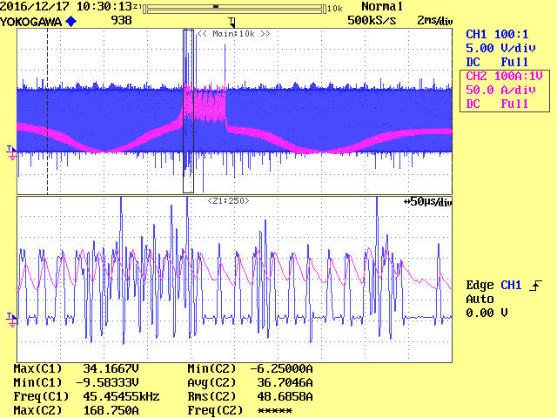

Pink: current through PFC inductor
Blue: gate source of IGBT

Problem faced:
Dear sir,
I am facing this problem as soon as I load my PFC circuit above 3.5KW.
Main problem is output of UCC28180 is perfectly alright but my gate to source waveform is getting problem.

