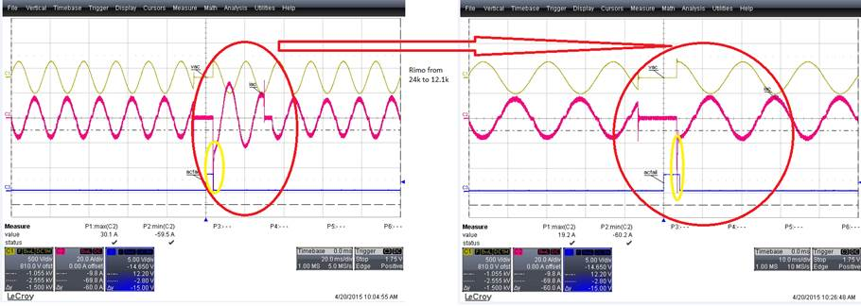

**There are initially two contributors to high current during AC Recover (PLD):**

1. **PFC response**
2. **X-Cap inrush current + Bulk Cap charging**

**For the PFC response, the multiplier gain (IMO) was reduced to limit the current during this transient condition. R_imo was reduced from 24k to 12.1k. Highlighted in the Red circle shows the reduced PFC current upon AC recover. However, the yellow circle still shows the spike current.**

**CH1: Vac CH3: Ac_Fail**

**CH2: Iin CH4: None**

**CH1: Vac CH3: Ac_Fail**

**CH2: Iin CH4: None**

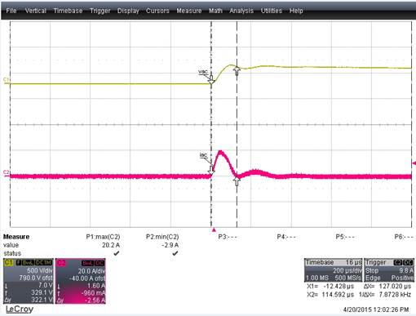

**The X-cap inrush current was measured to be  ~20Amps for 100uS (based on AC Source Chroma 6560). Icap = C * dv/dt**

**CH1: Vac CH3: None**

**CH2: Iin CH4: None**

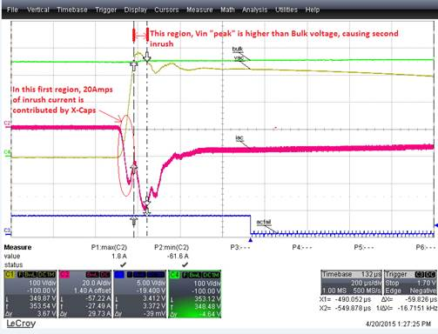

**During AC recovery at 230Vac PLD, the Input voltage to PSU overshoots or “peaks” to around 380V, before settling to the correct 325Vpeak level  (230Vac * sqrt(2) ). After 10mSec dropout, the Bulk voltage has been reduced ~350Vdc.**

**Therefore, the “peak” input voltage will cause some charging effect to the bulk cap.**

**CH1: Vac CH3: Ac_Fail**

**CH2: Iin CH4: Vbulk**