Startup
The startup waveform is shown in the figure below. The input voltage is set to 12V.
Channel 1 : 400V Output – Yellow (100V/Division)
Channel 2 : 12V Input – Pink (5V/Division)
Timebase : 5ms/Division
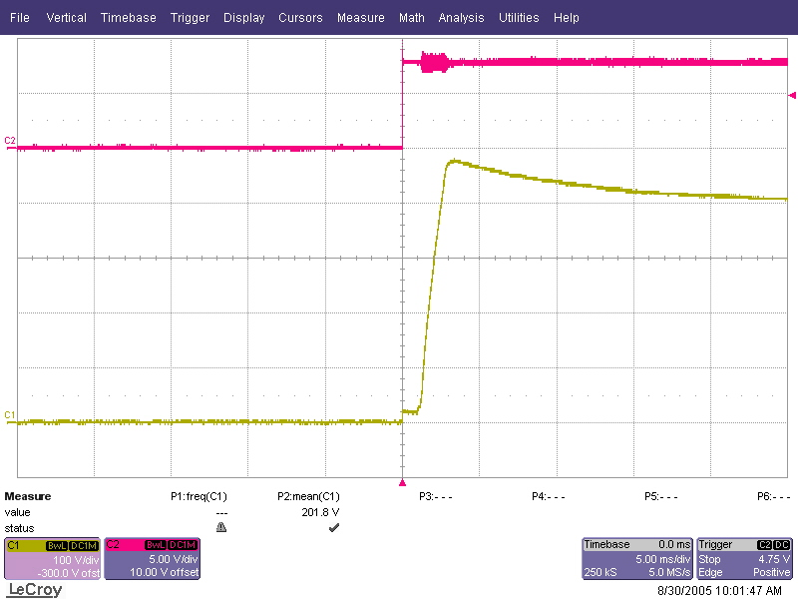

Shutdown
The shutdown waveform is shown in the figure below. The input voltage is set to 12V with a 1mA load on the output.
Channel 1 : 400V Output – Yellow (100V/Division)
Channel 2 : 12V Input – Pink (5V/Division)
Timebase : 5ms/Division
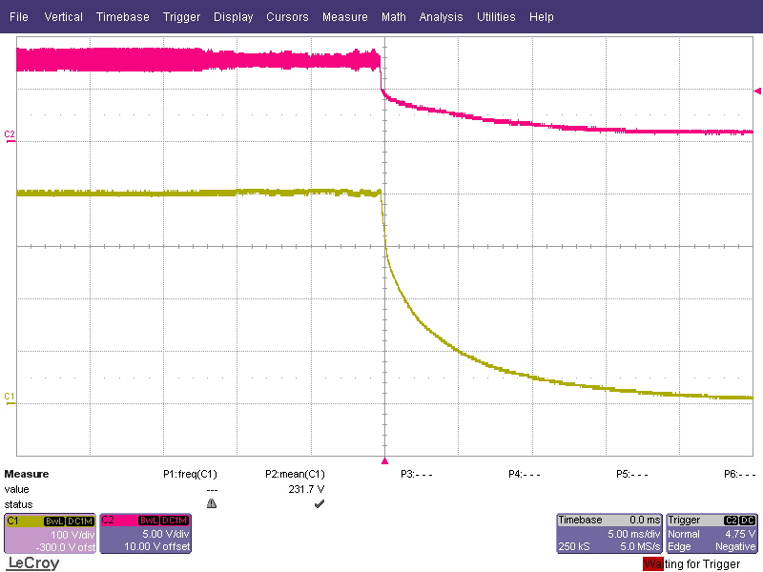

Output Ripple Voltage
The output ripple voltage is shown in the figure below.

Channel 1 : Vout – Yellow (AC Coupled 2V/Division)
Timebase : 2us/Division

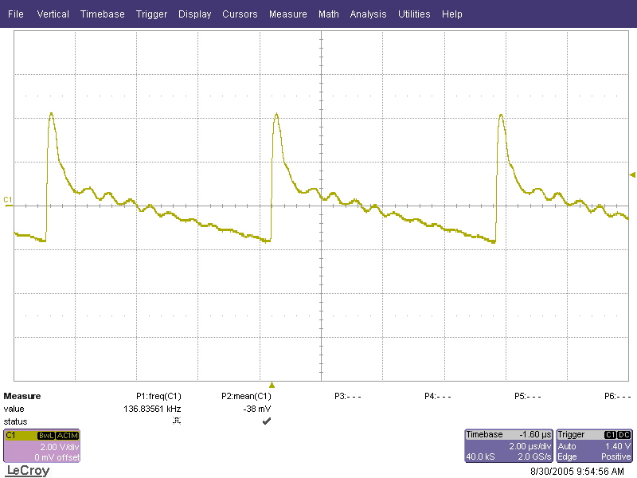

Transient Response
The transient response for PMP1435 is shown in the figures below. The output is pulsed using a resistive load from 0% to 100%

Channel 1 : Output Voltage – Yellow (10V/Division, AC – Coupled)
Timebase : 10msec/Division
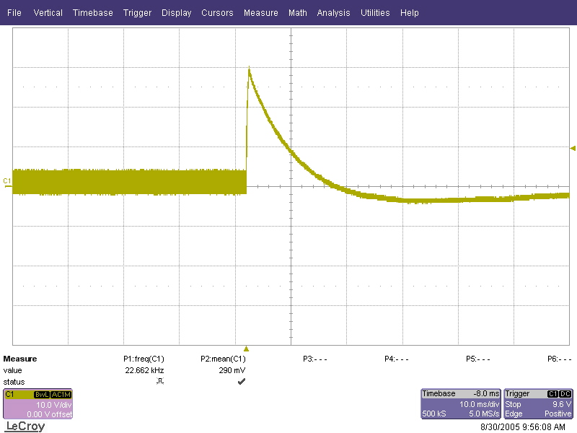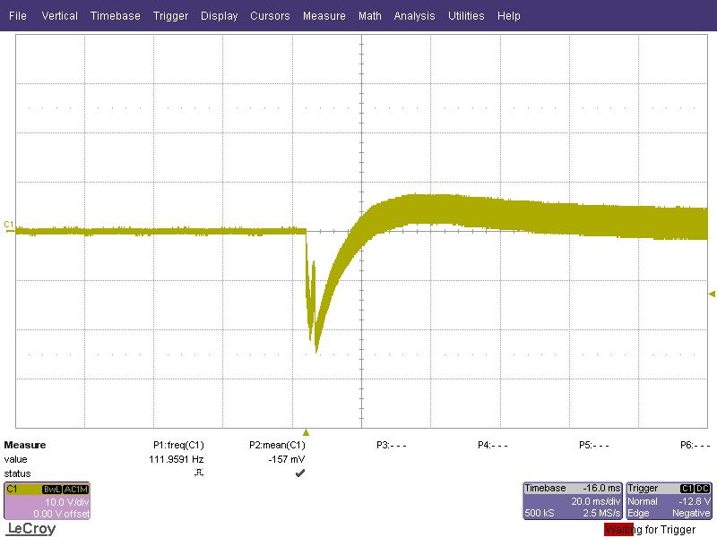

Miscellaneous
Shown in the figure below is the switch node of the converter.

Channel 1 : Switch Node – Yellow (50V/Division)
Timebase : 2usec/Division

