Photo

The photographs below show the PMP21007 Rev A assembly. This circuit was built on a PMP20654 Rev A PCB.

Top View

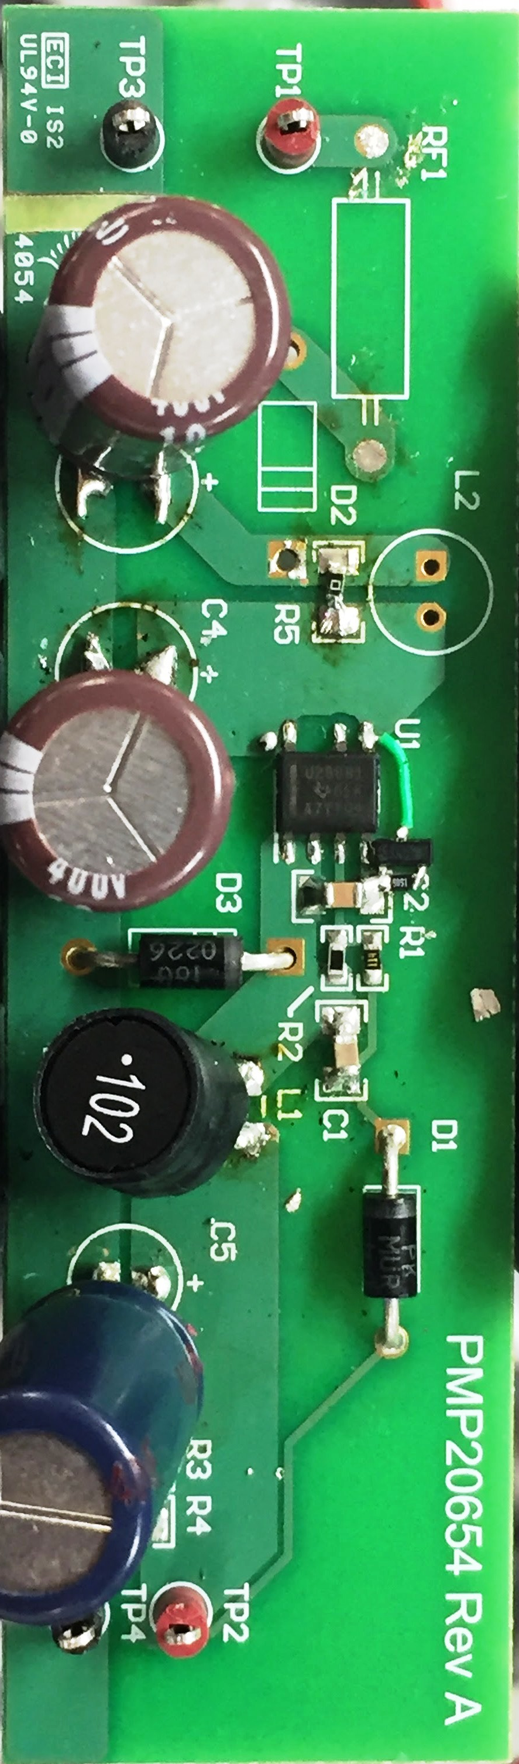

Bottom View

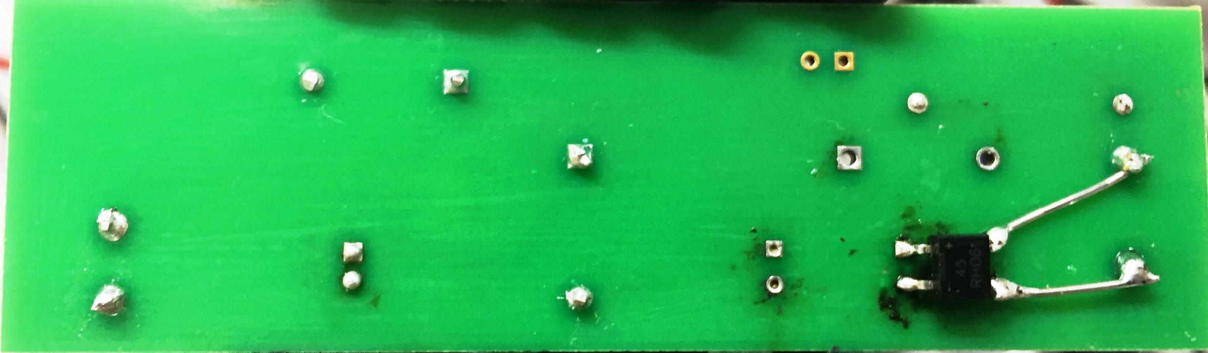

No-Load Regulation

Vin (V_{AC}) | Iout (mA) | Vout (V)
20.4 | 0 | 12.34
150 | 0 | 13.03
270 | 0 | 13.08

Converter Efficiency
The efficiency data is shown in the tables and graph below.

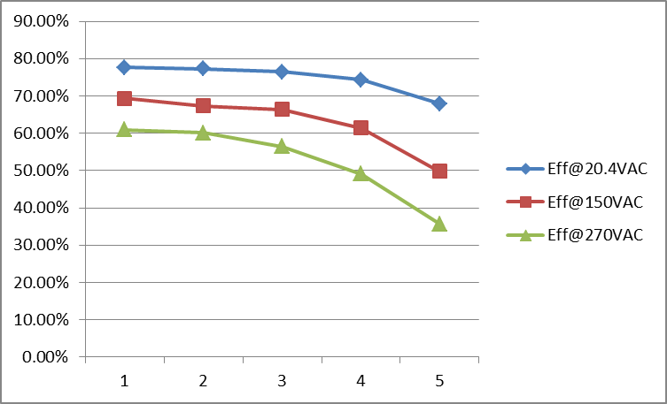

Vin(V_{AC}) | Iin(mA) | Pin(W) | Vout(V) | Iout(mA) | Pout(W) | Efficiency (%)
20.4 | 57.15 | 0.764 | 11.86 | 50 | 0.593 | 77.62%
20.4 | 51.47 | 0.624 | 12.05 | 40 | 0.482 | 77.24%
20.4 | 41.85 | 0.474 | 12.09 | 30 | 0.3627 | 76.52%
20.4 | 30.53 | 0.326 | 12.12 | 20 | 0.2424 | 74.36%
20.4 | 18.5 | 0.179 | 12.15 | 10 | 0.1215 | 67.88%
150 | 19.6 | 0.86 | 11.92 | 50 | 0.596 | 69.30%
150 | 16.47 | 0.71 | 11.95 | 40 | 0.478 | 67.32%
150 | 12.89 | 0.542 | 11.99 | 30 | 0.3597 | 66.37%
150 | 9.6 | 0.392 | 12.03 | 20 | 0.2406 | 61.38%
150 | 6.11 | 0.244 | 12.14 | 10 | 0.1214 | 49.75%
270 | 15.5 | 0.977 | 11.91 | 50 | 0.5955 | 60.95%
270 | 13.17 | 0.796 | 11.95 | 40 | 0.478 | 60.05%
270 | 10.8 | 0.637 | 11.98 | 30 | 0.3594 | 56.42%
270 | 8.27 | 0.49 | 12.03 | 20 | 0.2406 | 49.10%
270 | 5.43 | 0.34 | 12.15 | 10 | 0.1215 | 35.74%

Thermal Images
The thermal images below show a top view of the board. The ambient temperature was 20ºC with no forced air flow. The output was at full load: 12V/50mA.

V_{in}=20.4V_{AC}/60Hz

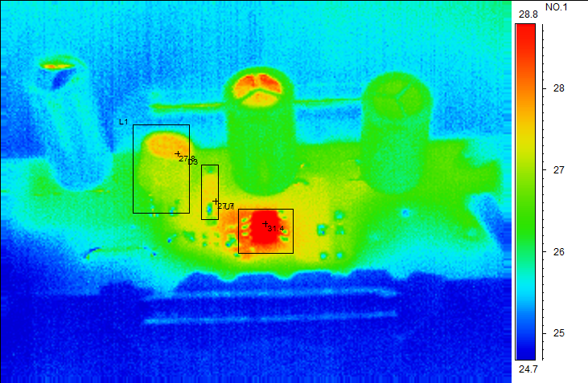

Parameters | Value
Ambient | 22.0°C
Area analysis | Value
U1Max | 31.4°C
D3Max | 27.7°C
L1 Max | 27.8°C

V_{in}=270V_{AC}/60Hz

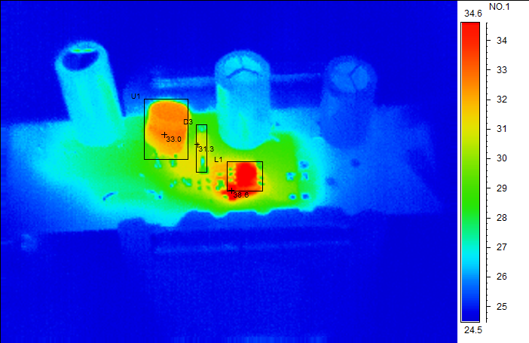

Parameters | Value
Ambient | 25.0°C
Area analysis | Value
U1Max | 33.0°C
L1 Max | 38.6°C
D3 Max | 31.3°C

Startup Waveforms
The output voltages at startup are shown in the images below.

Start Up @ 20.4V_{AC}: 12V/50mA.
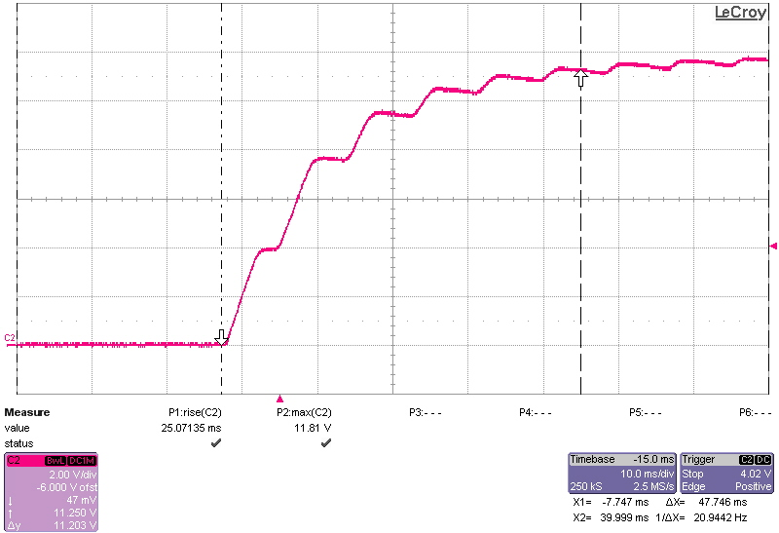

Start Up @ 20.4V_{AC}: no load.
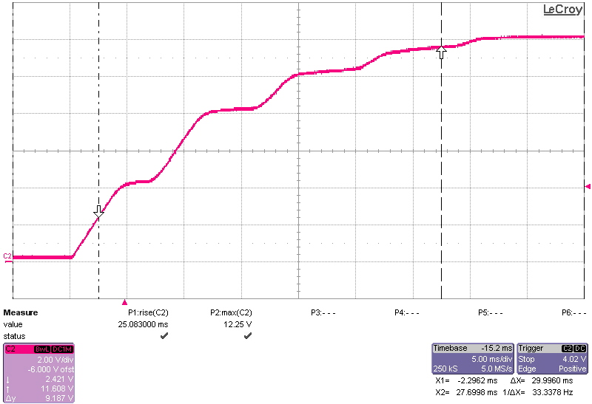

Start Up @ 150V_{AC}: 12V/50mA.
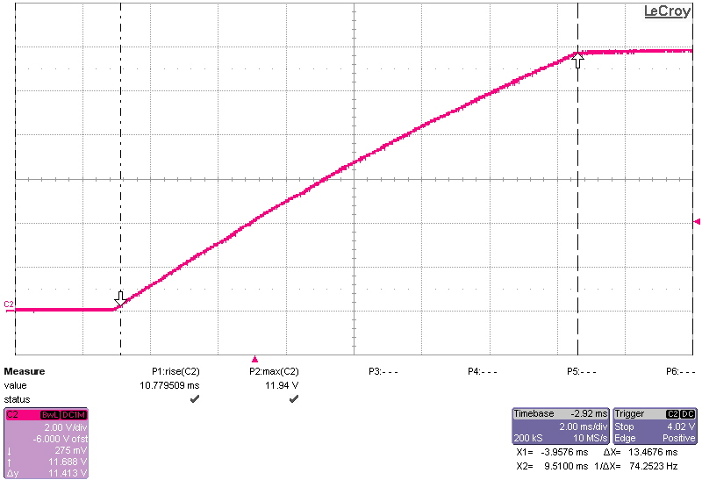

Start Up @ 150V_{AC}: no load.
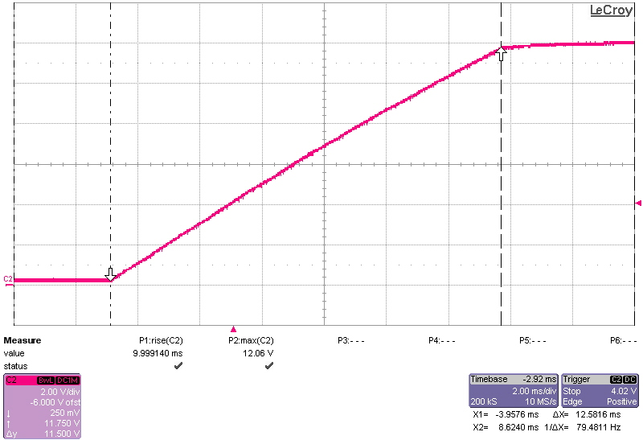

Start Up @ 270V_{AC}: 12V/50mA.
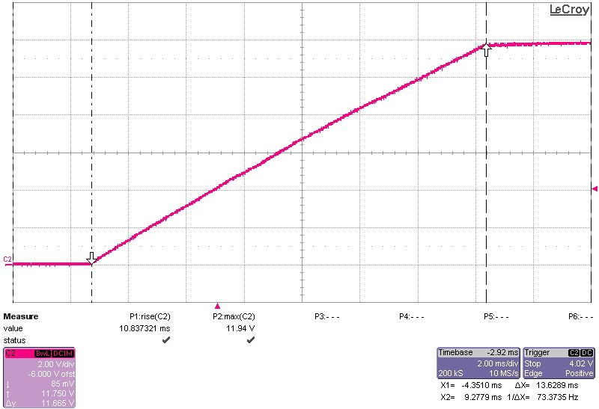

Start Up @ 270V_{AC}: no load.
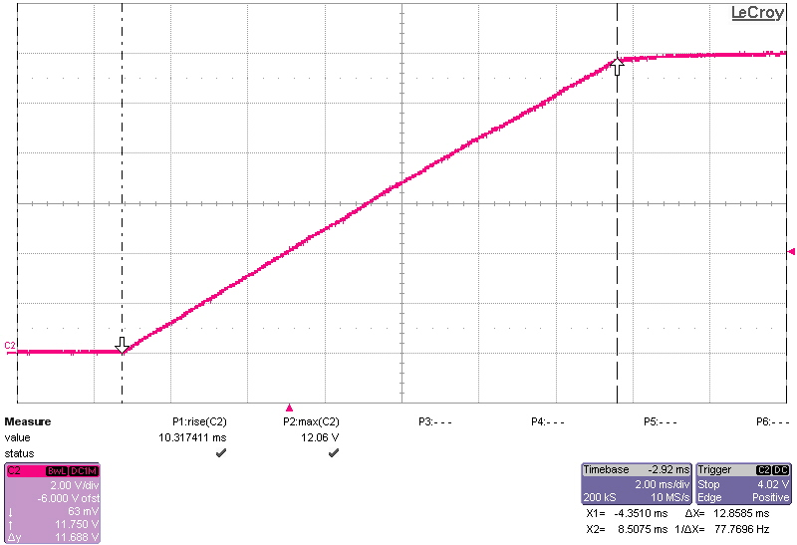

Turn off
The output voltage at turn off transient is shown in the image below at full load (12V/50mA).

Turn off @ 20.4V_{AC}: 12V/50mA.
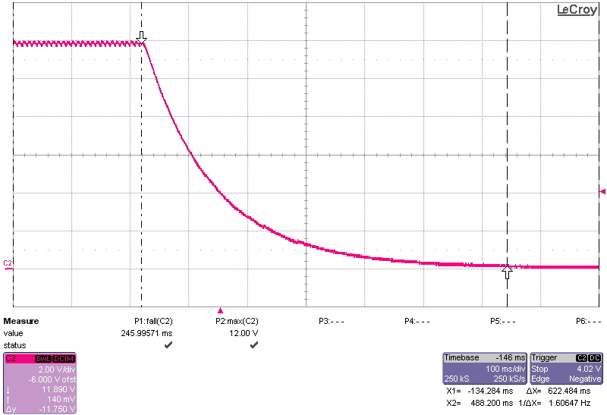

Turn off @ 150V_{AC}: 12V/50mA.
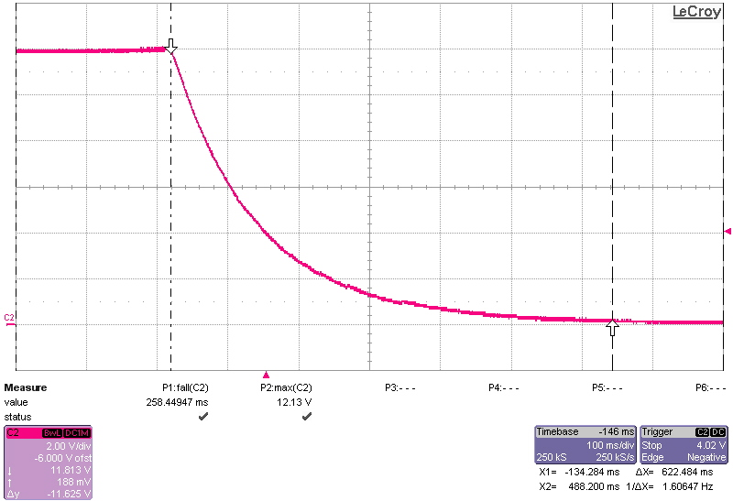

Turn off @ 270V_{AC}: 12V/50mA.
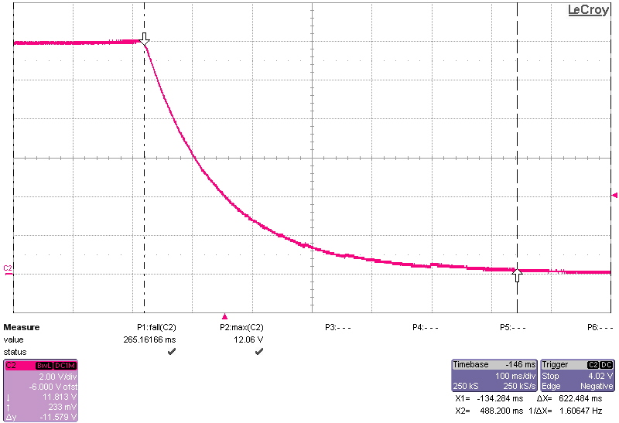

Output Ripple Voltages
The output ripple voltages are shown in the plots below. R5=4.7Ω in this test.

20.4V_{AC}: 12V/50mA:
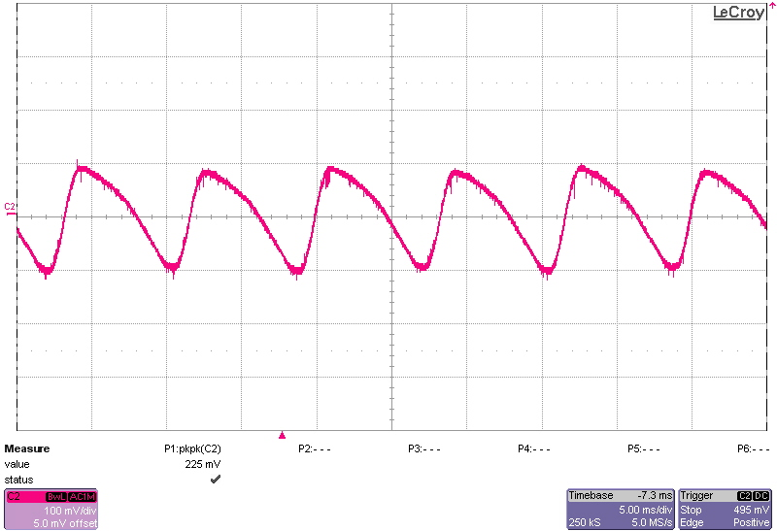

20.4V_{AC}: no load:
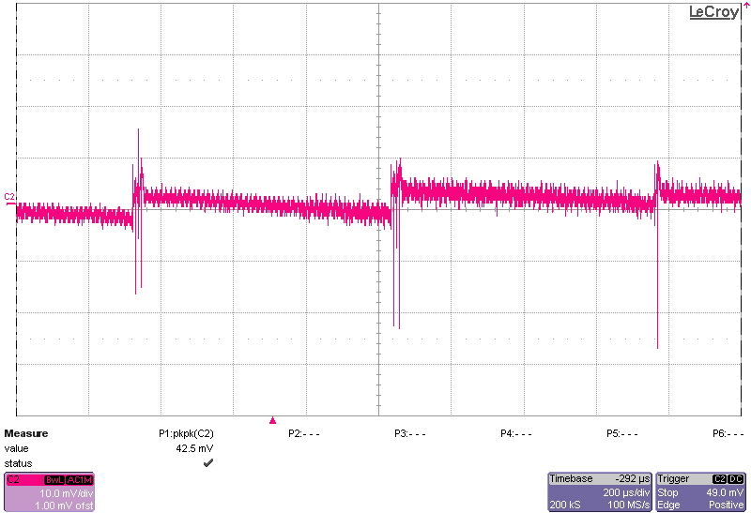

150V_{AC}: 12V/50mA:
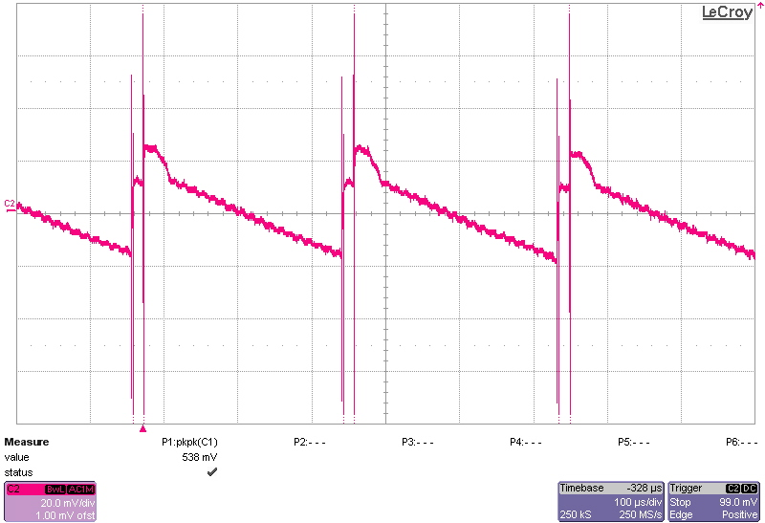

150V_{AC}: no load:
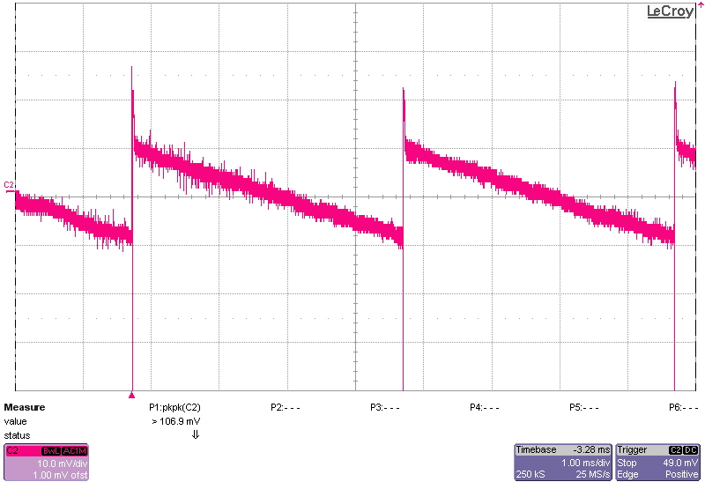

270V_{AC}: 12V/50mA:
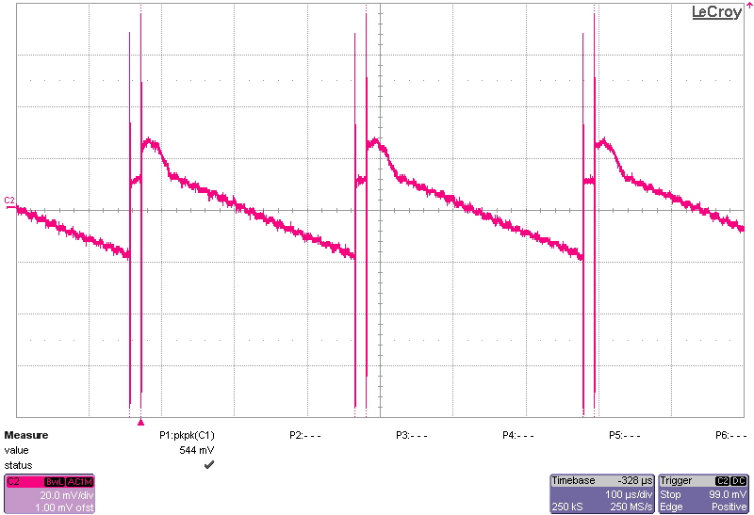

270V_{AC}: no load:
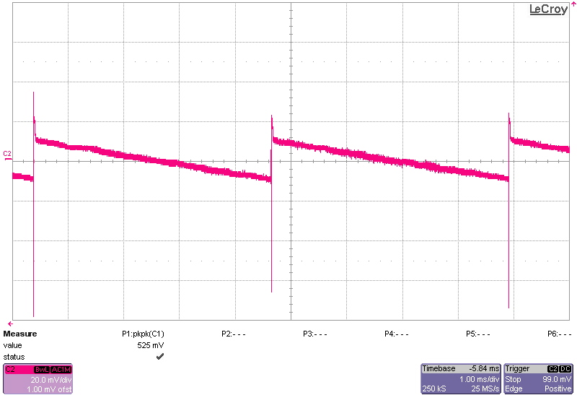

Switching Waveforms
The images below show key switching waveforms of PMP21007RevA. The waveforms are measured with 50mA full load.

Diode D3 @ 20.4V_{AC}/60Hz
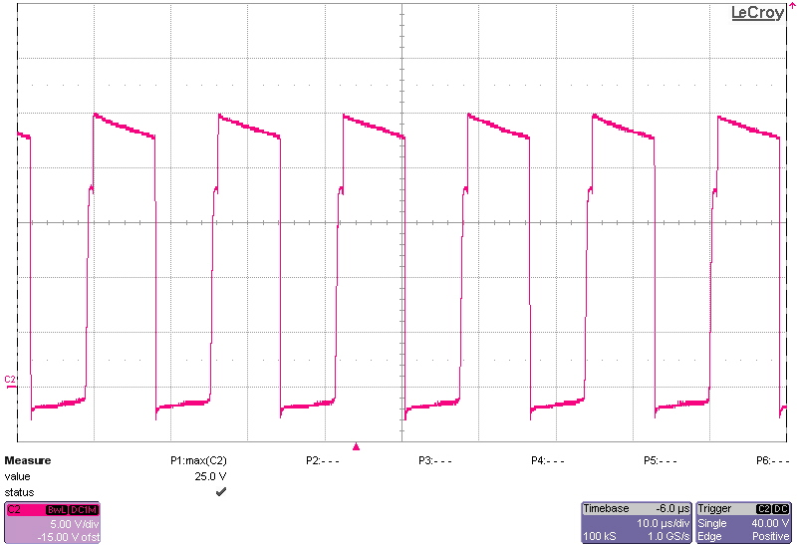

Diode D3 @ 270V_{AC}/60Hz
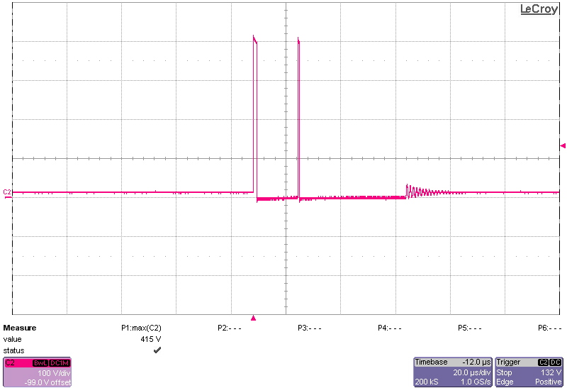

Key Waveforms:

L1 current @ 20.4AC (12V/50mA)
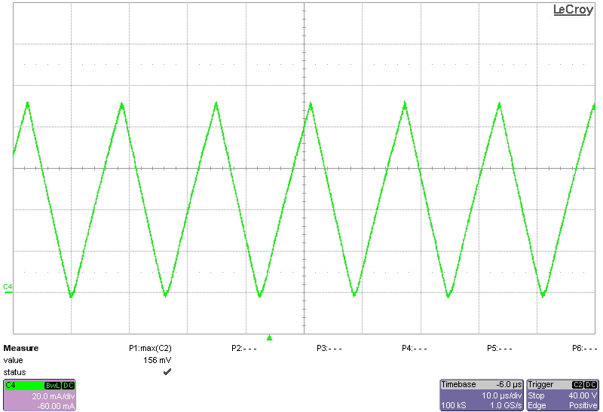

9.2 L1 current @270VAC (12V/50mA)
