Efficiency

The efficiency with a 50 V input is shown below:

VIN | Iin | Pin | Vout | Iout | Pout | Efficiency
50.00 | 0.0030 | 0.150 | 3.334 | 0.0 | NA | NA
49.99 | 0.0114 | 0.570 | 3.333 | 0.1 | 0.33 | 58.5
49.99 | 0.0274 | 1.370 | 3.332 | 0.3 | 1.00 | 73.0
49.97 | 0.0438 | 2.189 | 3.332 | 0.5 | 1.67 | 76.1
49.99 | 0.0604 | 3.019 | 3.332 | 0.7 | 2.33 | 77.2
49.97 | 0.0772 | 3.858 | 3.332 | 0.9 | 3.00 | 77.7
49.98 | 0.0939 | 4.693 | 3.331 | 1.1 | 3.66 | 78.1
49.97 | 0.1109 | 5.542 | 3.331 | 1.3 | 4.33 | 78.1
49.95 | 0.1286 | 6.424 | 3.331 | 1.5 | 5.00 | 77.8

Output Ripple and Noise

Output voltage ripple and noise with a 48 V input, 3.3 V/1 A output (20MHz bandwidth):

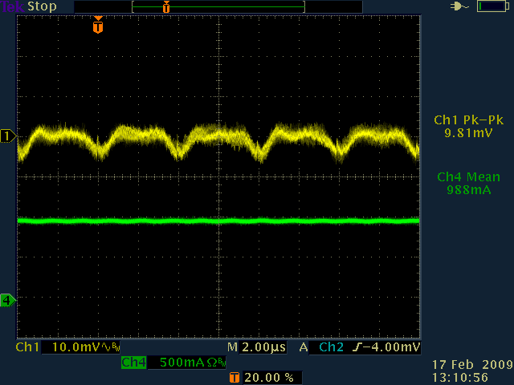

Turn On Response

The output voltage turn-on response with a 48 V input and a 3.3 V at 0 A and 1A load:

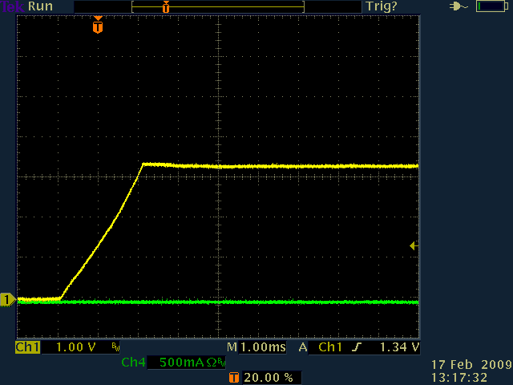

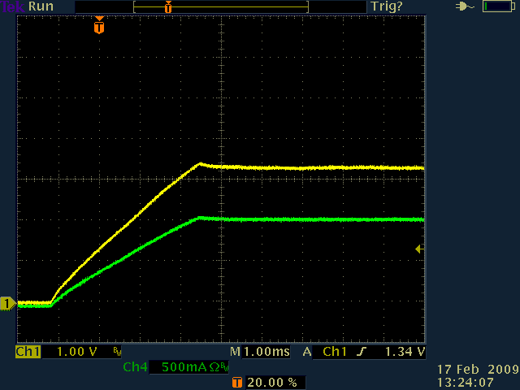

Dynamic Loading

The output voltage transient response was measured with 0.5A to 1A dynamic load at 48V input:

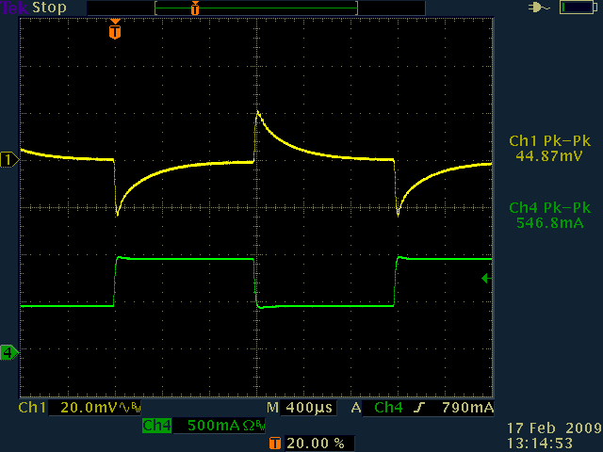

Bode Plot

The total loop Bode plot with 1A load at 48V input:

