TI part no. TPS2121RUX
Application: To switch between two power supply sources, one from DC power source (main power supply) and another from lithium battery pack(backup)
Issues observed: Mux output switching delay and drop in voltage
CASE 1: There are two inputs IN1=15V (Main) and IN2=12V (Backup). We are using the XCOMP Mode where the priority is given to IN1 by setting PR1 value greater than CP2 value. PR1=3.54V and CP2=3.04V. Output is IN1. When the voltage of IN1 drops to 12.87V the PR1=3.03V, now CP2>PR1 and hence the Output switches to IN2. This condition is true as per calculations.
When the two inputs are applied, IN1=15V and IN2 changes to 14.3V even though the source voltage is 12V before , the PR1 and CP2 values are changed to 3.51V and 3.60V respectively. When load is applied IN1=15V and IN2 changes to 13.8V even though the source voltage is 12V before, the PR1 and CP2 values are changed to 3.51V and 3.41V respectively. Irrespective of these changes output switches between IN1 and IN2 correctly.
The load at the output is DC-DC controller to convert the switched input (either IN1 or IN2) to 5V DC and further we have 5V to 3.8V LDO. We use these 5V and 3.8V required for the downstream components
We observed restart of 5V and 3.8V output when mux output Vout dips below 10V and switching time was observed to be 2s. Below screenshot shows the IN1, IN2 and Vout values along with Voltage dip and delay.
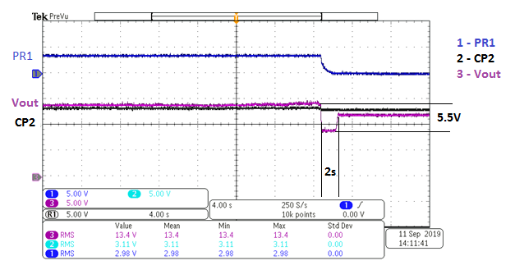
We also tried the VCOMP Mode by setting PR1 and CP2 to 0V and keeping IN1=15V and IN2=12V. The Output was IN1 and in absence of IN1 the output switches to IN2. However we still observe restart issue with same delay of 2s.
OV1= OV2=21.84V is set for both VCOMP and XCOMP Modes. Soft Start Control pin SS has been tried with 0.1uF, 1uF and 10uF for both the Modes and the delay still persists.
The below table summarize the behavior at different conditions
STEPS | IN1 | IN2 | OUT | DESCRIPTION | RESULTS
1 | 15V | - | 15V | IN1 PRESENT, IN2 ABSENT | PASS
2 | - | 12V | 12V | IN1 ABSENT, IN2 PRESENT | PASS
3 | 15V | 12V | 15V | IN1 PRESENT, IN2 PRESENT | PASS
4 | 15V | 12V | 12V | IN1 AND IN2 PRESENT, IN1 REMOVED | DELAYED
5 | 15V | 12V | 15V | IN1 AND IN2 PRESENT, IN2 REMOVED | PASS
6 | - | 12V | 15V | IN1 ABSENT, IN2 PRESENT, IN1 APPLIED | DELAYED
7 | 15V | - | 15V | IN1 PRESENT, IN2 ABSENT, IN2 APPLIED | PASS

As per observations, when mains (IN1) is either removed or applied in presence of backup (IN2) there is restart of DC-DC controller or LDO observed.

The test was also conducted with No Load condition (i.e switch for the load is turned OFF). It was observed that there was no dip in voltage or delay as mentioned above. Below is the waveform captured in this case.
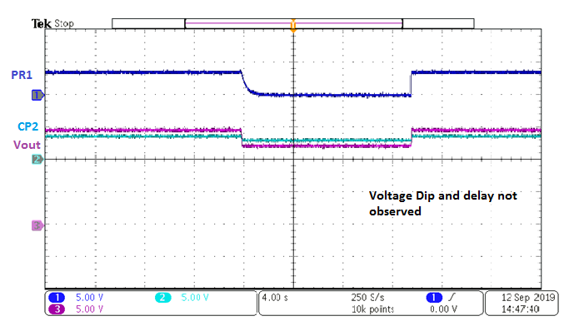
Below figure shows the schematics of power mux used as per our application. Note that the input and output capacitors are missing here, but have been included in the experiment. Input capacitor used is 10uF each and Output Capacitor is 320uF. Also status pin ST is grounded as it is unused.
What can be done to reduce the switching delay to avoid the restart? Does output voltage dip has any influence on the restart?
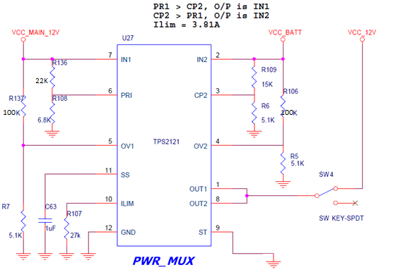

CASE 2: There are two inputs IN1=15V (Main) and IN2=12V (Backup). We are using the XCOMP Mode where the Priority is given to IN1 by setting PR1 value greater than CP2 value. PR1=3.54V and CP2=3.04V. Output is IN1. When the voltage of IN1 drops to 12.87V the PR1=3.03V, now CP2>PR1 and hence the Output switches to IN2. This condition is true when there is no load applied.
When load is applied, the first one or two instances output switching between IN1 and IN2 works correctly and later there is no output observed. Even if the load is disconnected, no output is observed hereafter.
Input current is set to 3.8A and the Switch used for isolating the load has a current rating of 4A. Refer to the same set-up as above figure. We would like to know what factors are affecting the failure?

