RSC-IMX61 TPS51220A

+V12S Phase pin Waveform.

1. Boot Phase pin waveform for Rise time and over voltage.

Rise time = 2.975nS ( 10%~90%)

Over voltage = 26.42V

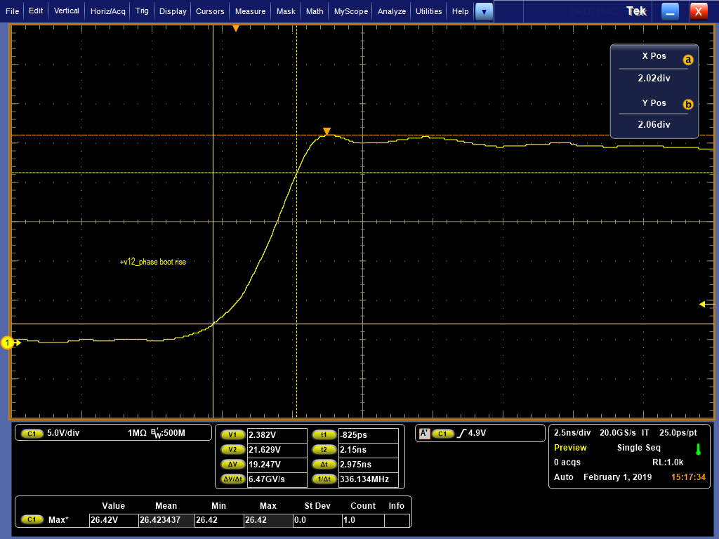

1. Phase Pin Fall time and Under voltage waveform.

Fall time = 8.425nS

Under voltage = -2.248V.

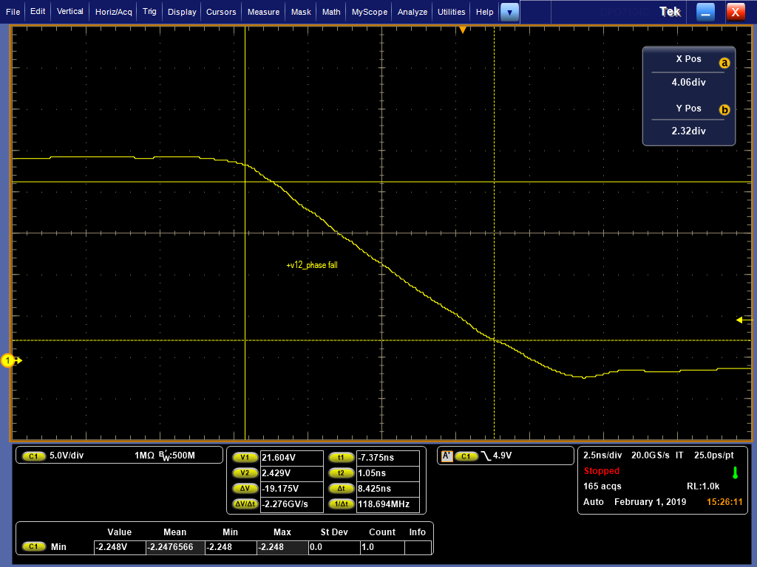

1. Over / Under voltage test.

Over voltage = 27.829V

Under voltage = -2.96V.

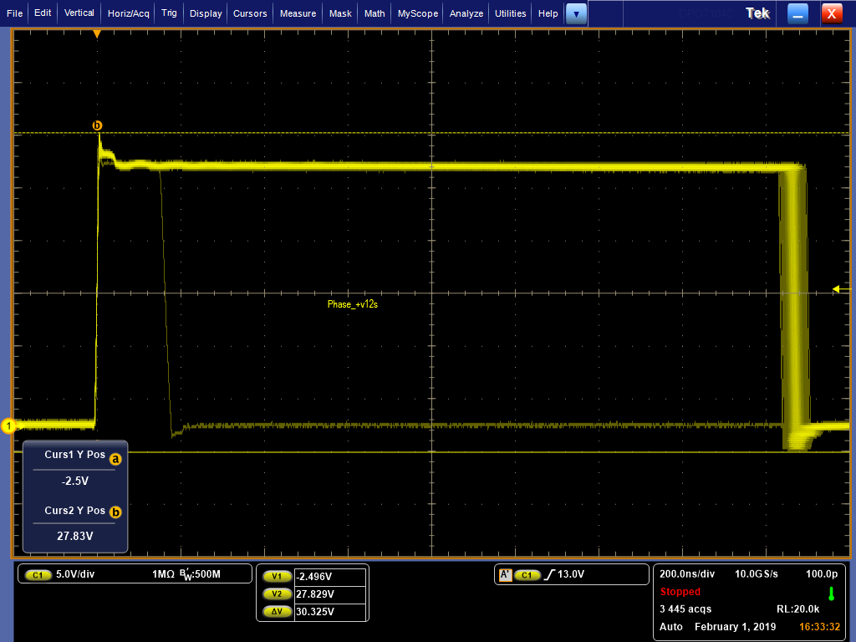

1. Phase pin Frequency.

Frequency =299.401KHz.

Over voltage = 28.129V

Under voltage = -2.496V

