Plots are obtained as under: (GB=Good board, BB=Bad Board) (Ch1-Yellow=GDRV, Ch2-Blue=Isense, Ch3-Pink=Vout)

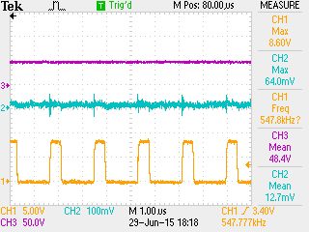 (GB, 48Vapprx @ digipot=255)

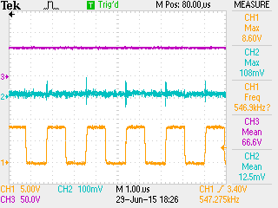(GB, 66Vapprx @ digipot=100)

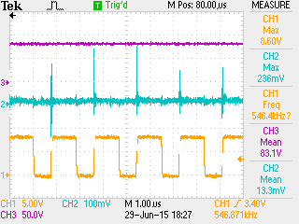 (GB, 83V apprx @ digipot=50)

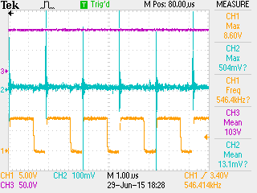(GB, 103V apprx, @ digipot=20)

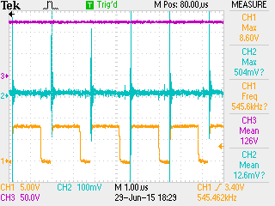 (GB, 126V apprx @ digipot=0)

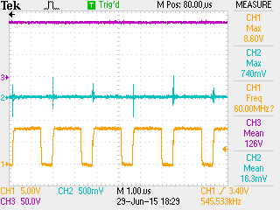 (GB, 126Vapprx, digipot=0, Isense scaled to 500mV)

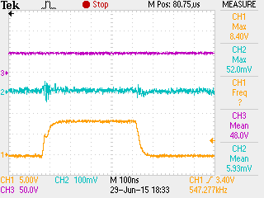 (GB, 48Vapprx, digipot=255, time scale to 100ns)

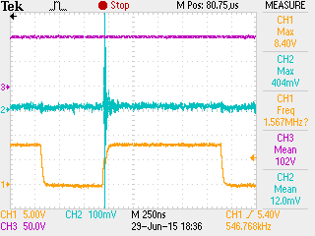 (GB, 102Vapprx, digipot=20, time scale to 250ns)

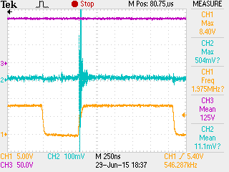 (GB, 125Vapprx, digipot=0, time scale to 250ns)

Sr No 1505122 tried as Bad board (as 180pF caps finished to be used on 1505071)

Plots were obtained as below:

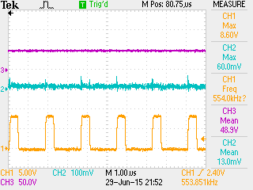 (BB, 48V apprx, digipot=255)

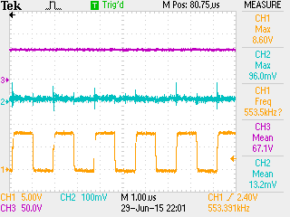 (BB, 67Vapprx, digipot=100)

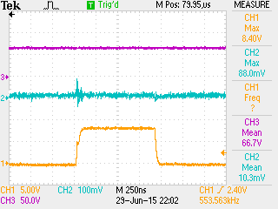 (BB, 67Vapprx, digipot=100, timescale=250ns)

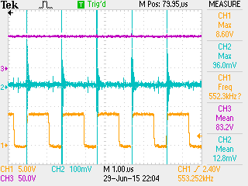 (BB, 83Vapprx, digipot=50)

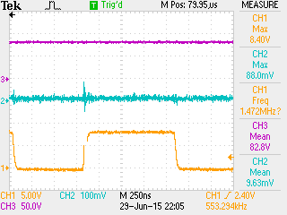(BB, 83Vapprx, digipot=50, timescale=250ns)

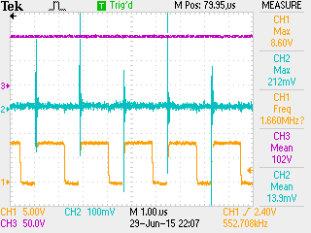 (BB, 102Vapprx, digipot=20)

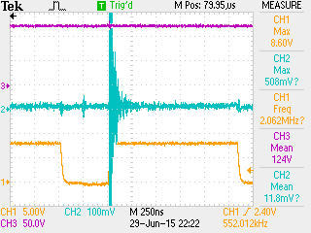 **(See videos for collapsing of output voltage. It Went upto 125V during one instance, see waveform at digipot=0)**

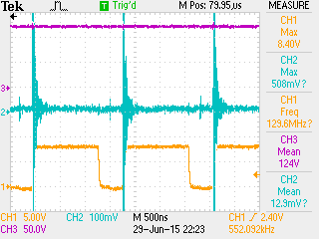 (same conditions as above but with time scale changed to 500ns)