Power net Connection 1 :
Please see follow green and blue arrow of PoE power current loop on the same diode bridge (D12 of HD01).
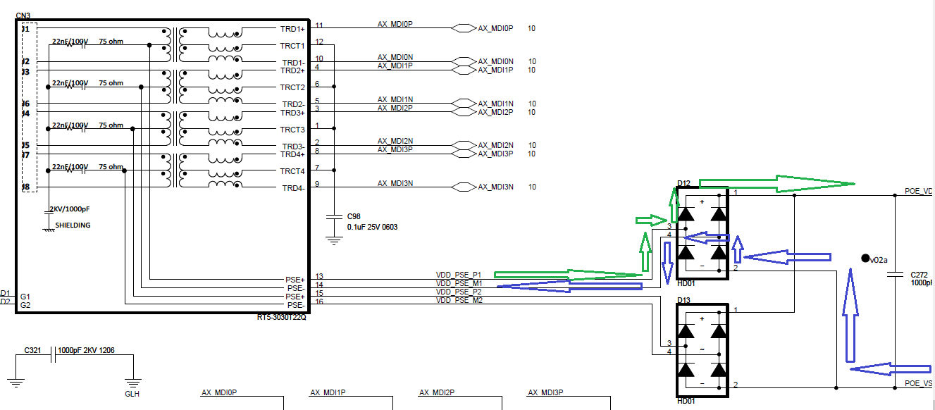

Power net Connection 2 :
Please see follow green and blue arrow of PoE power current loop on different diode bridge (D12 and D13 of HD01)

