1. Problem Description of TPS56637 Application
Problem: Power supply chip in the application process of dc-dc chip damage short-circuit phenomenon.
The design application is 24V to 12V DC, the main application is to compare and test whether the two inductors can work properly under full load current (6A) and to test the consistency of the two inductors. PCB is a 4-layer board, our application is drawn 2-layer board, the other parameters are the same. (The schematic and PCB, and the inductor manual are in the zip file)
Figure 1 below shows the test environment, and Figure 2 and Figure 3 show the schematic. However, during the test, when the electronic load output is 6A, the input voltage and output voltage dip phenomenon occurs. After inspection, we found that the input voltage and output voltage were shorted (input shorted, output shorted), and we removed the TPS56637 chip and found that the positive and negative terminals were shorted.
Remove the damaged chip and replace it with a new one, the PCB will whistle when the electronic load only adds 1A current, but it is normal when the electronic load only adds 0.5A current.
Figure 1 Test experimente
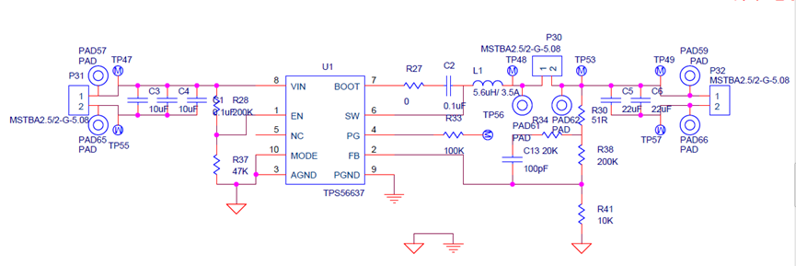
Figure 2 Circuit Schematic 1

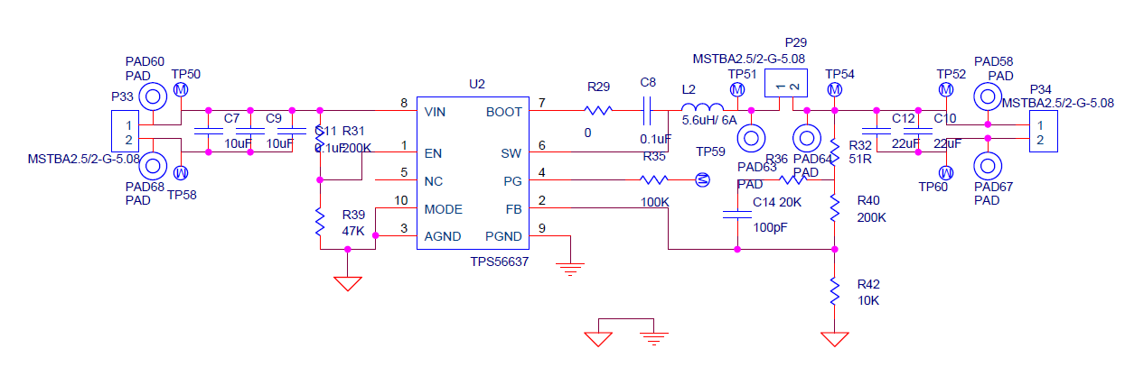
Figure 3 Circuit Schematic 2

