Procedure followed and report attached of learning cycle.

Gauge: BQ34Z100-G1

ChemID: 6112

Cells: NiMH, 10S configuration, BK220SCHU.

Document followed: SLUA903 (July 2018) – Achieving the successful learning cycle.

Document attached in the community: SLUA777 (June 2016) – refer to BQ28Z610/BQ78Z100, so its not same as the BQ34Z100-G1, changes specs, changes registers and bits.

The short procedure for learning cycle,

1. Discharge battery to empty
2. Relax for at least 5hours
3. Charge battery to full
4. Relax for at least 2hours
5. Discharge battery to empty
6. Relax for at least 5 hours
7. Generate the golden image

Reference: Learning Cycle Graph

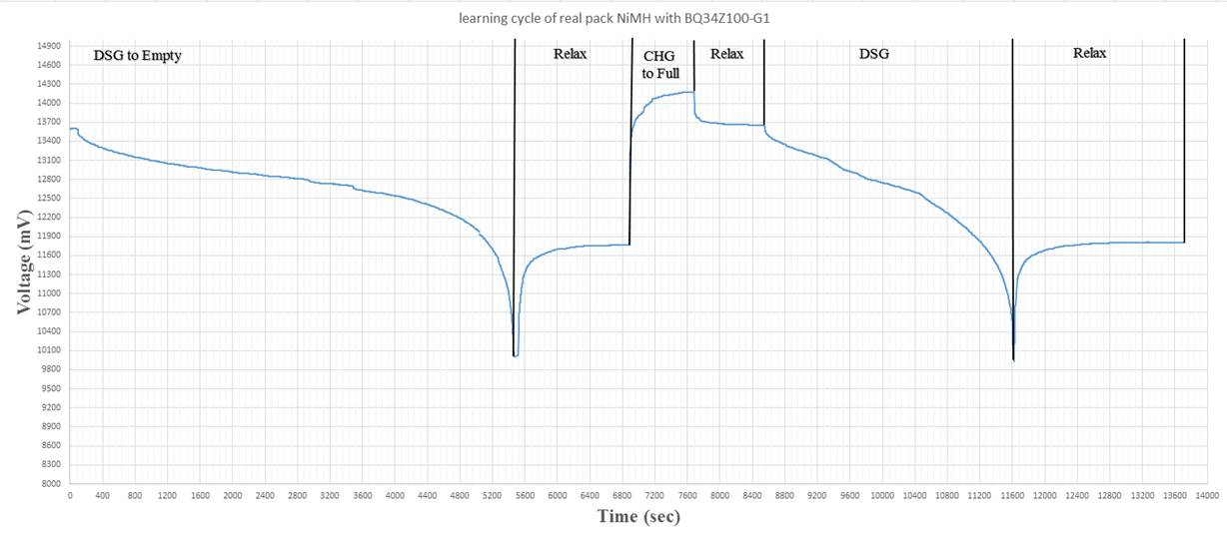

Clarification RDIS is RUP_DIS in case of BQ34Z100-G1

1. **Discharge battery to empty** – verification of Update status in gas gauging section of Data memory as 04

End of the discharge cycle : learned status is 04, Update status 04

Condition: C/5

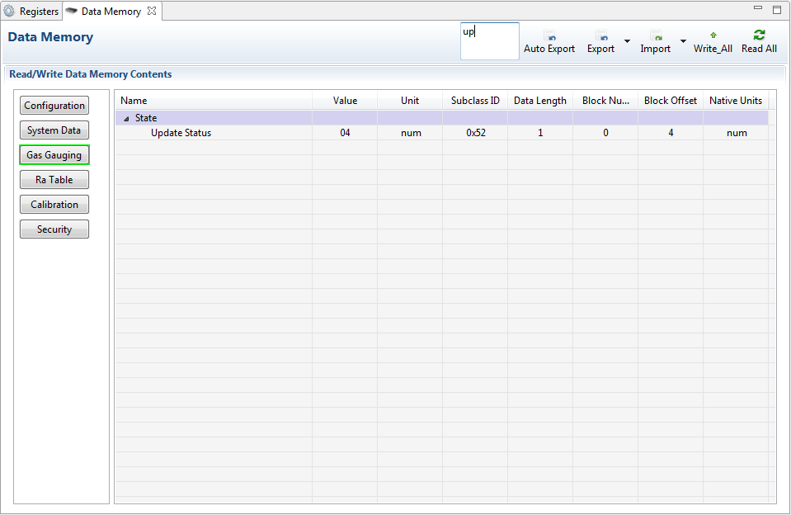

RUP_DIS: Bit HIGH

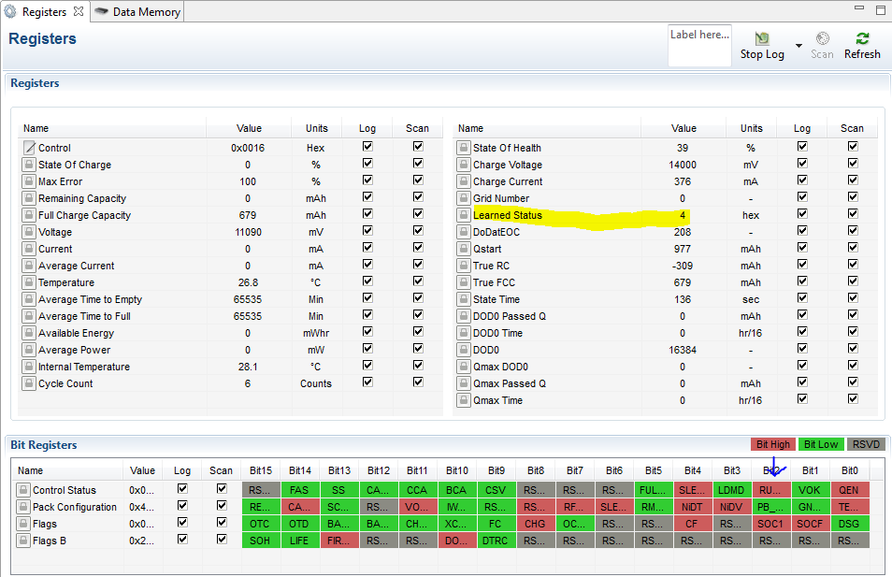

Battery discharged until the termination voltage reaches the Term Voltage (10000 mV)

1. **Relax for at least 5hours** -relaxation time allowed for a valid OCV reading to be taken and stored for the Qmax update.

Condition:  The [VOK] and [RDIS] bits in the IT status() register clear once the gauge has taken an OCV reading and qualified it for a Qmax update.

VOK and RDIS bit is cleared.

Refer to screenshot in point 3.

1. **Charge battery to full**

Condition: C/2

At the start of charge, the [VOK] bit in the IT status () register should set automatically.

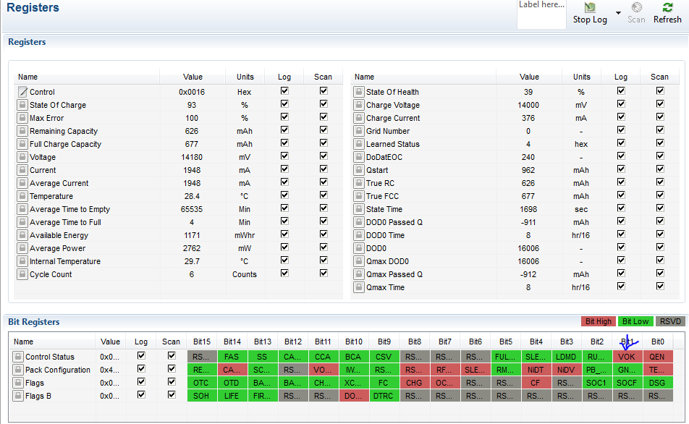

At the end of charge the [FC] bit in the Battery Status () register should be set.

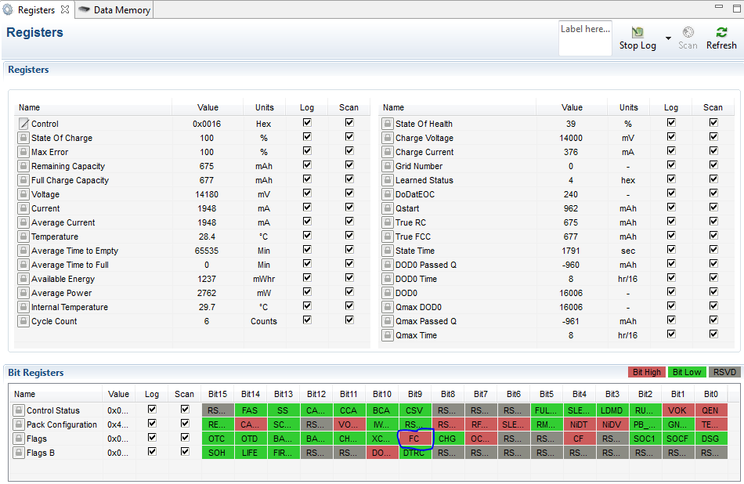

1. **Relax for at least 2hours** - relaxation time allows for a valid OCV reading to be taken and stored for the Qmax update

[VOK] bit in the IT status() register clears

GaugingStatus[REST] flag is set when a valid OCV reading occurs

[VOK] and [RDIS] bits are clear.

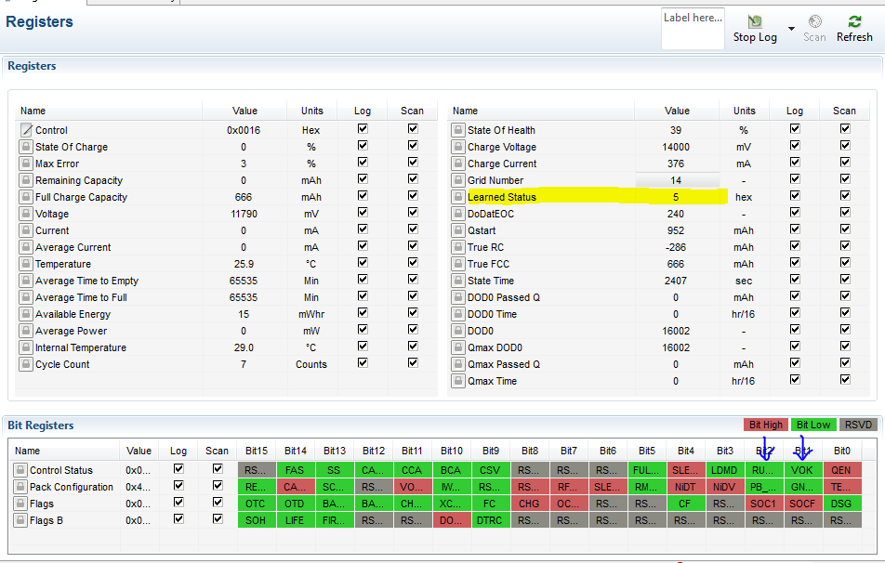

At this point, the first Qmax update should have occurred. The [QMax] flag is toggled when the QMax update occurs. Update Status would now be 0x05

1. **Discharge battery to empty**

Condition: C/5

Notice the Grid number in screenshot

The data memory file(dm_1.gg) and auto exported data memory file (File001.gg) is attached.

During discharge

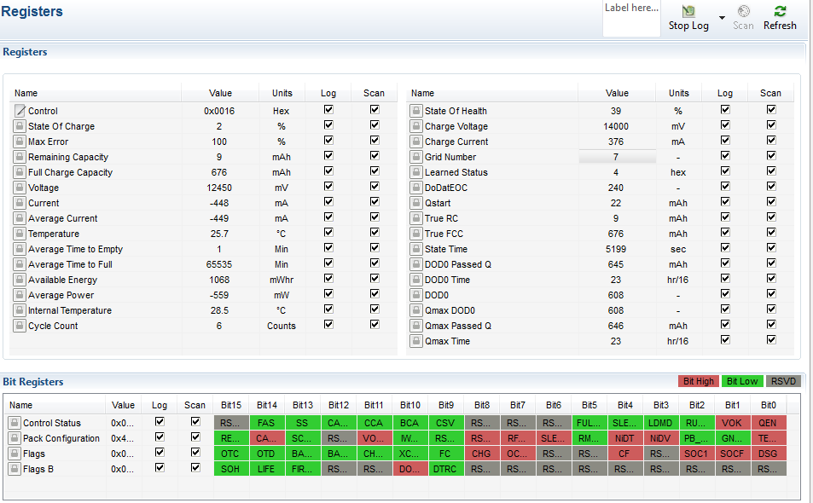

End of Discharge

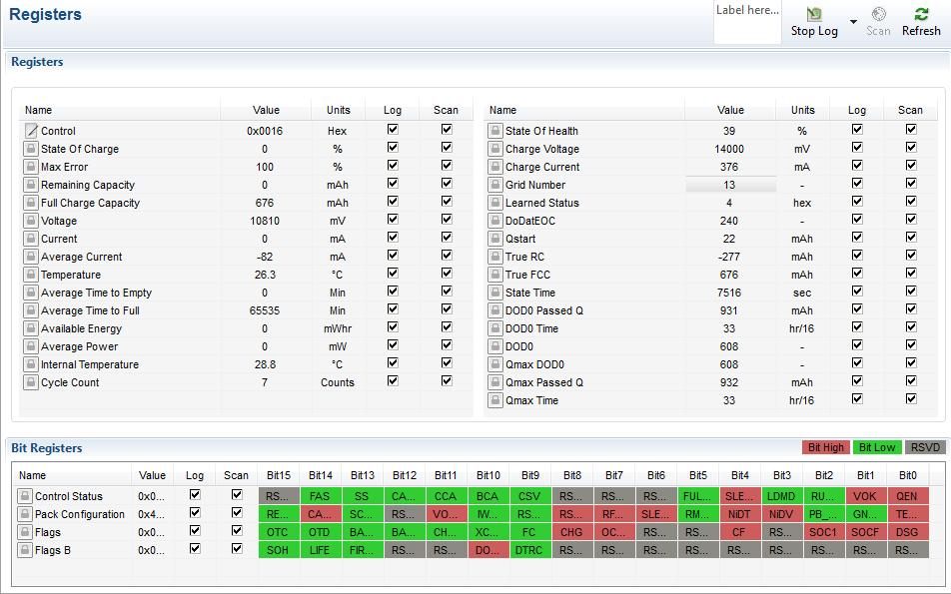

OCVTAKEN flag low

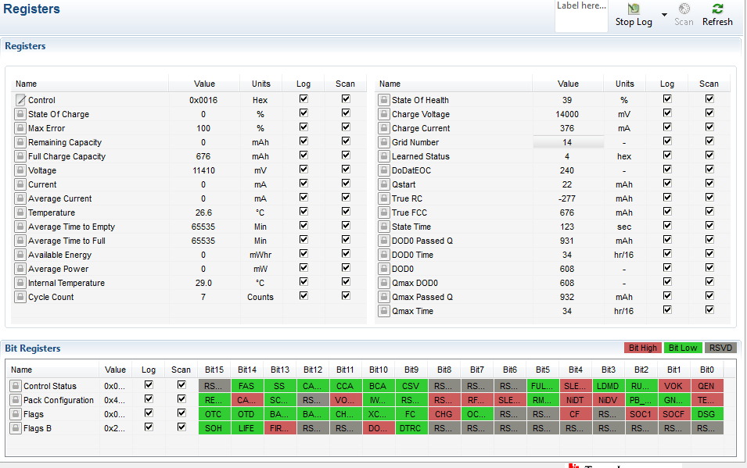

Qmax Passed and cycle count

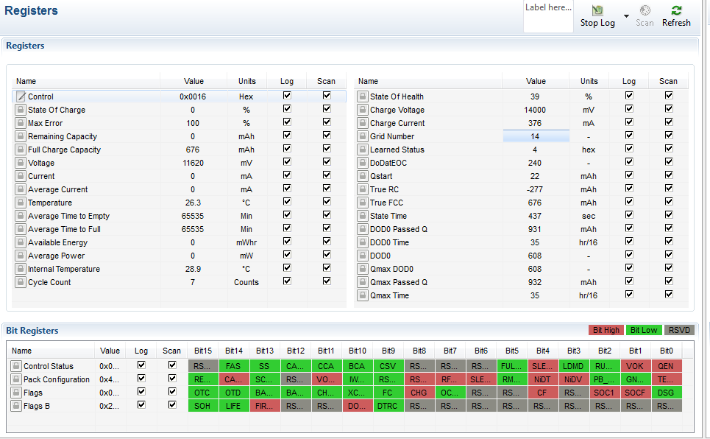

Resistance tables

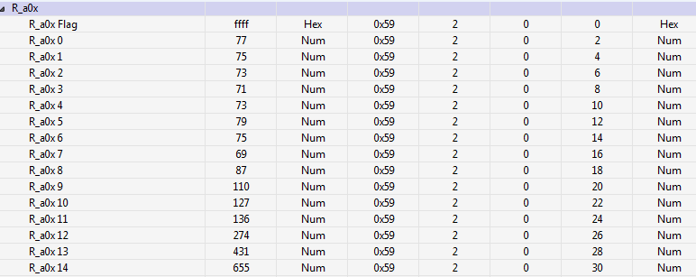

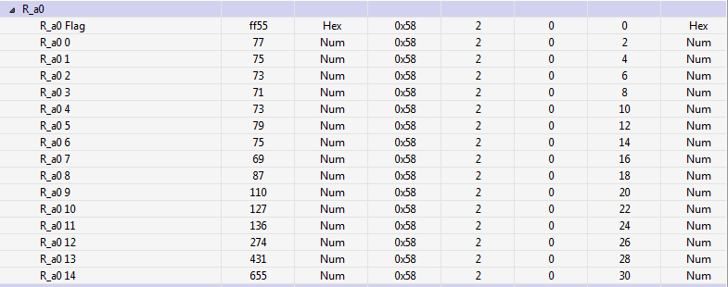

1. **Relax for 5 Hours**

[VOK] bit conditions is considered.

Update status didn’t change to 0x06 or 0x0E remains at 0x05

