JCD
Answer 1 to Texas.
***********************
Dear Jonathan Navor,
Thanks for your answer.
Sorry my problem is not resolved.
******************************
Hardware Configuration :
I use actualy :
- My PC
- USB2ANY HPA665 of Texas Instrument
- Demoboard USB-PD-CHG-EVM-01 (TPS25750 & BQ25792)
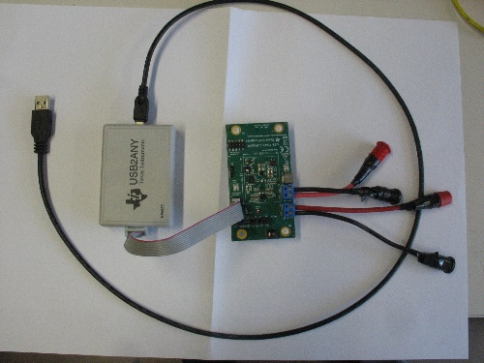
Solfware Configuration :
- USB2ANY explorer 2.8.2.0 setup.exe
- GCruntime-10.0.0 windows-installer2 .exe ( TPS25750_application_customisation_toll 7.0.2)
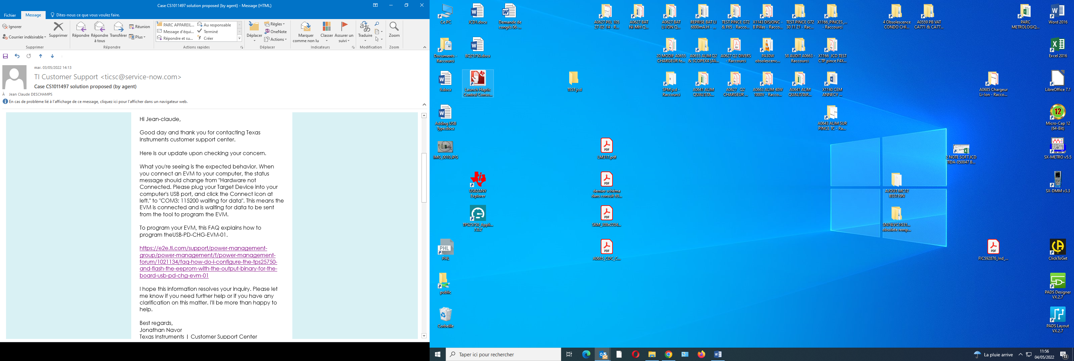

Diagnostic :
The interface USB2ANY HPA665 Work.
Detail :
I connect only USB2ANY to my personal computer.
I launch
.
I click to open device knob.
After I clik successively on 3.3V knob
I mesure the voltage between pin 4 (GND) end pin5(3.3V) of J4 :3.3V if ‘’on’’ and 0V if ‘’off’’.
It ok.
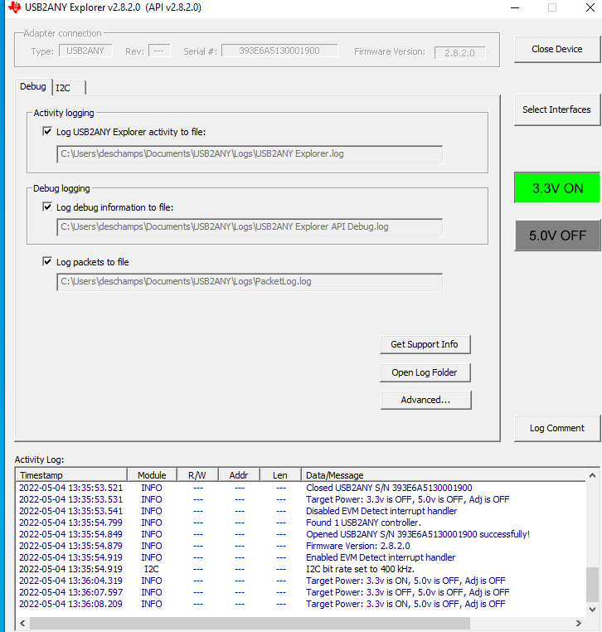
It is oK. The 3.3 V is connected to J4 (central connector)
5V is not on J4…
Conclusion : The module USB2ANY is operational. OK Satisfaying We let 3.3V in the state ‘’on’’ on USB2ANY . Normaly i twill power the TPS25750and the fash memory

I connect the ‘’USB-PD-CHG-EVM-01’’ at J3 (USB2 ANY connector)
3.3V is always present.
OK.
I launch the TPS25750 Application customistion tool
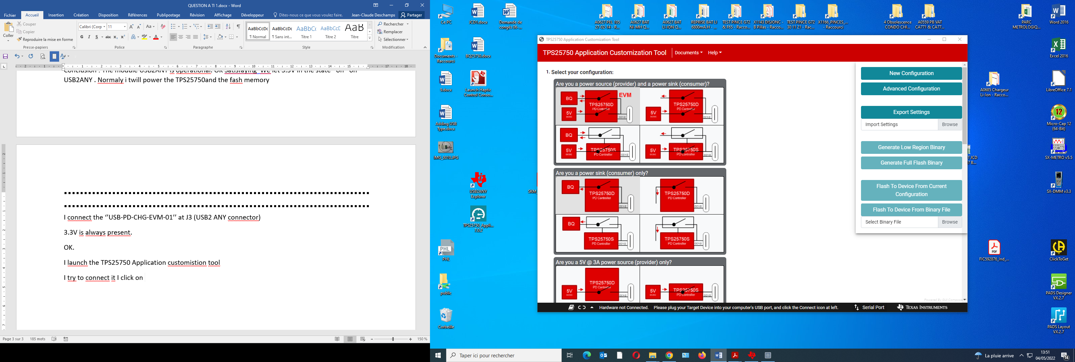

I try to connect it I click on

It is impossible to connect it !
I open serial port
The error message apear :
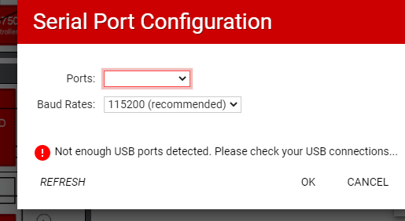

In fact impossible to communicate with USB2ANY.
No COM X port !!!

What can I do ?
TPS25750 APPLICATION SOFT is perhaps not compatible with the demo board ?
Can you tell me please.
Best regards
JC Deschamps

