After enable the system watchdog, and add the WDT event to PMON_PORST_N, then the WDT time out will triger PMON_PORST_N as what we expected. See the configuration below. The signal PMON_PORST_N is a power on reset for the whole system, **the system could not bootup with max reset period 32,256ms that UCD90106A allows**. So the system software is keeping under reset. Software like have 300s before issue SYSTEM_WATCHDOG_RESET command.

What’s the possible solution? I’ve tried some experiments to use system reset, but it doesn’t work.

**This is the first experiments: Enable Watchdog Timeout and add timeout event to PMON_PORST_N( the board system power on reset)**

1. Enable the system watchdog

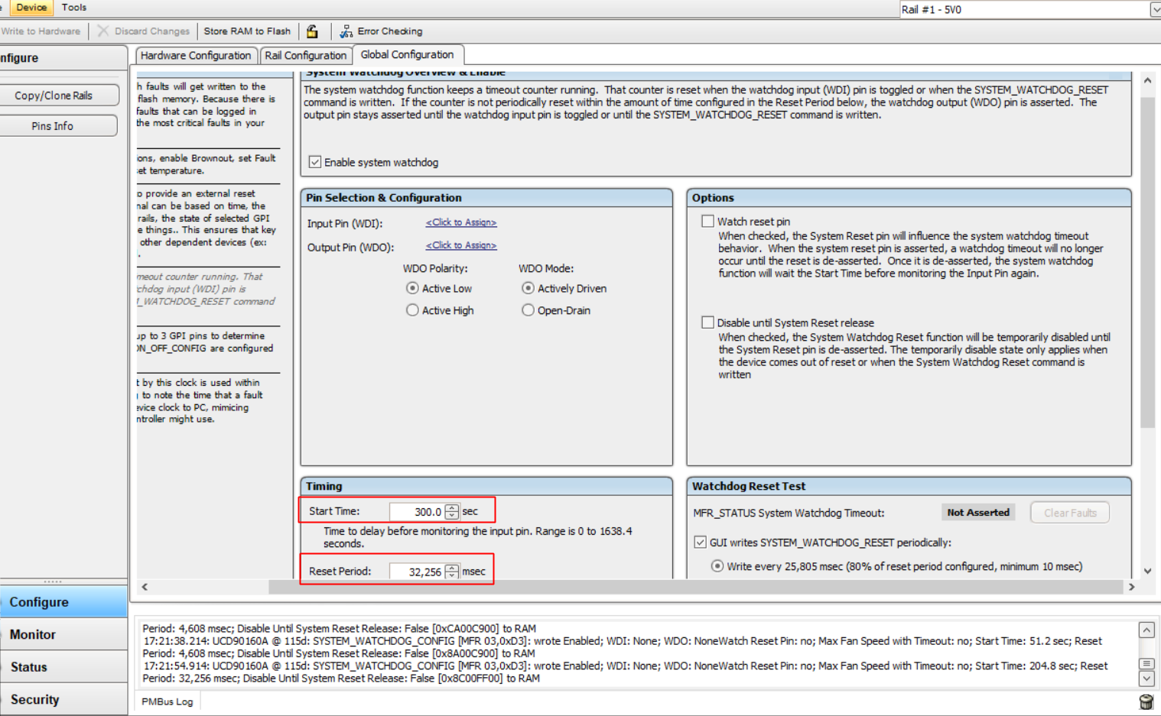

2. Add WDT time out event to PMON_PORST_N

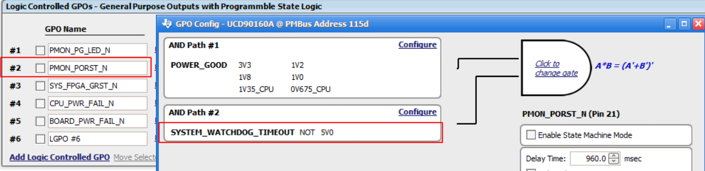

IT works for the first time bootup because there 300s Start Time, but when timeout happens, software system can’t bootup within **32,256ms, then system will keep reboot.**

**Second expriment is to try using system reset to have 300s “Start Time” for timeout reset, but it failed.**

1. Enable systen reset, assert the reset when watchdog time out

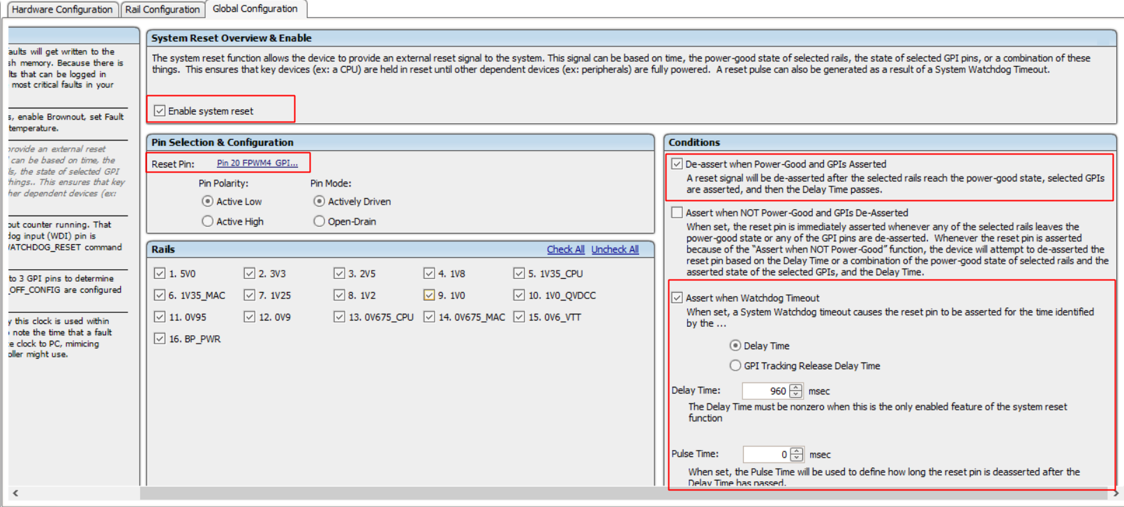

2. Then check “Watch reset pin”, per the description, when system reset is de-asserted, sytem watchdog function will wait the **Start Time** before monitor the input pin again. I expect it will have give system software 300s bootup time again. But PMON_PORST_N will keep low until SYSTEM_WATCHDOG_RESET command from “TI Fusion Digital Power Designer”.

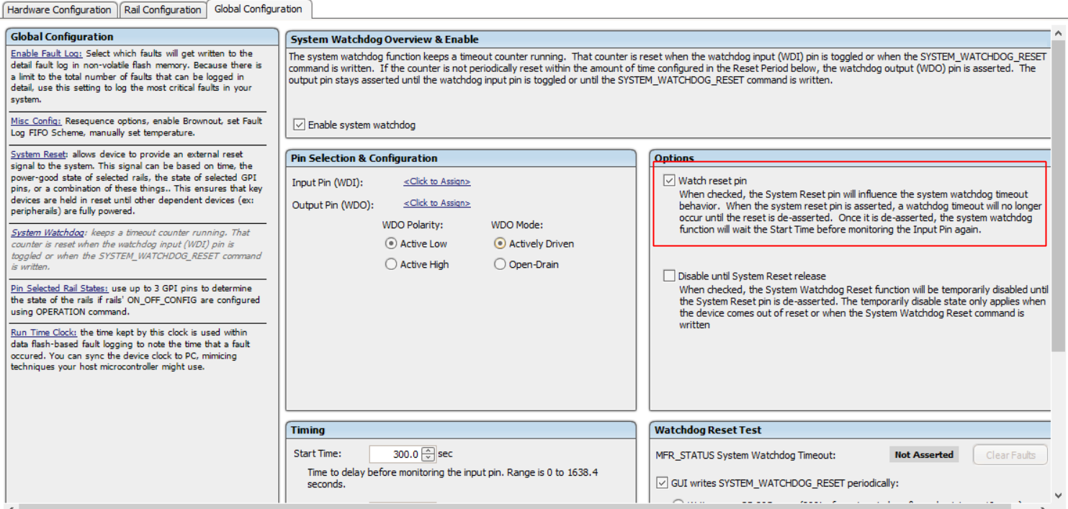

I’ve captured the System Reset Pin, Pin 20, it asserted 960ms then de-assert as configuration, but PMON_PORST_N be kept low. PMON_PORST_N is only de-asserted after apply SYSTEM_WATCHDOG_RESET command from “TI Fusion Digital Power Designer”