We are experiencing unexpected output voltage jumps on the LMZ14203TZ. The output voltage randomly jumps upwards from its expected 5.08Vdc to a level of 5.23Vdc. That’s a jump of 0.15 Vdc. This is followed by a distinct drop back to the expected voltage of 5.08V. At the same time the FB pin is seen to jump from 0.796V to 0.816V and back again. That’s a FB jump of about .020Vdc. In the photo below the upper waveform (yellow) is the output (Pin 7) (50mV/div; offset by 5V) showing the 0.15V steps. The lower waveform (blue) shows the FB pin 6 voltage (20mV/div; offset by 0.8V) showing the 0.02V steps. Note how quickly the voltage rises and falls. Also note the time-base of 1.00 sec/div which is about 13 seconds across the entire image. (Details continued below)

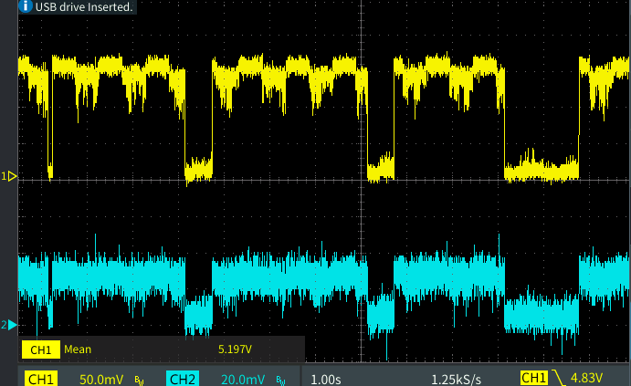

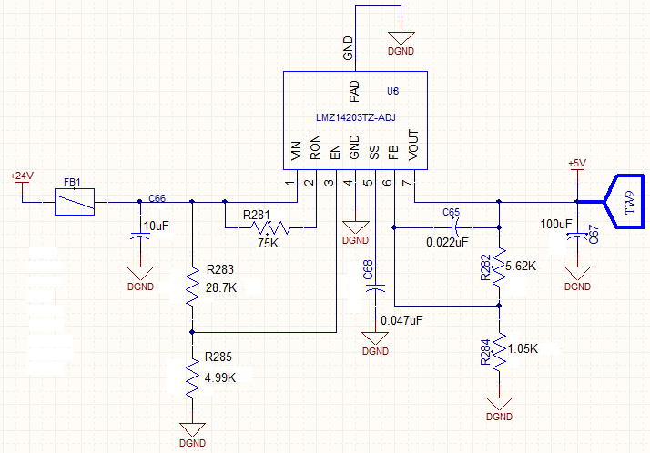

The current entering VIN (Pin 1) was measured at 125 milliamps. I couldn’t easily measure the output current but it should be approximately 125mA \* 24V/5V = 600 milliamp.

Here’s where it gets interesting: By adding a resistor of 1K ohm from +5V (Pin 7) to DGND (Pin 4) the 5V output stabilizes completely! Why would 1K ohm additional load make everything work?

Here’s a photo of the 5V output and FB voltage when a 1K resistor is added at mid-trace. It goes from jumpy to stable:

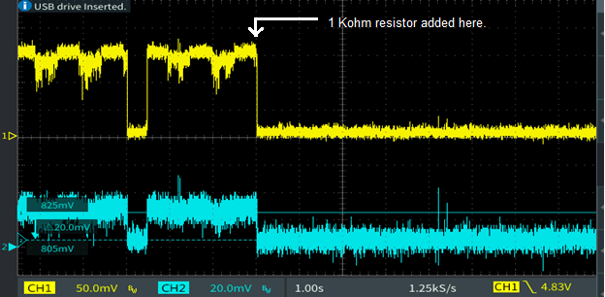

Summary:

Vin = 24Vdc

Vout = 5.08Vdc = 0.8 \* (1 + 5.62K/1.05K) = 5.08Vdc

C66 (i.e. Cin) = Cap, SMT, Cer, 10 MFD, 50V,X7R.

C67 (i.e. Cout) = Cap, SMT, cer, 100 Mfd, 6.3V

Ron (Pin 2) = 75K which will give Ton = (1.3\*10^-10 \*75K)/24 = 406nS which is greater than the recommended 125nSec minimum on time.

Finally – What’s causing the jumpy output and why does adding even a 1K across the output clean everything up? We are seeing this issue on some, but not all, units. The board layout is shown below.

