SM72445 EVM and USB2ANY User Guide

Step1. Hardware setup
Instruments list:
- USB2ANY Interface Adapter (Use J4 10 pin cable connector)
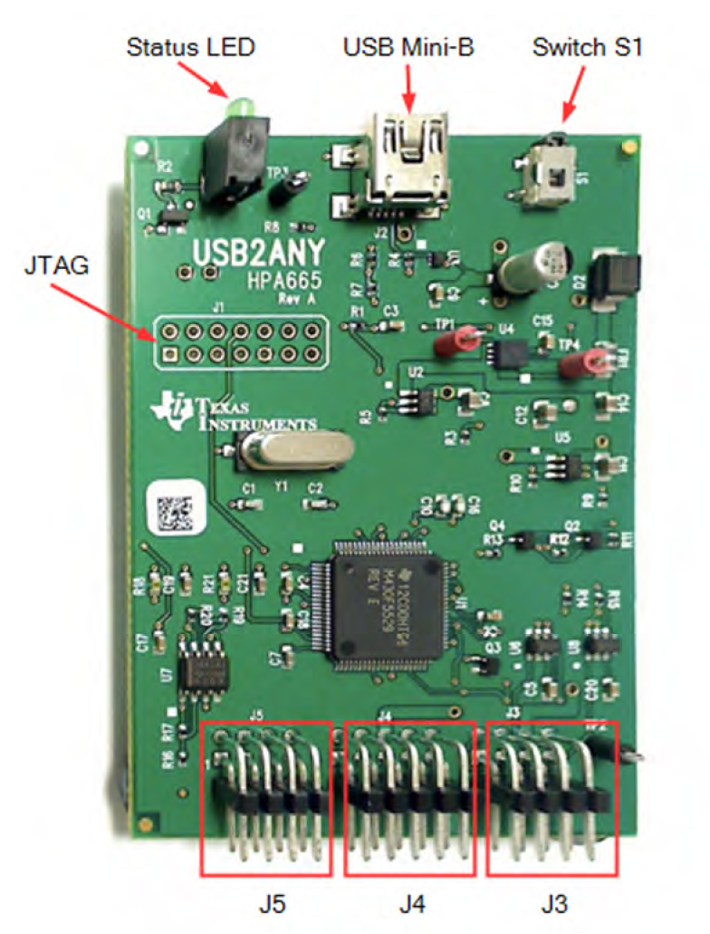
- Power Supply – Agilent E3634A
20V for SM72445 EVM PV(+) to PV(-) is OK.
- Connect wire.
- PC with USB2ANY Explorer.exe
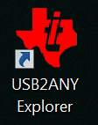
EXE Download link:
http://www.ti.com/tool/USB2ANY?keyMatch=usb2any&tisearch=Search-EN-Everything

Step2. Software setup
- Install USB2ANY Explorer.exe
- Open exe → click ‘I2C’ → click ‘select interfaces’ → choose ‘I2C’.
Attention: If your PC screen resolution is very high(e.g: 2560*1440), you will not able to see ‘I2C’ sheet. So you should decrease resolution first.
Then you will see the following picture. Setting bit rate =100Khz.
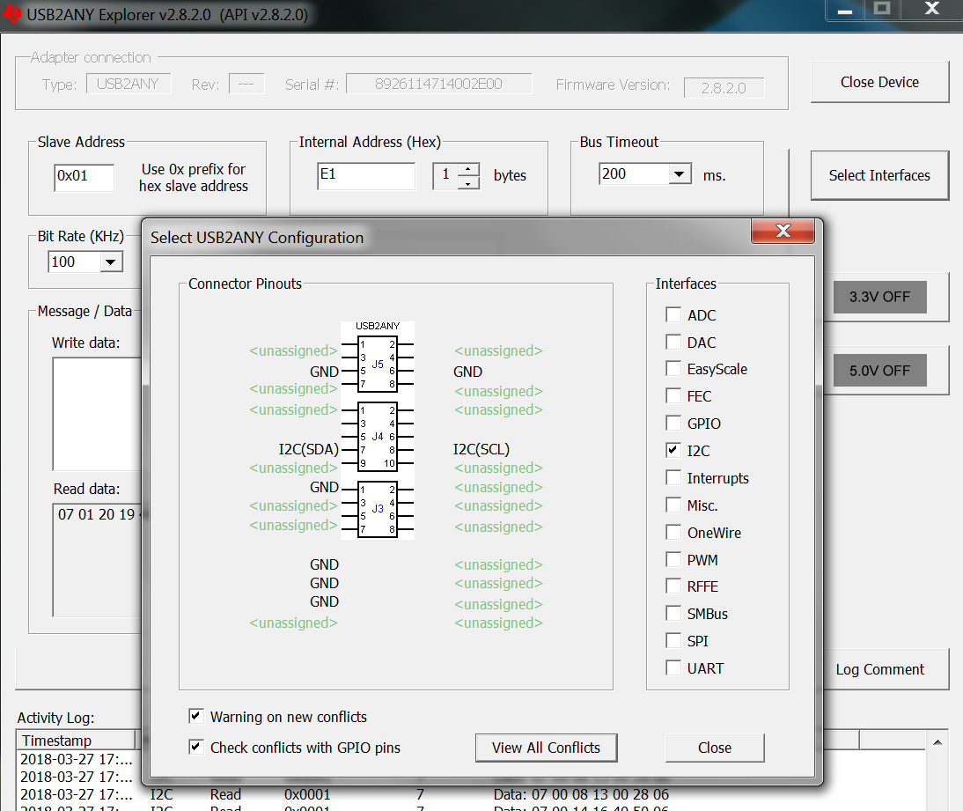

- From SM72445 datasheet, we know the EVM schematic and I2C master & slaver address.
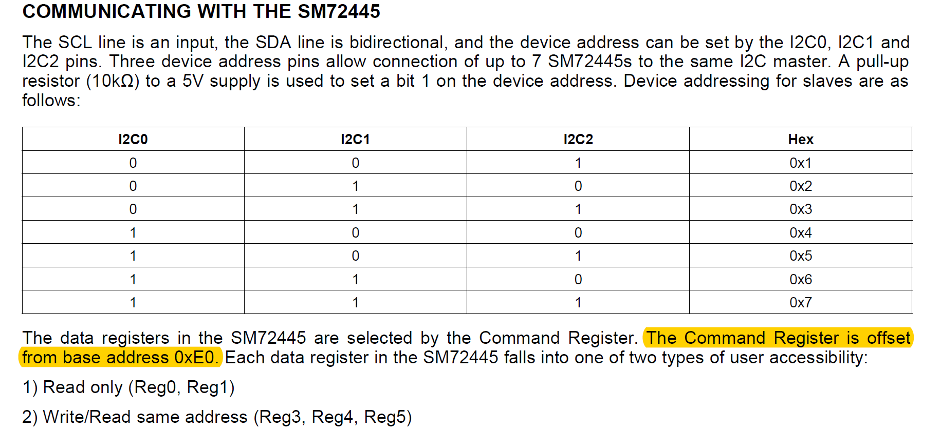
So the internal address is base on 0xE0, if you want read reg0 information. Just type E0 in the following blank: for reg1, just type E1.
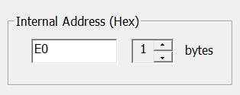

Due to EVM schematic we know. I2C0 pull high, I2C1/I2C2 pull low. Show as following schematic.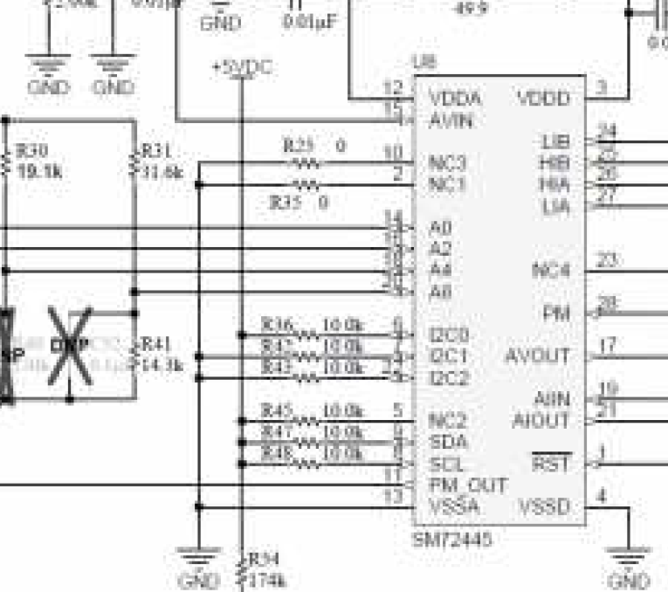

So A0=1, A1=0, A2=0. We set A2,A1,A0=0,0,1 as slaver address. The following figure shows.
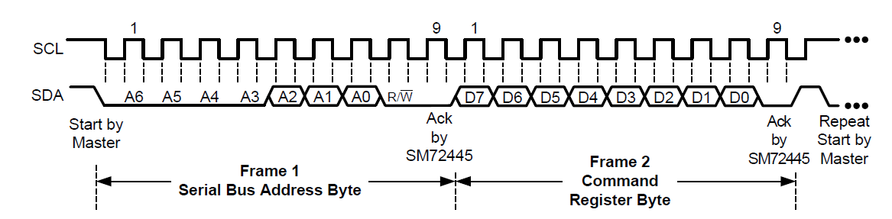

Then we type 0x01 as slaver address in the following blank.
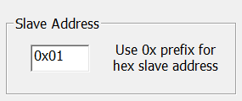

Step3. Communicating
After set parameter. We can read or write register information now.
For example:
If we want to read reg1 information. Just type 0x01 as slave address and E1 as internal address.
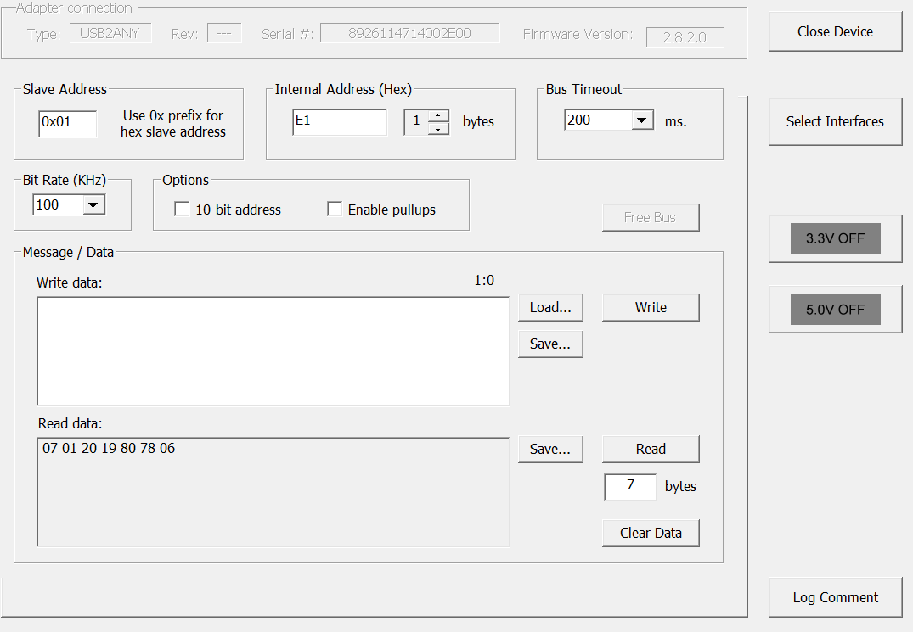
Then click ‘read’.
07 01 20 19 80 78 06 is 7 bytes (56bits) reg1 data. You can also write in reg3,4,5 by the above operation.

