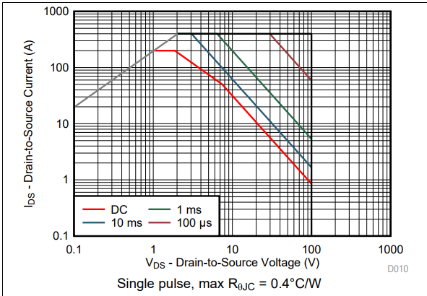 | 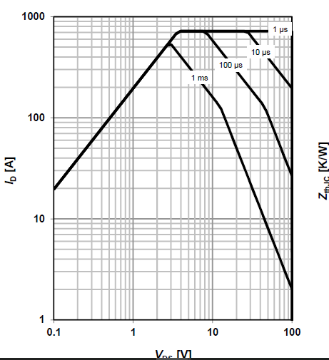
CSD19536KTT -----SOA Graph | Infineon-IPB180N10S4_02 ---SOA Graph

