UCC28951-Q1

Behaviour of OUTx signals as SS/EN pin is pulled to 0

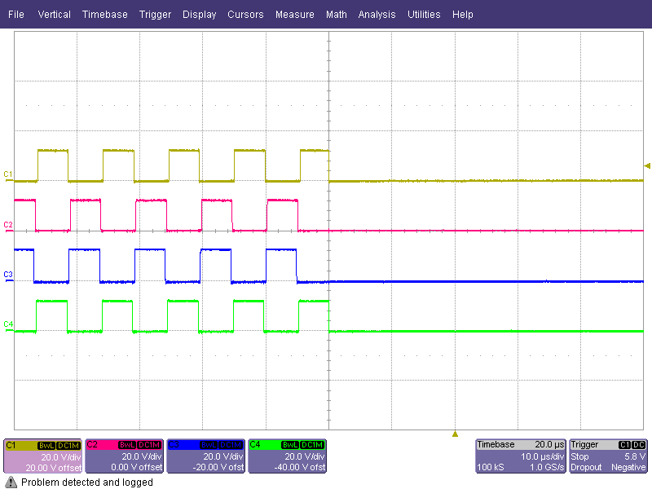 | Yel: OUTA  Red: OUTB  Blu: OUTC  Grn: OUTD  UCC28951 as SS/EN pin pulled quickly to 0V in approx. 1us  OUTx pulses cease immediately and asynchronously.
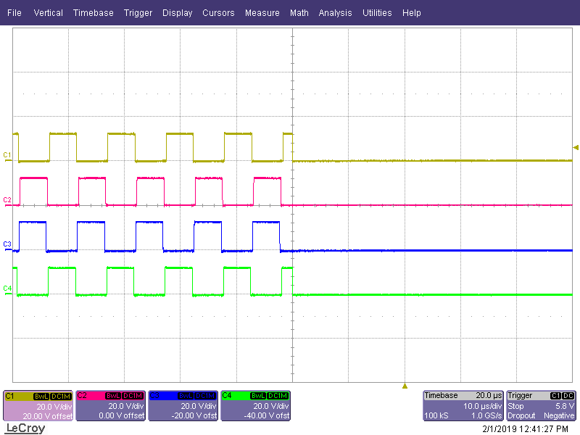 | Yel: OUTA  Red: OUTB  Blu: OUTC  Grn: OUTD  UCC28951 as SS/EN pin pulled quickly to 0V in approx. 1us  OUTx pulses cease immediately and asynchronously.
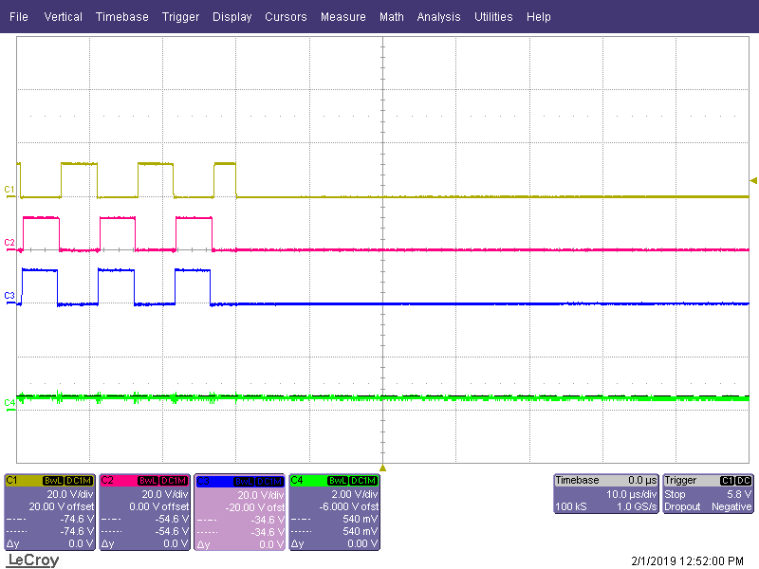 | Yel: OUTA  Red: OUTB  Blu: OUTC  Grn: OUTD  UCC28951 as SS/EN pin pulled slowly to 0V  OUTx pulses cease immediately and asynchronously.
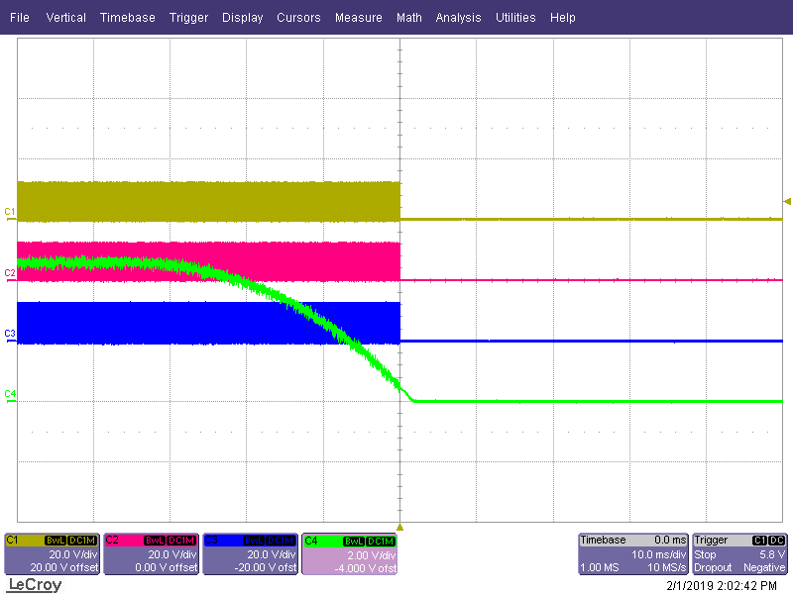 | Yel: OUTA  Red: OUTB  Blu: OUTC  Grn: SS/EN  UCC28950 as SS/EN pin pulled slowly to 0V  OUTx pulses cease immediately and asynchronously.
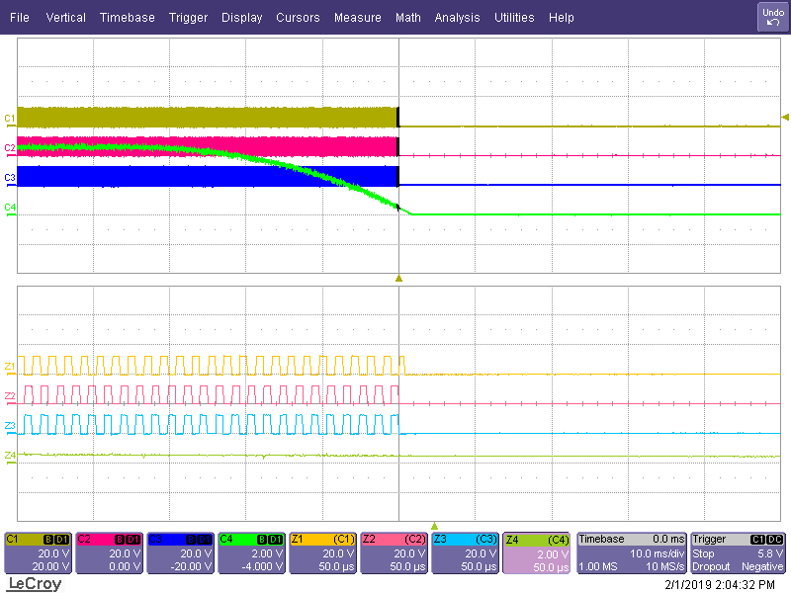 | Yel: OUTA  Red: OUTB  Blu: OUTC  Grn: OUTD  UCC28951 as SS/EN pin pulled slowly to 0V  Expanded view of above  OUTx pulses cease immediately and asynchronously.
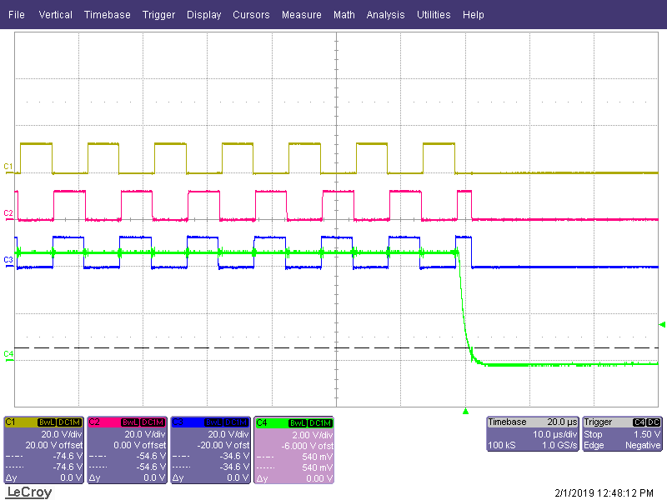 | Yel: OUTA  Red: OUTB  Blu: OUTC  Grn: SS/EN  UCC28951 as SS/EN pin pulled quickly to 0V in approx. 1us  OUTx pulses cease immediately and asynchronously.
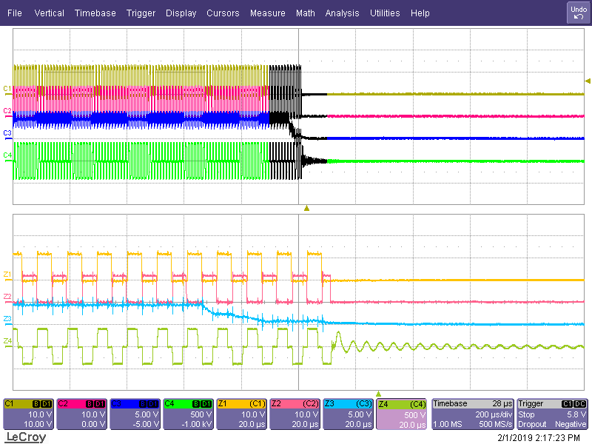 | Yel: OUTA  Red: OUTB  Blu: SS/EN  Grn: Transformer primary  UCC28951 in EVM  OUTx pulses cease immediately and asynchronously as EN passes through threshold.
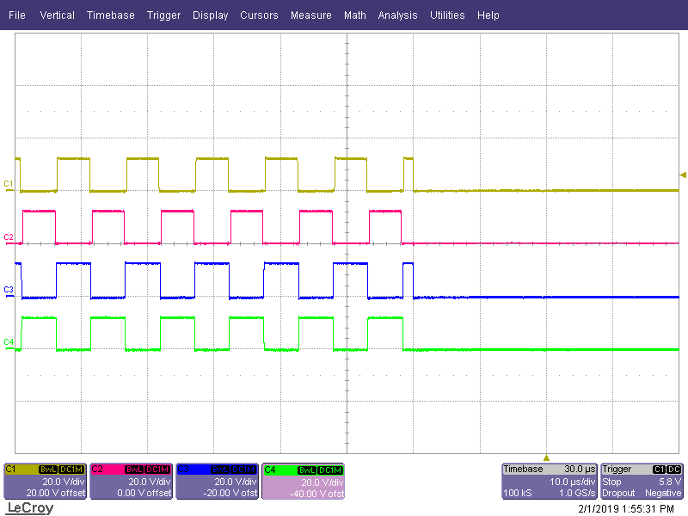 | Yel: OUTA  Red: OUTB  Blu: OUTF  Grn: OUTE  UCC28951 as SS/EN pin pulled quickly to 0V in approx. 1us  OUTx pulses cease immediately and asynchronously.

