The connections around the controller and for the power stage seem ok with the exceptions listed below.

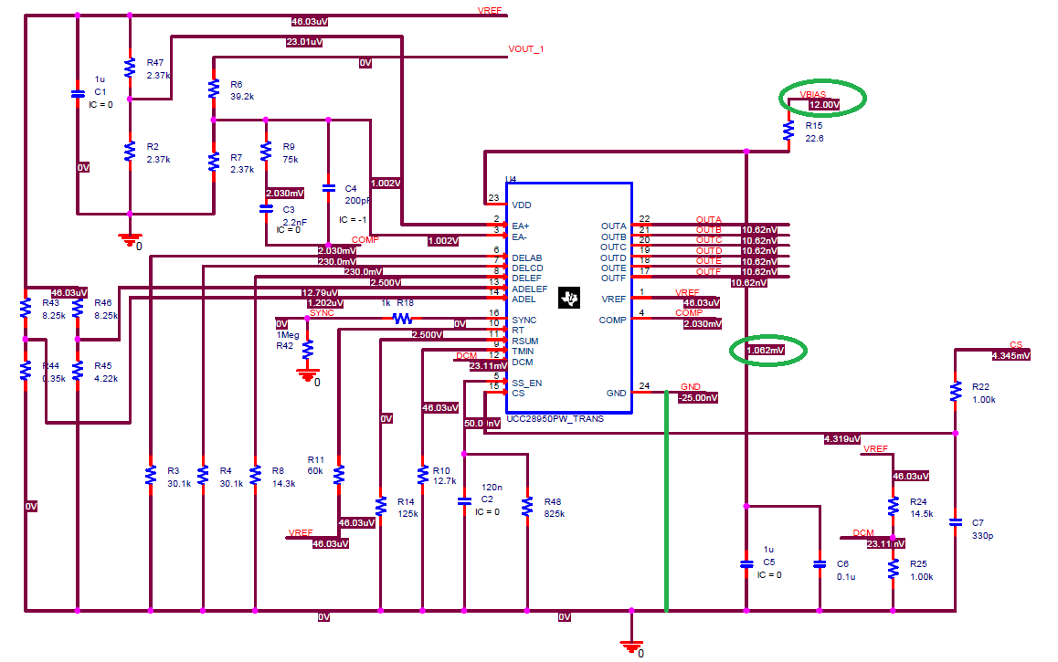 | The GND pin of the controller should be tied to 0V  VBIAS is measured at 12.00V but the VDD pin of the controller is showing only 1.062mV. This may be due to the grounding – I don’t know.

