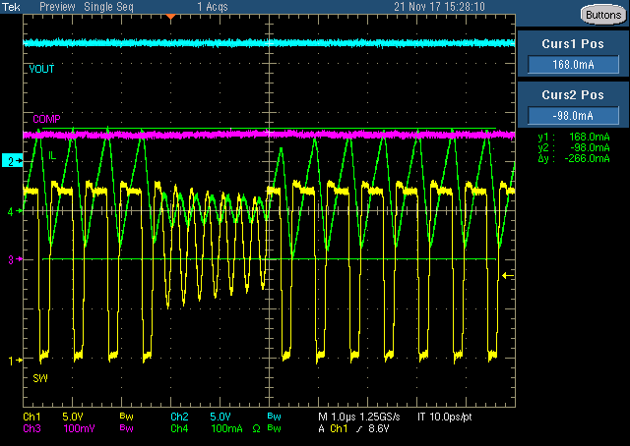

Fig.1

**18Vin** to 12Vout, 1.5MHz, 10uH

Skip mode, Comp voltage clamped. The peak current is 168mA.

b

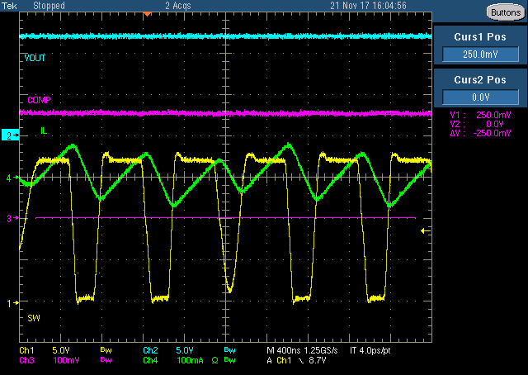

Fig.2

**18Vin** to 12Vout, 1.5MHz, 22uH

Comp voltage clamped Starts working but still no pulse skipped. The peak current is about 50mA.

But this value makes little sense for the 22uH is much larger than the required inductance; the internal slope compensation has already made some side-effect to the inductor current.

Fig.3

**12Vin** to 3.3Vout, 340kHz, 15uH

Skip mode.

500mA is the skip point under this condition.