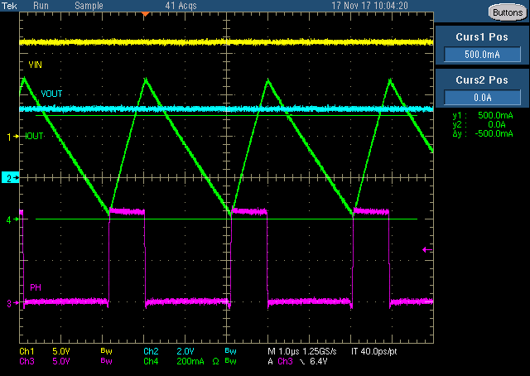

Fig.1

**12Vin** to 3.3Vout, 340kHz, 15uH

Before entering skip mode.

b

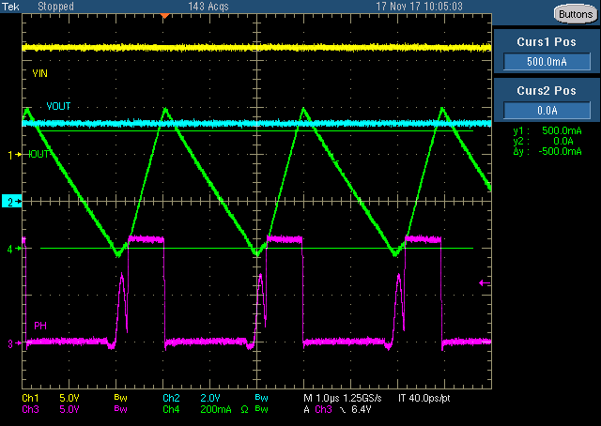

Fig.2

**12Vin** to 3.3Vout, 340kHz, 15uH

Comp voltage clamped Starts working but still no pulse skipped.

b

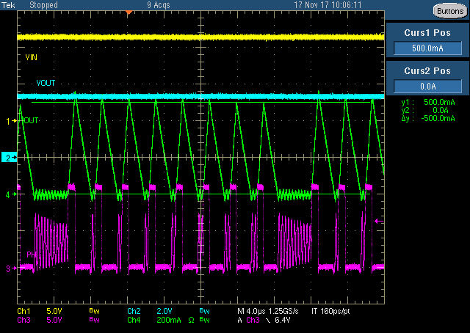

Fig.3

**12Vin** to 3.3Vout, 340kHz, 15uH

Skip mode.

500mA is the skip point under this condition.

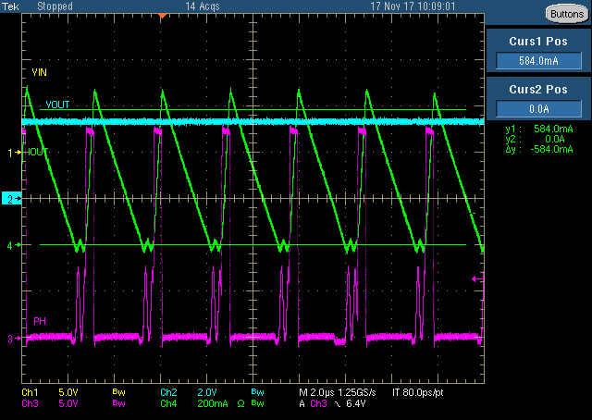

Fig.4

**24Vin** to 3.3Vout, 340kHz, 15uH

Comp voltage clamped, skip mode Starts working but still no pulse skipped.

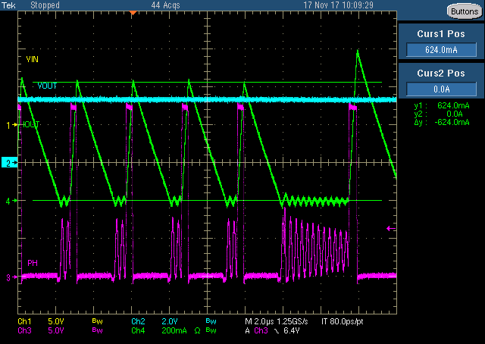

Fig.5

**24Vin** to 3.3Vout, 340kHz, 15uH

Skip mode.

624mA is the skip point under this condition.