REFERENCE SERVICE REQUEST #1-1987053761

**TEXAS INSTRUMENTS DOCUMENT TPS2834, TPS2835**

**SYNCHRONOUS-BUCK MOSFET DRIVER WITH DEAD TIME CONTROL**

I am currently building a prototype of the above referenced TL5001 along with the TPS2834 as referenced above shown on page 12 of the TPS2834 datasheet. My current problem is that the output transistor is turned off and I am trying to find the culprit causing it.

TPS2834 DATASHEET – PAGE 12

Capacitors C2, C3 and C4 are noted by symbol that they are a type polarized, and also have a value associated with each. (SEE FIGURE 1 THIS SHEET)

Problem: All three of these capacitors are nF’s and are not available as polarized, neither electrolytic or tantalum. The smallest size in the commercial market is .1uF (1000nF).

*Question: Are polarized capacitors required for C2, C3 and C4? If required, where can they be purchased or can they be purchased through Texas Instruments.*

*Question: If not required to be polarized capacitors, will np-capacitors of same value have any adverse effect on the engineers calculations of the negative feedback compensation network.*

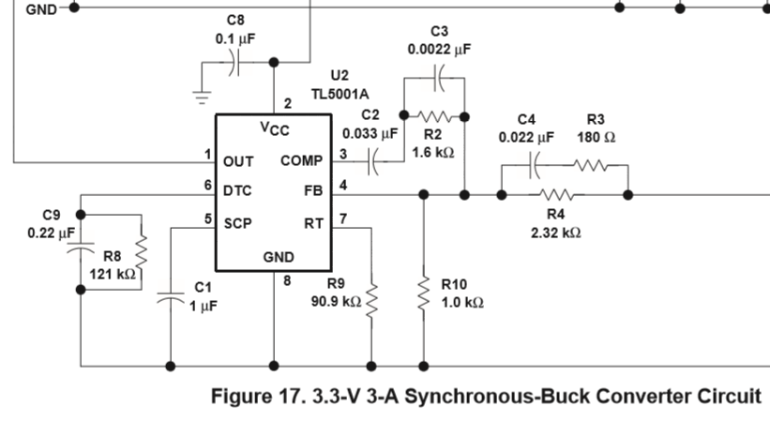



**Figure 1 - TPS2834 DATASHEET – PAGE 12**

Please look at the schematic below (FIGURE 2) of where I believe the problem might be, the negative feedback circuit, pin #3 and pin #4. I have included voltage reading, taken by DVM and verified with the oscilloscope. Take note that I have tried n-polarized caps with values matching C2, C3 and C4 and also have tried inserting a .1uF polarized capacitor for each, C2, C3 and C4. Voltage measurements are within 5% between the n-polarized and the polarized caps. All voltage readings are referenced to the source ground.

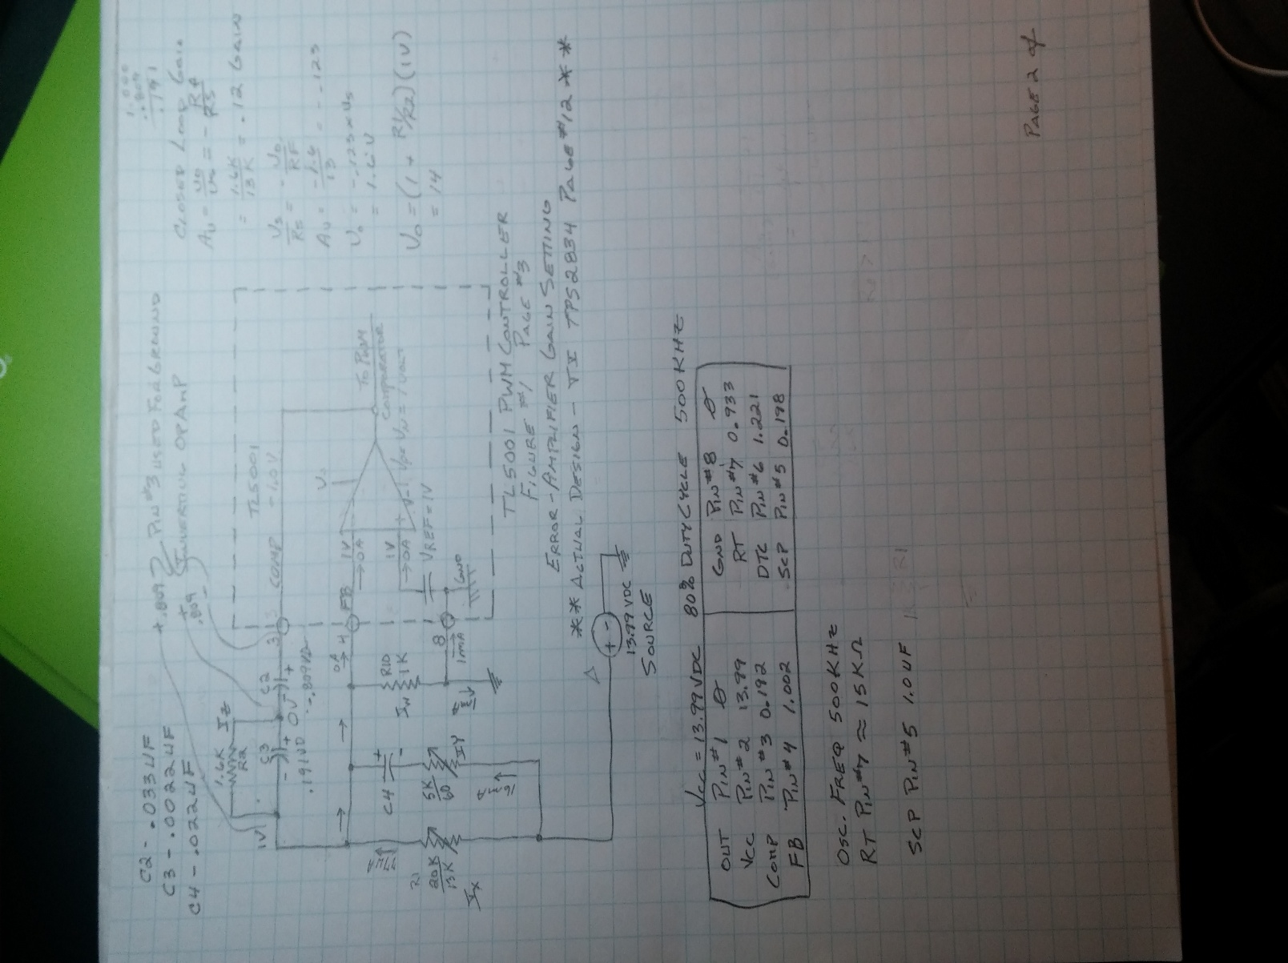

**Figure 2 – TL5001 DATASHEET FIGURE 1, PAGE 3 – ERROR-AMPLIFIER GAIN SETTING (Actual design T.I. TPS2834 DATASHEET – PAGE 12)**

*Question: The TL5001 pin out voltages, are they within reason or are any of them wrong? Please list out what the correct values should be for all pins.*

Pin #3 has a negative 1 volt. The two voltages shown, (.809 volt Pin #3 across C2, .809 volt Pin #3 across C2 to Pin #4 ), reference pin #3 as the ground.

*Question: Is this correct voltage readings?*

**Reference TL5001 DATASHEET FIGURE 1, PAGE 3 – ERROR-AMPLIFIER GAIN SETTING**

**“**The error-amplifier output is brought out as COMP for use in compensating the dc-to-dc converter control loop for stability. *Because the amplifier can only source 45µA, the total dc load resistance should be 100kΩ or more.*”

*Question: Is the referenced load resistance of 100K Ohms part of the Pin #3 Compensation Network? If it is then I am confused, reference Figure 21, Pin #3 to #Pin #4, TL5001 DATASHEET FIGURE 21, PAGE 17, which shows the compensation network utilizing a 5.1K ohm resistor. Please explain where this “total dc load resistance should be 100kΩ or more.” Is located.*

See Figure 3 Below showing the Texas Instruments TL5001 design that I have prototyped and am having difficulty getting the output signal working. This design comes from Texas Instruments TPS2834 Datasheet, Page 12. Please note the values for the C2, C3 and C4 capacitors which is shown in the T.I. TPS2834 Datasheet Page 12.

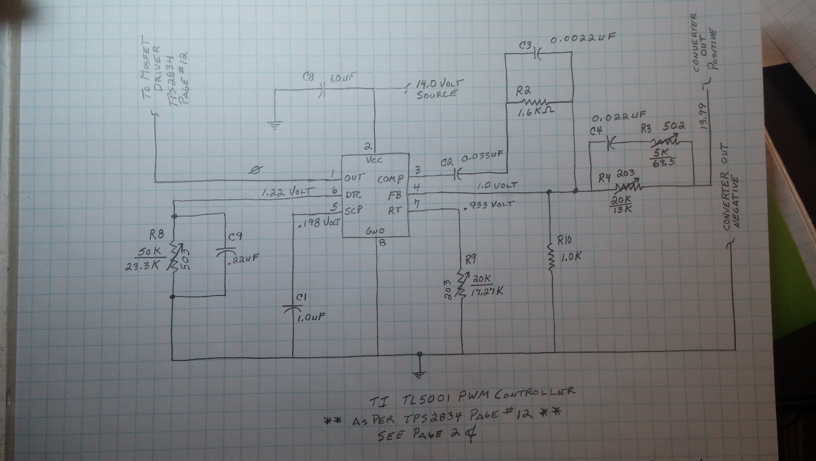

**Figure 3 – TL5001 Schematic – (Actual design as per T.I. TPS2834 DATASHEET – PAGE 12)**

*Question: Should Pin #8 have a de-coupling capacitor tied to ground or will this have an adverse effect on the proper functioning of the IC.*

*Question: Are the listed component values in agreement with the Product Engineer’s review?*

TL5001 DATASHEET – PAGE 5

“The timer operates by charging an external capacitor (CSCP), connected between the SCP terminal and ground, towards 2.5 V through a 185-kΩ resistor (RSCP). The circuit begins charging from an initial voltage of approximately 185 mV and times out when the capacitor voltage reaches 1 V. The output of SCP comparator 2 then goes high, turns on Q2, and latches the timer circuit. The expression for setting the SCP time period is derived from the following equation:

VSCP = (2.5 - 0.185)(1 - e–t/ 0.185

Where

τ = RSCPCSCP

The end of the time-out period, tSCP, occurs when VSCP = 1 V. Solving for CSCP yields: CSCP = 12.46 x tSCP

Where

t is in seconds, C in µF.

tSCP must be much longer (generally 10 to 15 times) than the converter start-up period or the converter will not start.”

*Question: The above referenced formula regarding VSCP, uses “t” for time, but there is no reference to where this information can be found. Please explain where this information can be found.*