1. **Remaining capacity alarm**:

There are two descriptions in 《bq40z50-R2 Technical Reference》，the value to read and write in two different ways, but the return values are difference, do they two values can not synchronous update such as the SN value?

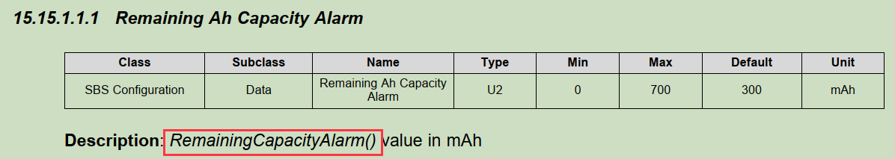

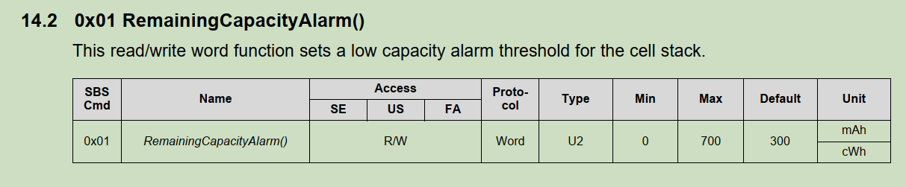

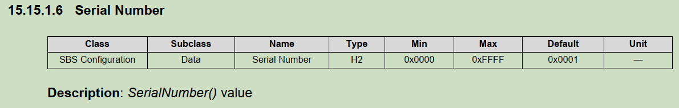

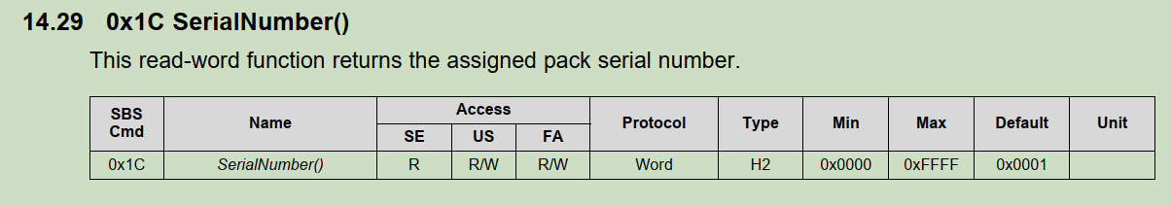

1. **Read the battery status:**

1st time to read and sent back （0x02c0）

2ndtime to read and sent back UnknownError（0x02c7）, the 3rd time、4th time、5、6…are all the same issue, send a command to write and read, then it recovered, but at this time to read other blocks are fine, what‘s the reason with it?

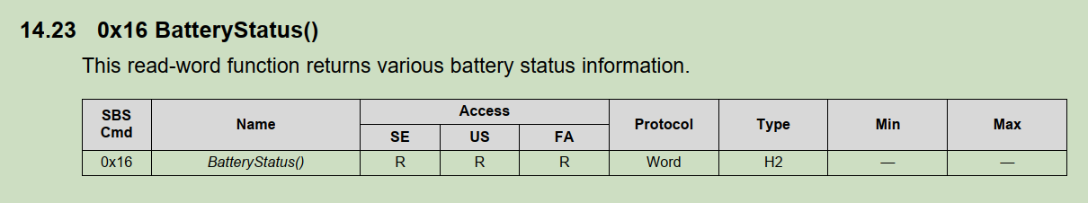

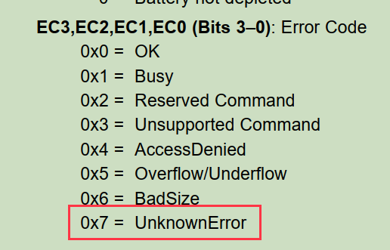

1. **Device reset :**

What kind of function value will be impacted and be recovered after Device reset？

