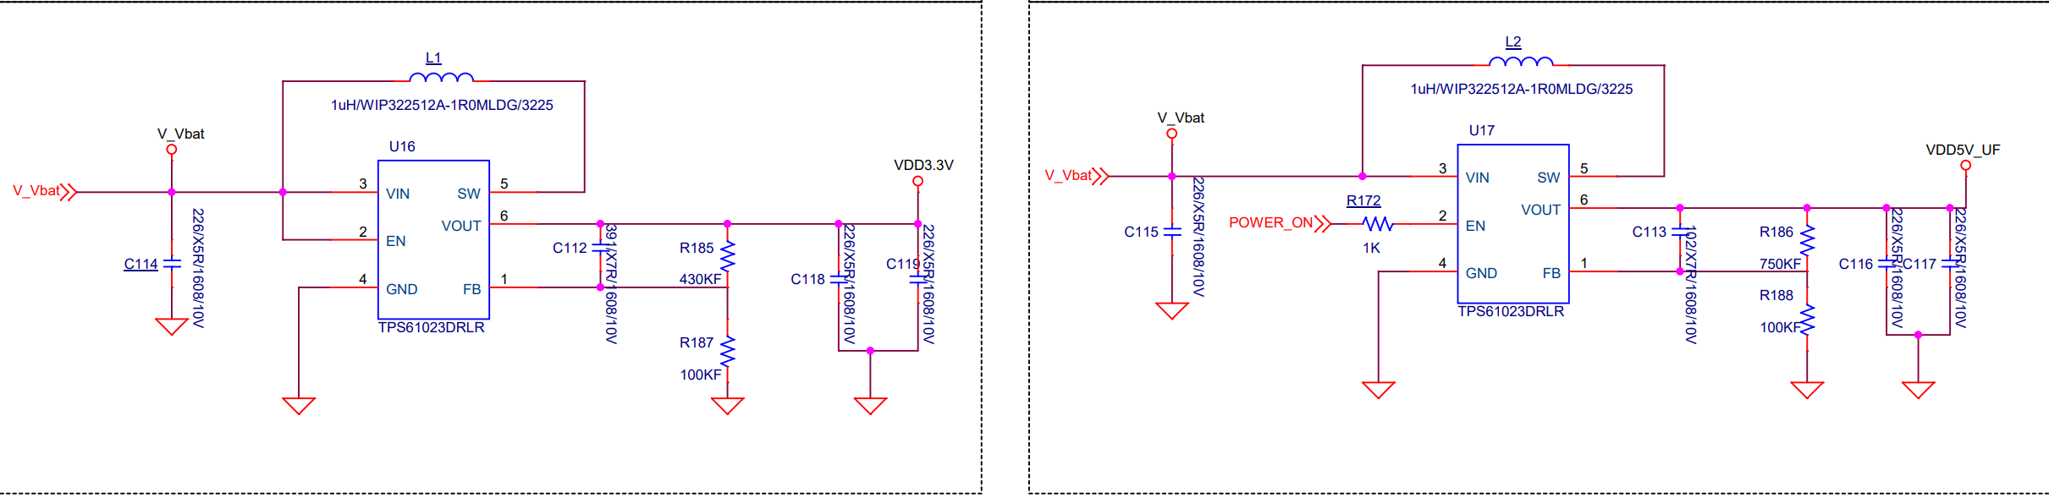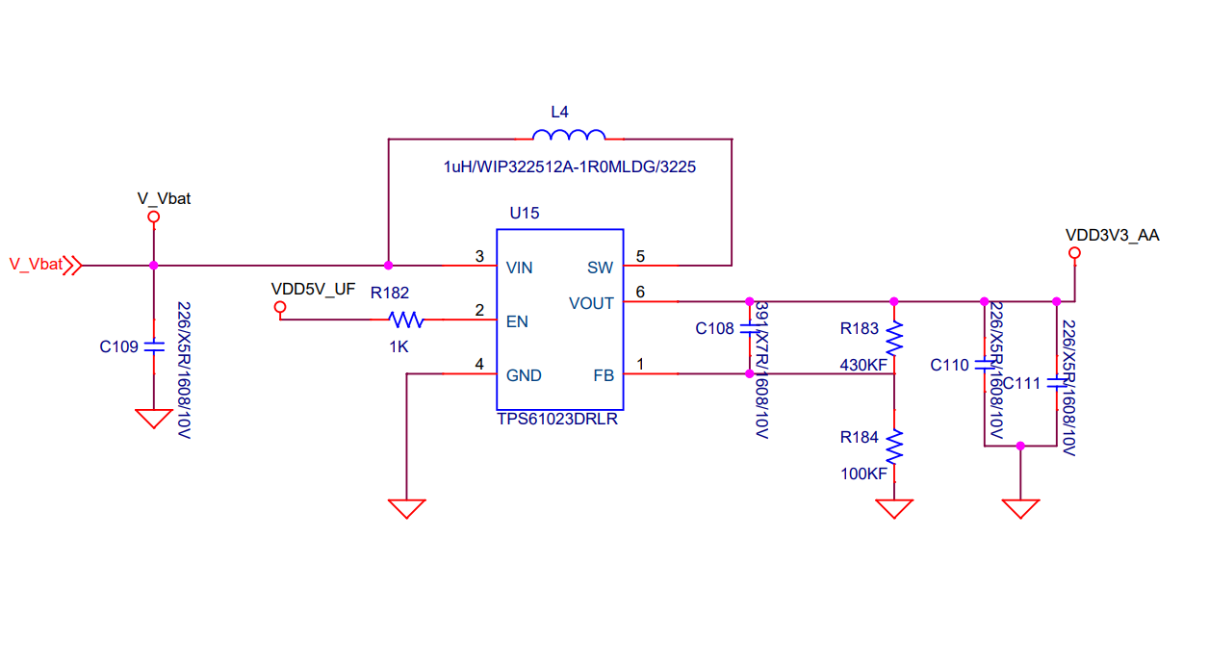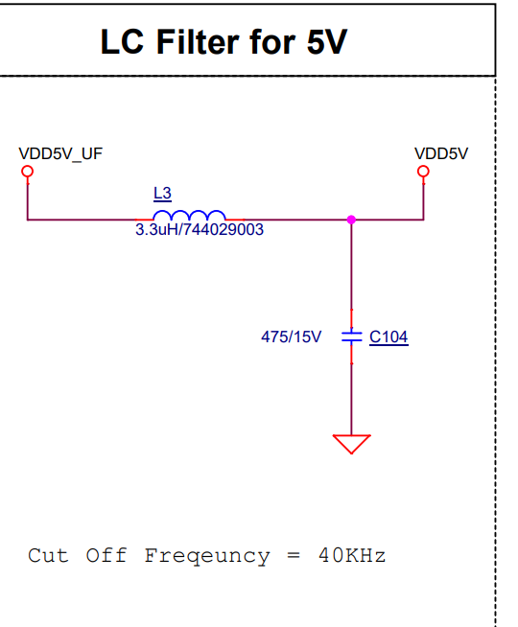
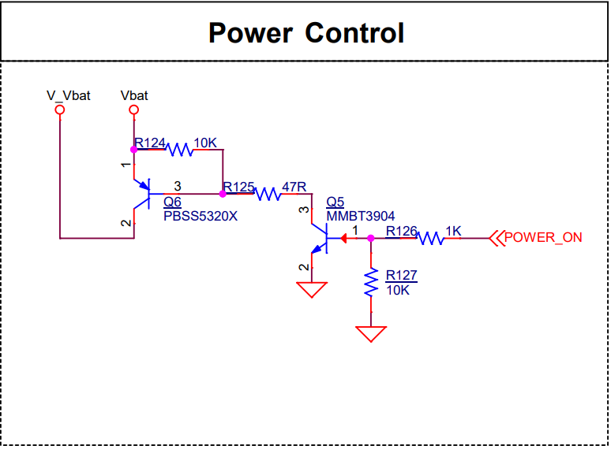
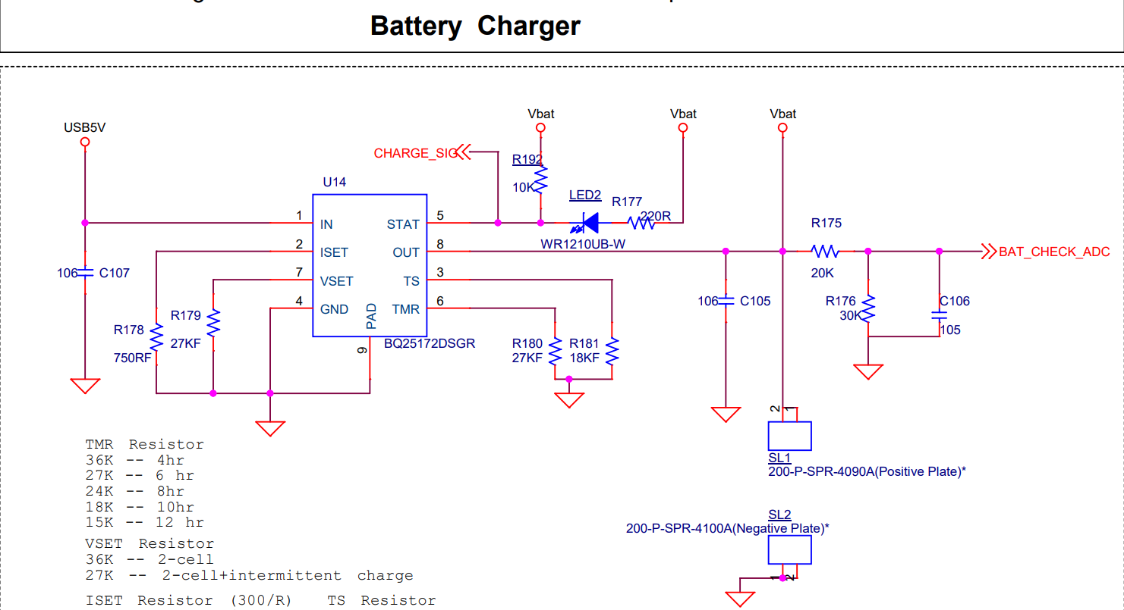

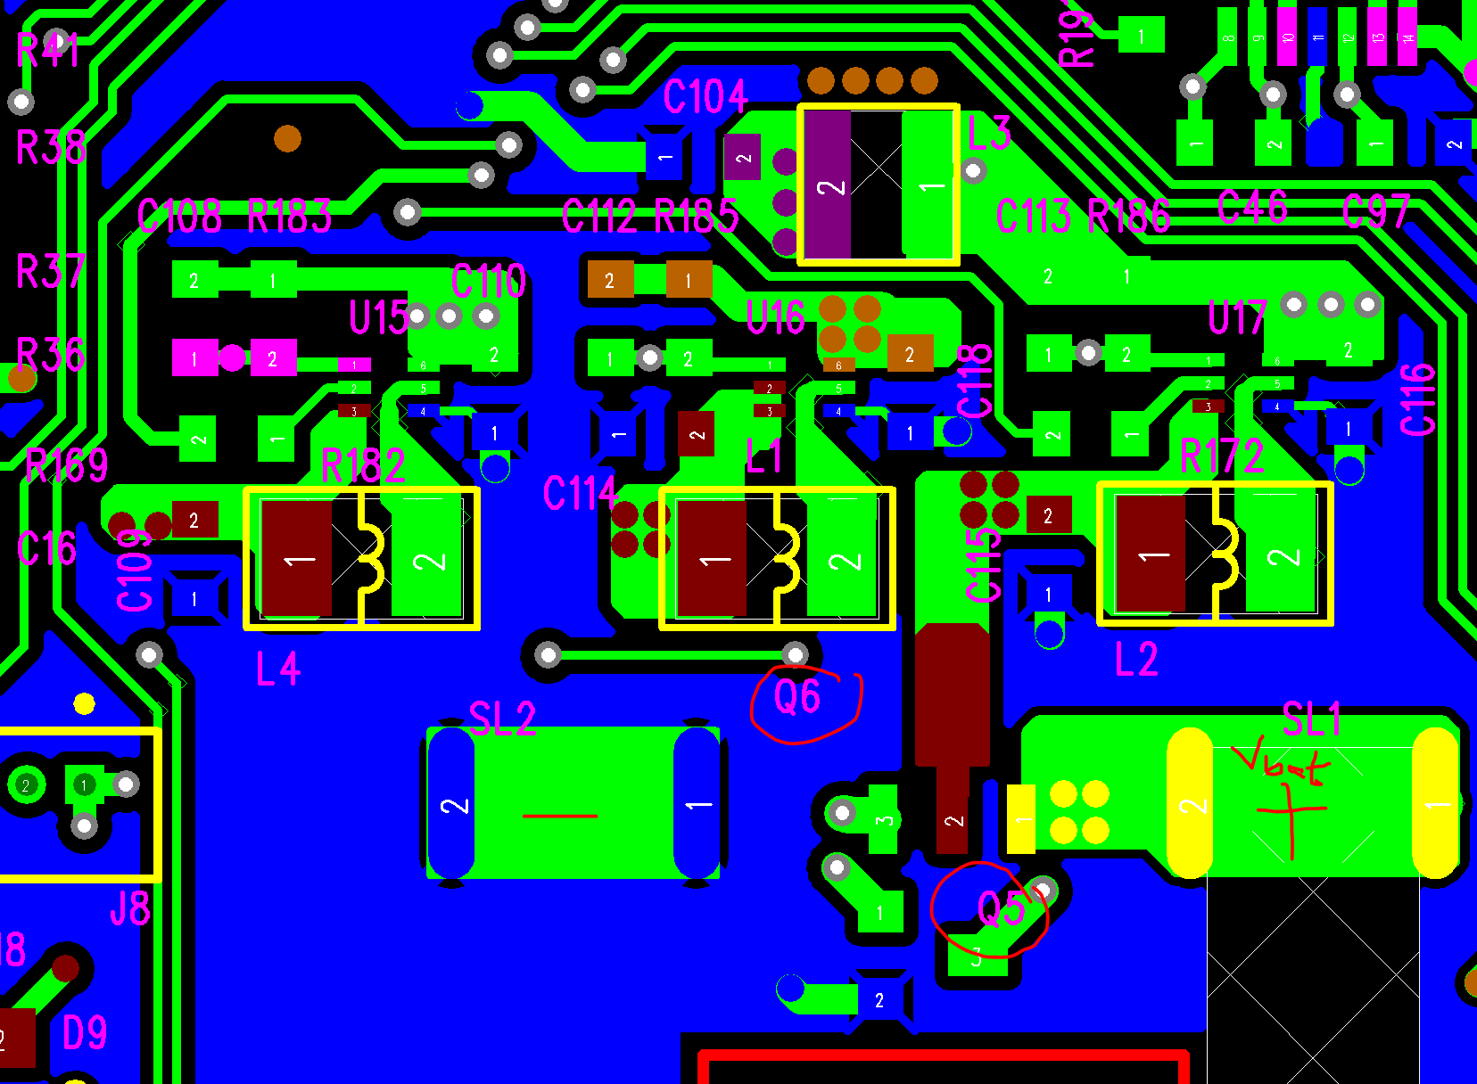

VDD3.3V – Used for MCU, Flash and Display (approx. 50mA)
VDD3V3_AA—Used for driving LM4871 audio amplifier (Approx 100mA) and speaker
VDD5V – used for driving some analog circuitry and outside board circuitry (approx. 150mA)

Is the circuit correct?
The output is same as input most of the time and ICs. When we change the resistors and capacitors of the output, the output is correct for some time, but again becomes same as input (2.8V) after some time of use.

The feedback voltage is 1V~2.5V when the output (2.8V) is same as input (2.8V). There is no SW pulses.

Is the circuit OK? The issue with DC DC output is not resolved since 3 weeks and based on the simple circuit we can not think much.

We are a big company and want to move forward from this issue. Can you help in resolving or finding some alternative?

