Problem:

Not able to have communication between EV2300 and battery Gas Gauge BQ27541-G1.

Steps takes:

1. Added Pull up Register to EV2300 to emulate device I2C communication
2. Both SCL and SDA line are pull up, but not able to communicate.
3. Scop plot attached.

EDA50 Battery

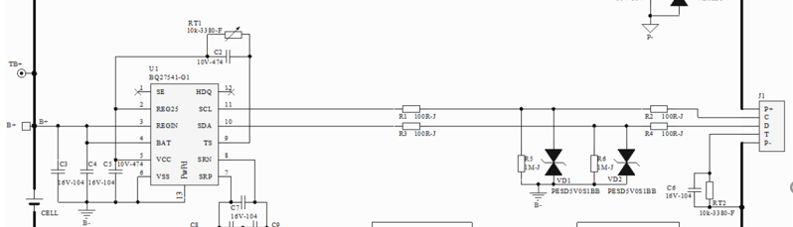

Device side

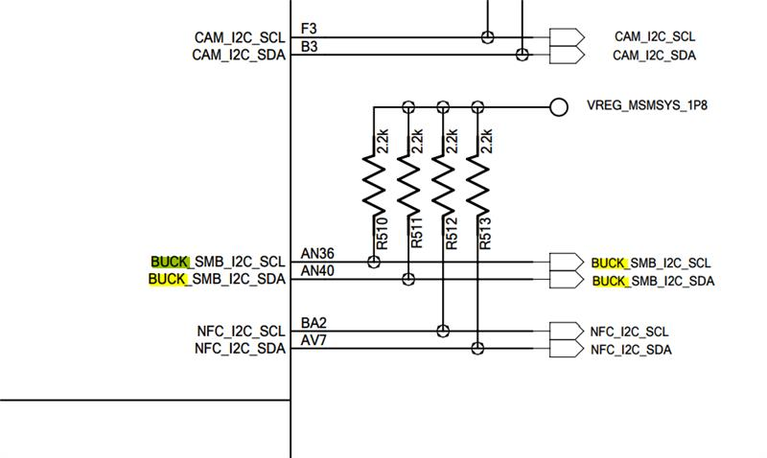

EV2300

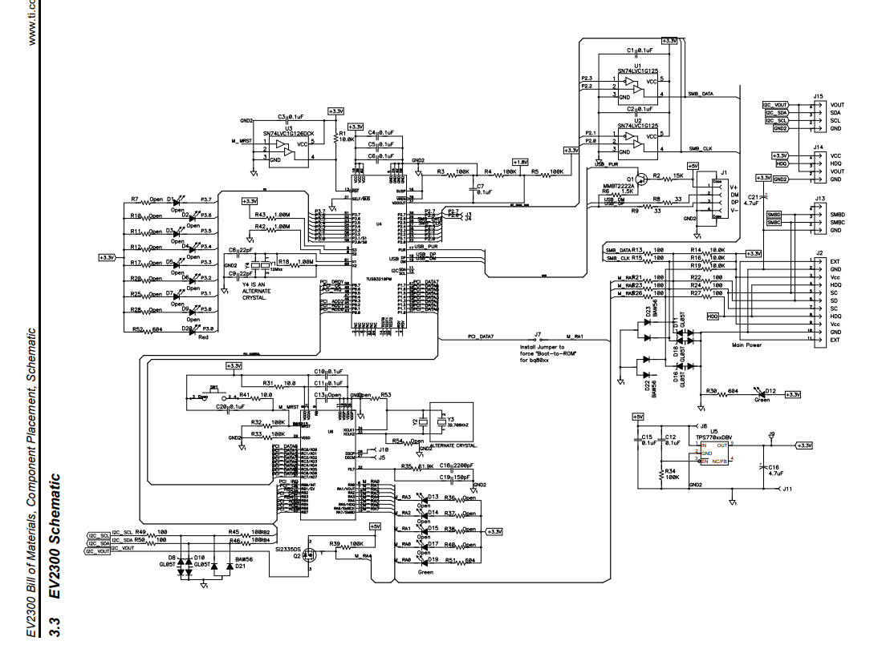

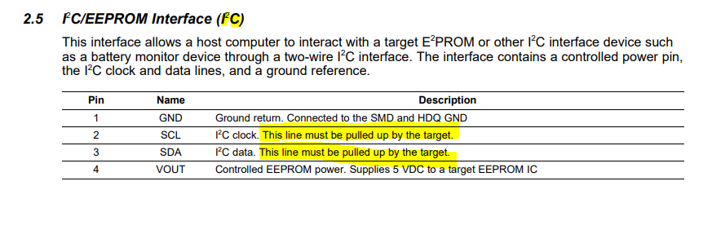

We added Pull up register under EV2300.

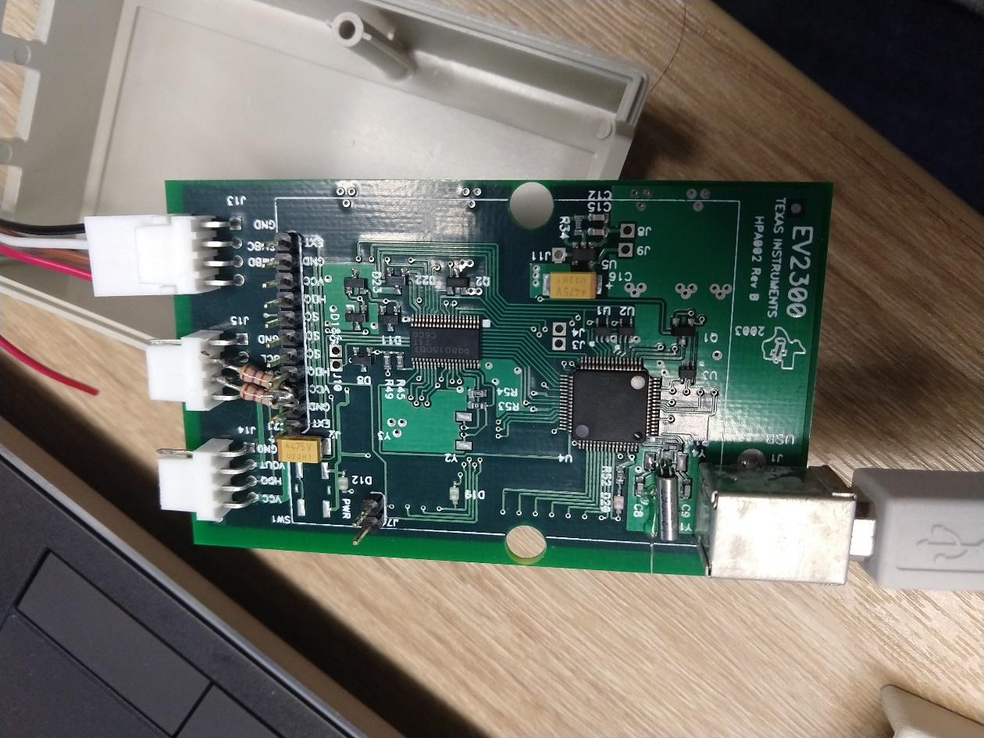

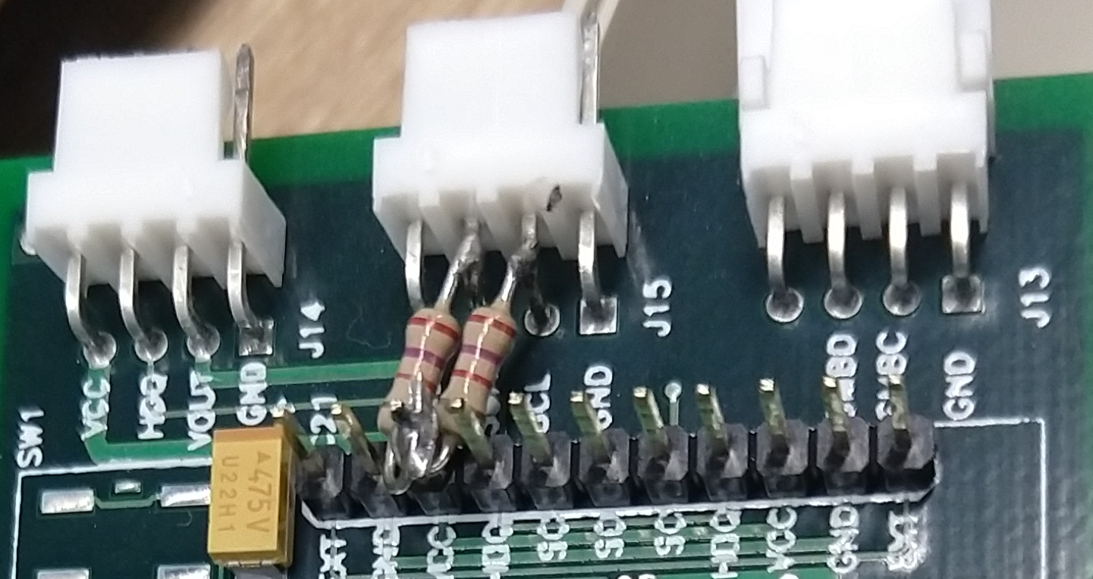

**Scope plots for SCL and SDA lines.**

Every 1mS some activity on the I2C.

