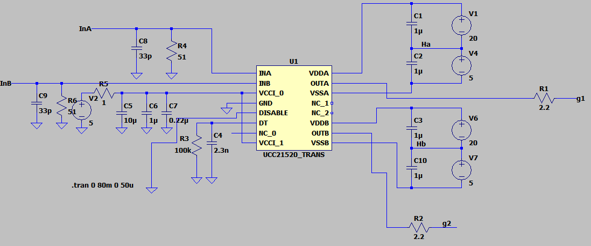

**Gate Driver in SiC Half Bridge Operation Mode**

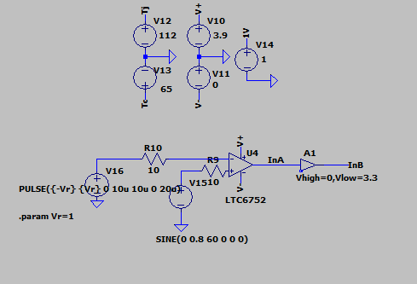

**Creating 3.3 V input for InA and InB pin of driver**

**Output Current**

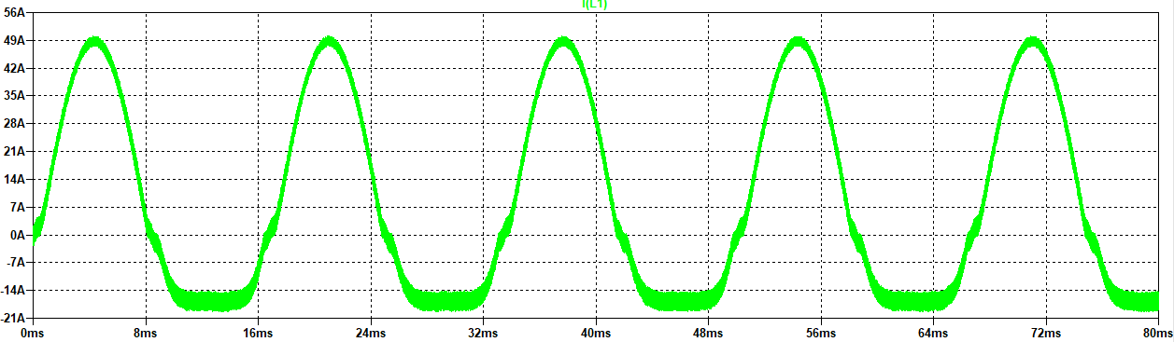

**Gate Driver output**

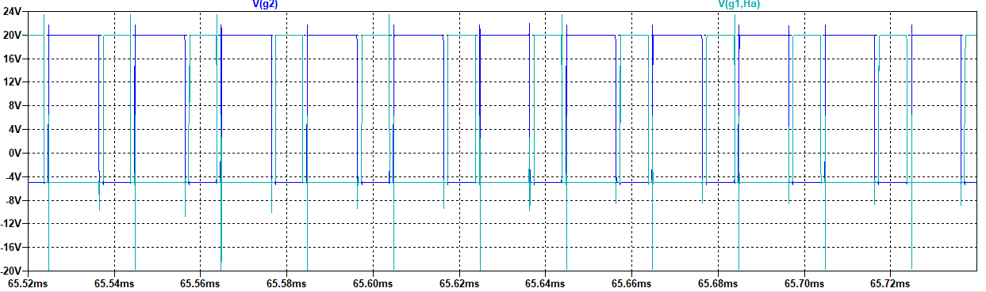

**Main Circuit**

