25th Jan 2022
24 th Jan 2022 Hello Jeff
Can you change COMP waveform scale so that I can read ?
Can you show me VCC, FB and RT voltage with readable scales ? ?
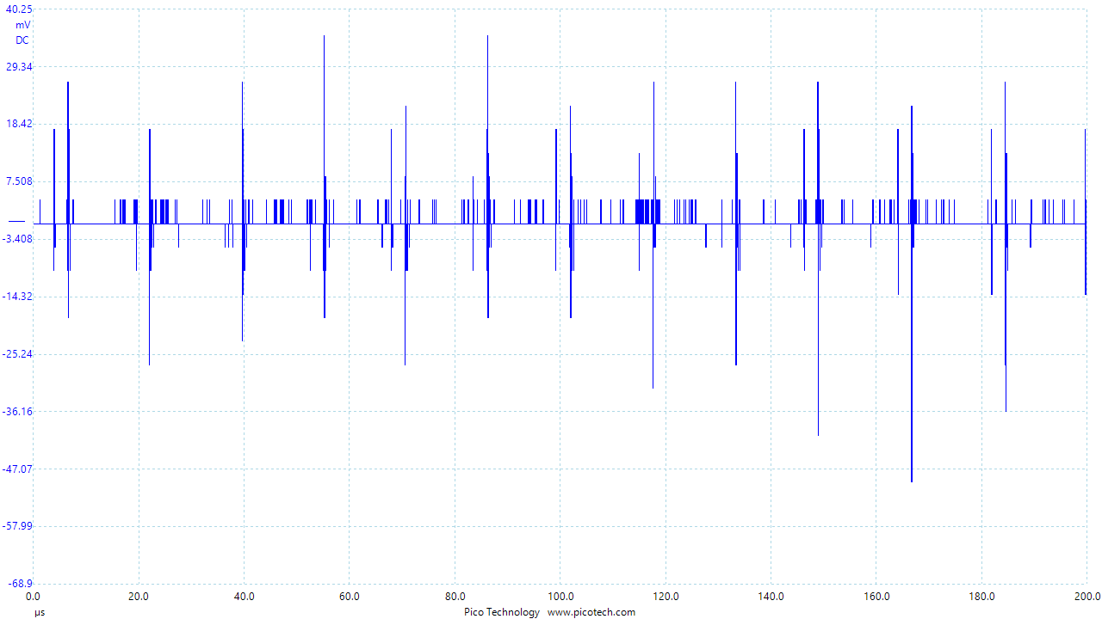
Comp. Vertical scale mV (DC). Horizontal scale 20uS/div

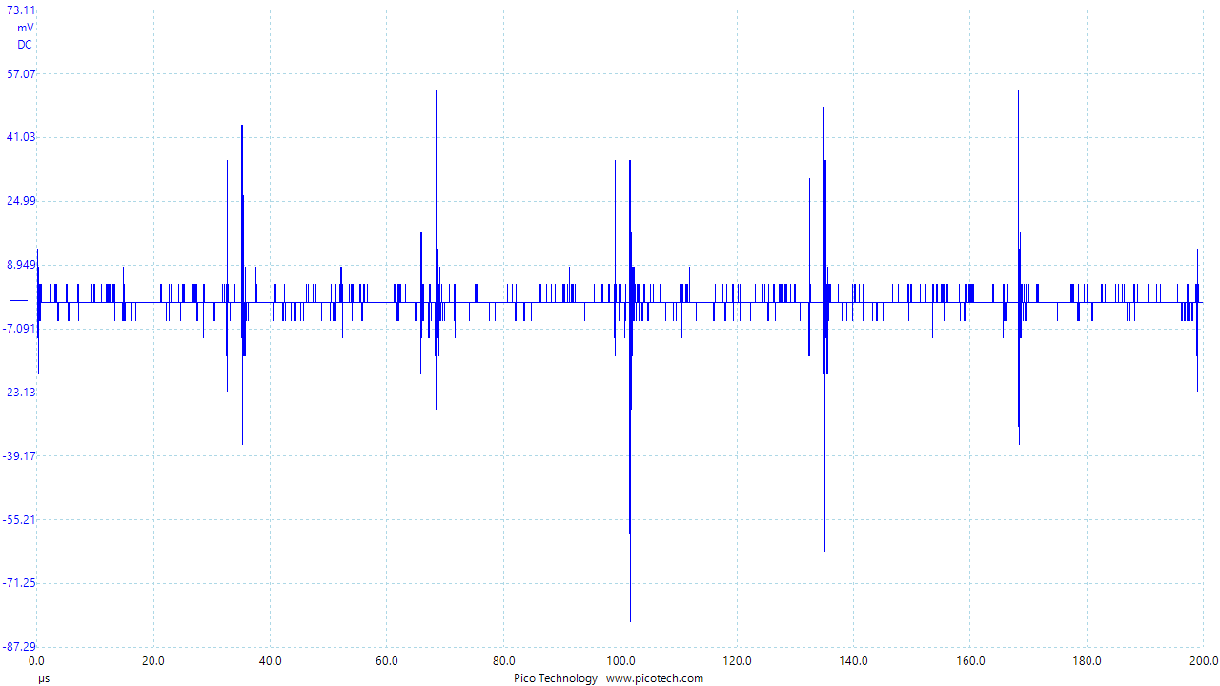
VCC Vertical scale mV DC. Horizontal scale 20uS/div

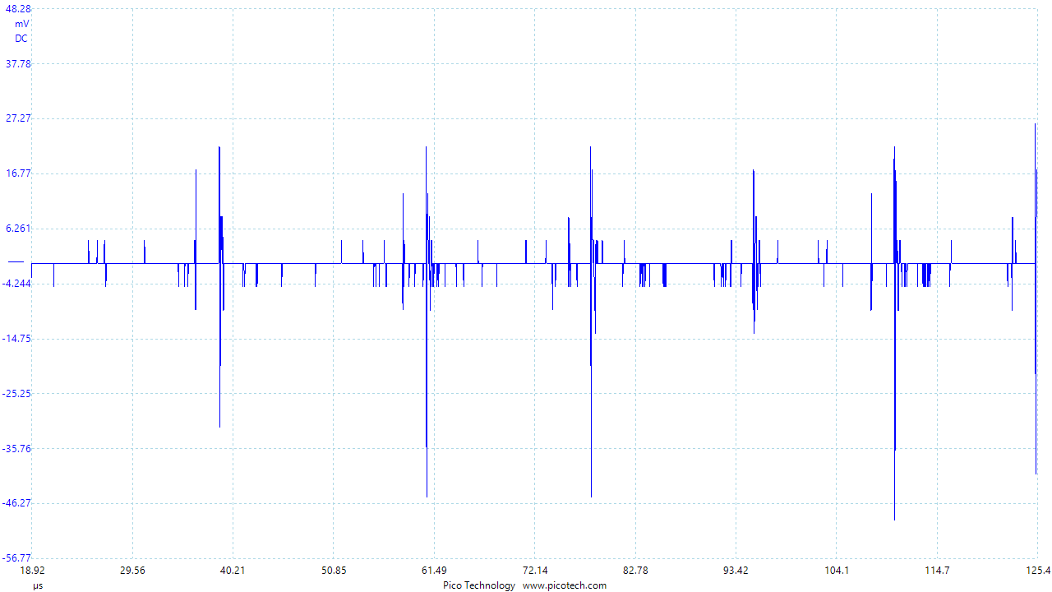
FB. Vertical Scale mV DC. Horizontal scale 20uS/div
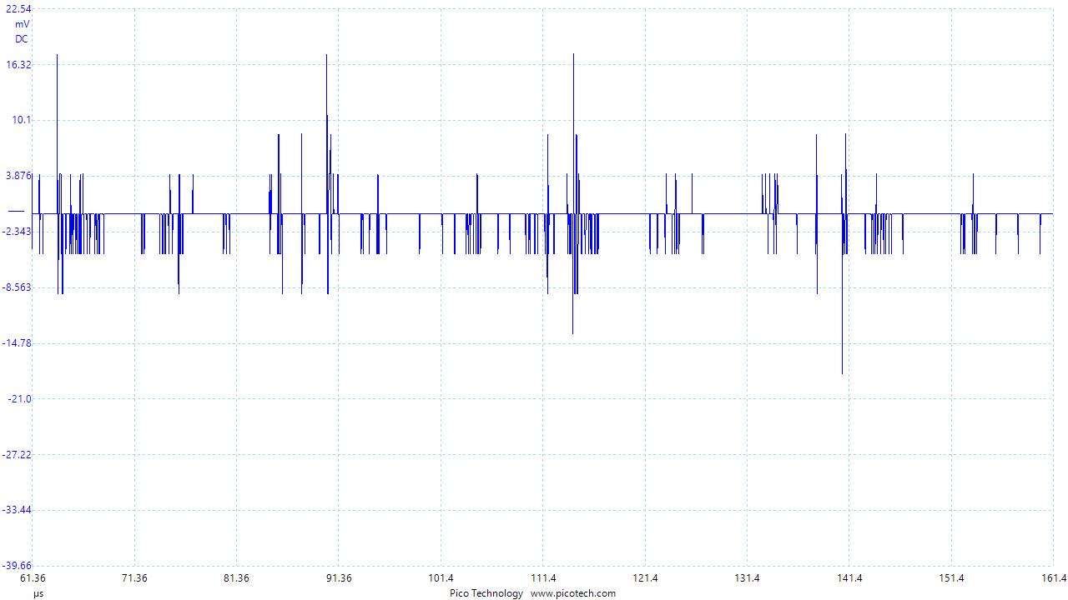

RT Vertical scale mV DC. Horizontal scale 10uS/div

