1. need below highlighted **three** missing dimensions, kindly refer the picture, and provide the dimensions

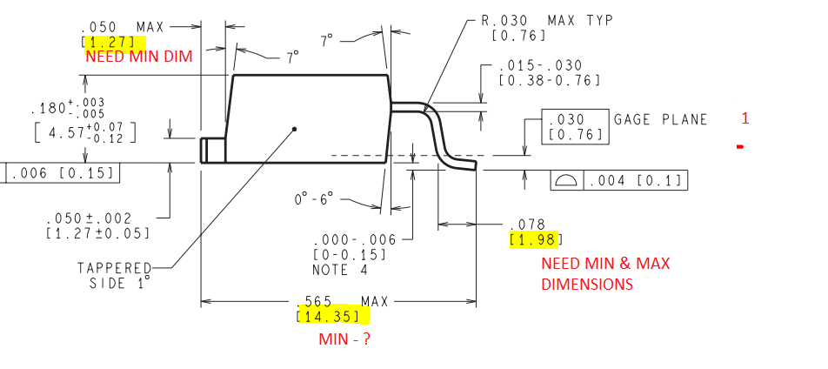

1. Provide the maximum dimension for the below red marked one?

