1st EVM Board (bought from Mouser)
Note there is faults on two channels. Hitting soft reset causes the 3.3V output to go unstable but the behavior has now changed. It eventually regulates now (see video clip) . Originally it would not achieve regulation after the second soft reset.
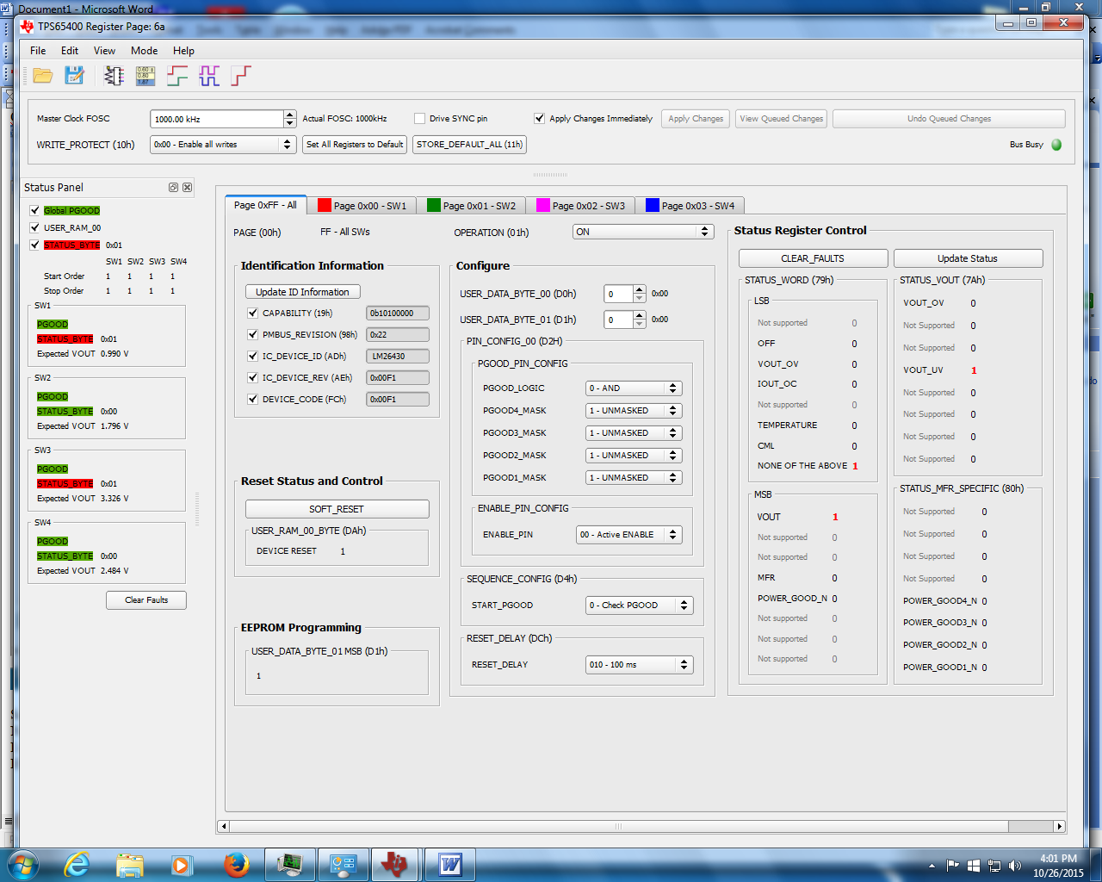

2nd EVM
1st powerup
Note error

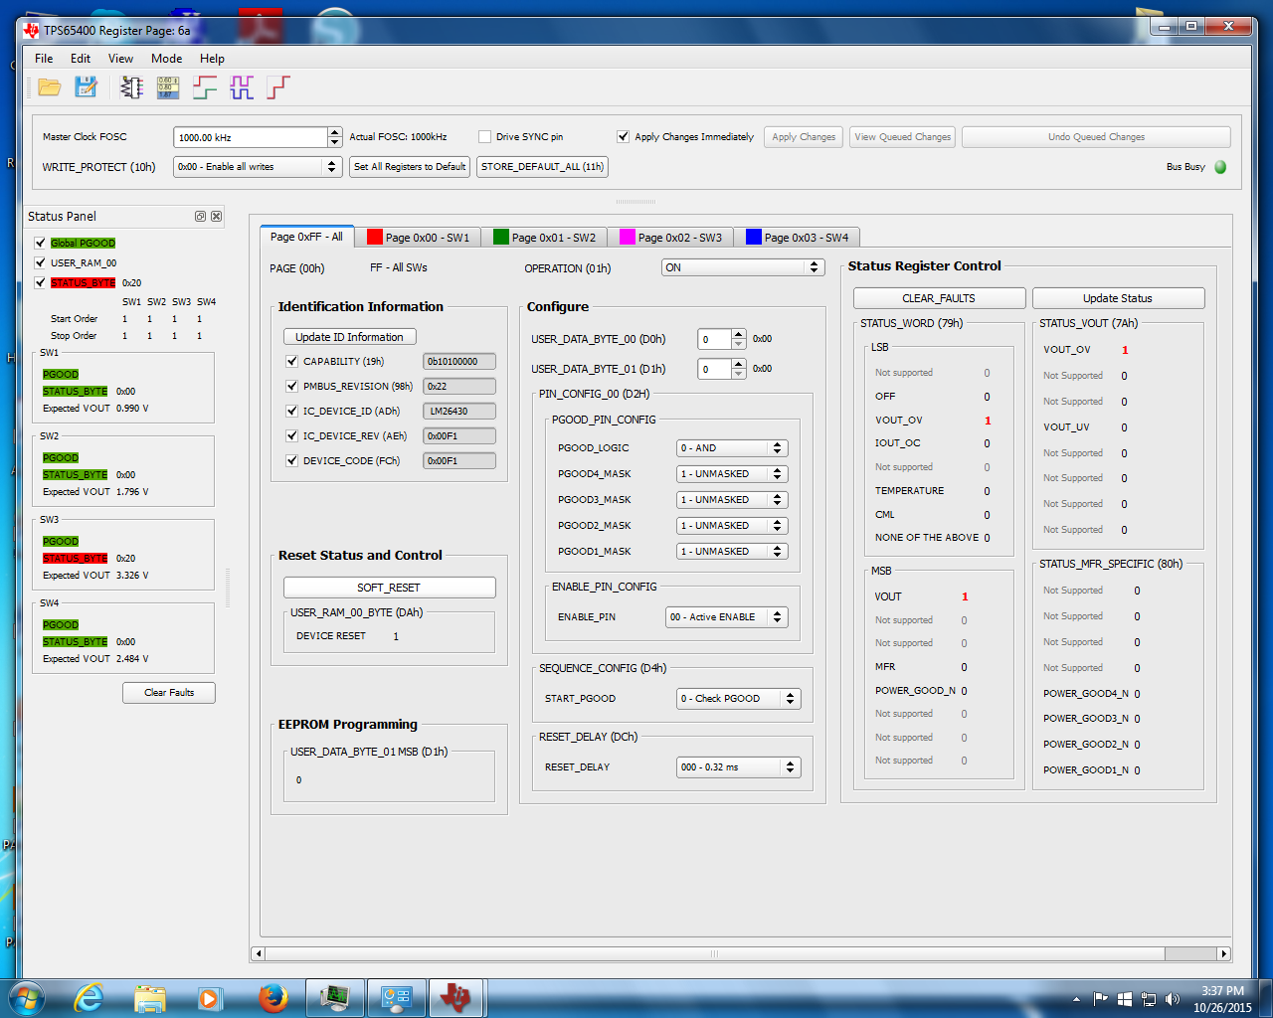

Adjust 3v3 up using sw2 tab (note expected out is 1.931V instead of 3.55V). Measured voltage is 3.557.
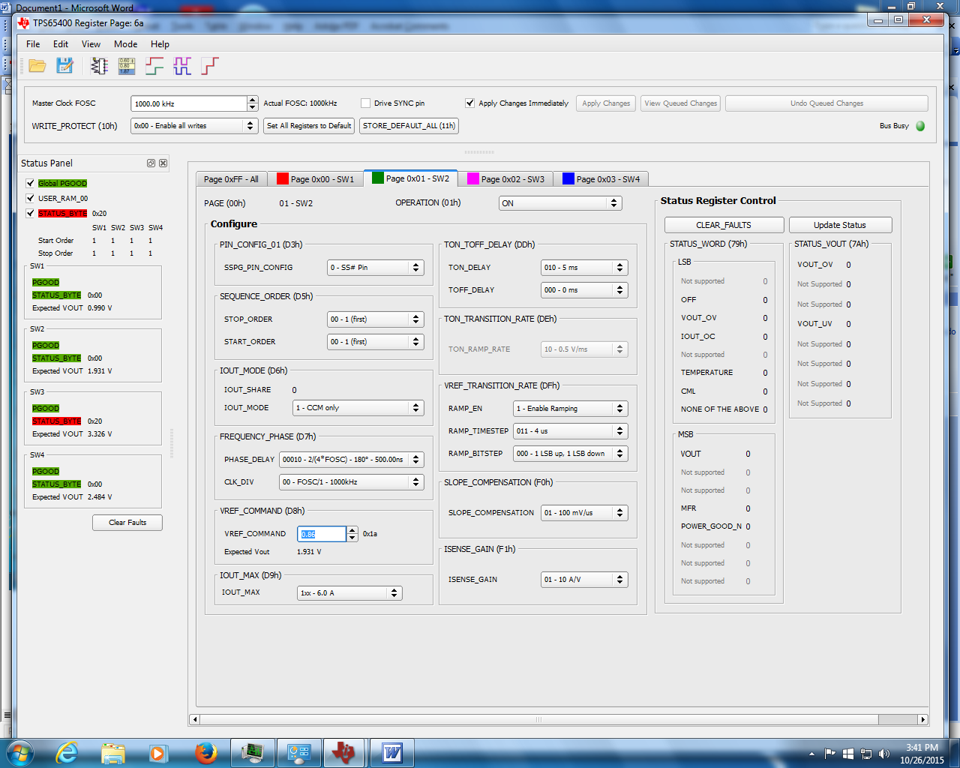

Correct expected Vout on SW3 tab (wrong Tab)
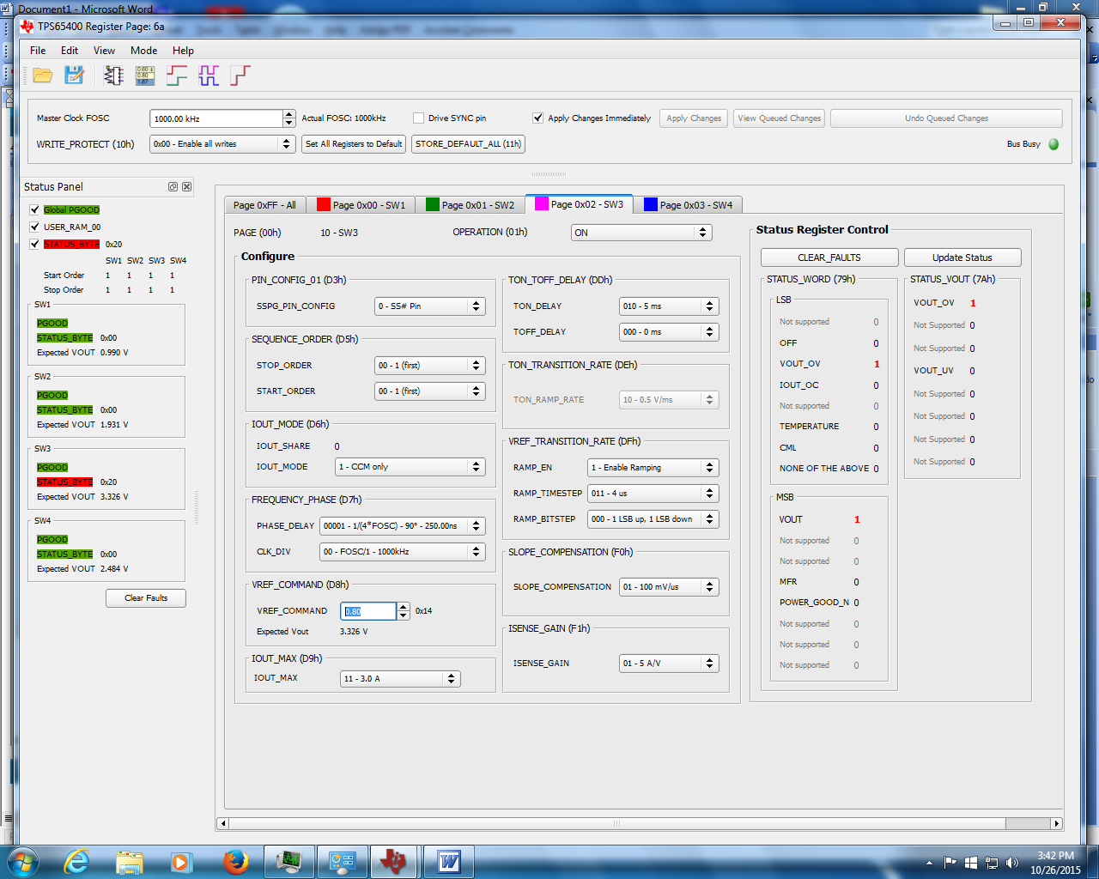

Soft Reset causes 3.55V to reset to 3.309V as you would expect.
Note the error on sw3
I can Clear Faults and the error clears. If I Update Status the error remains cleared.
If I soft reset the error is seen again.

