Requirement :-

- Input Voltage : 1.5V to 3.2V
- Output Voltage : 5V
- Output Current : 0.5A to 0.750A

Selected IC Parameters :-

- Selected IC : TLV61070A
- Manufacturer : TI
- Input Voltage : 0.5V to 5.5V
- Output Voltage : 2.2V to 5.5V
- Switching Current : 2.5A
- Switching freq : 500KHz to 1MHz
- UVLO Rising : 1.0V to 1.3V
- UVLO falling : 0.4V to 0.5V
- VEN(H) : 1.2V
- VEN(L) : 0.35V to 0.45V

Readings :-

Test 1:-
Below is the Image of the TLV61070A Encrypted PSpice Model.

- Input Voltage : 3.2V
- Output Voltage : 5V
- Output Current : 0.750A
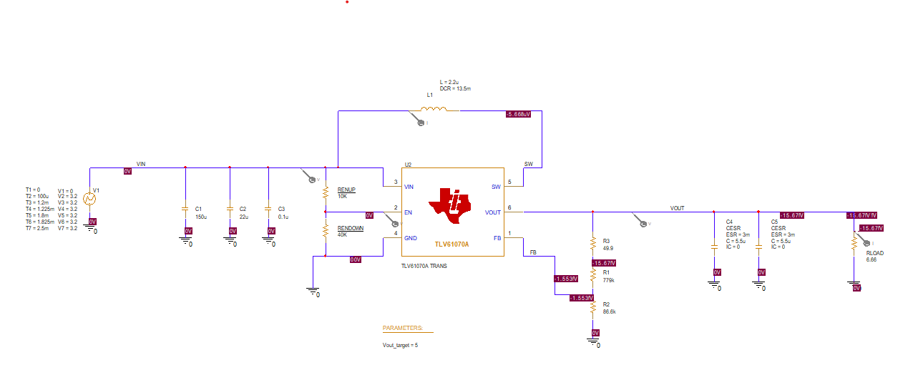

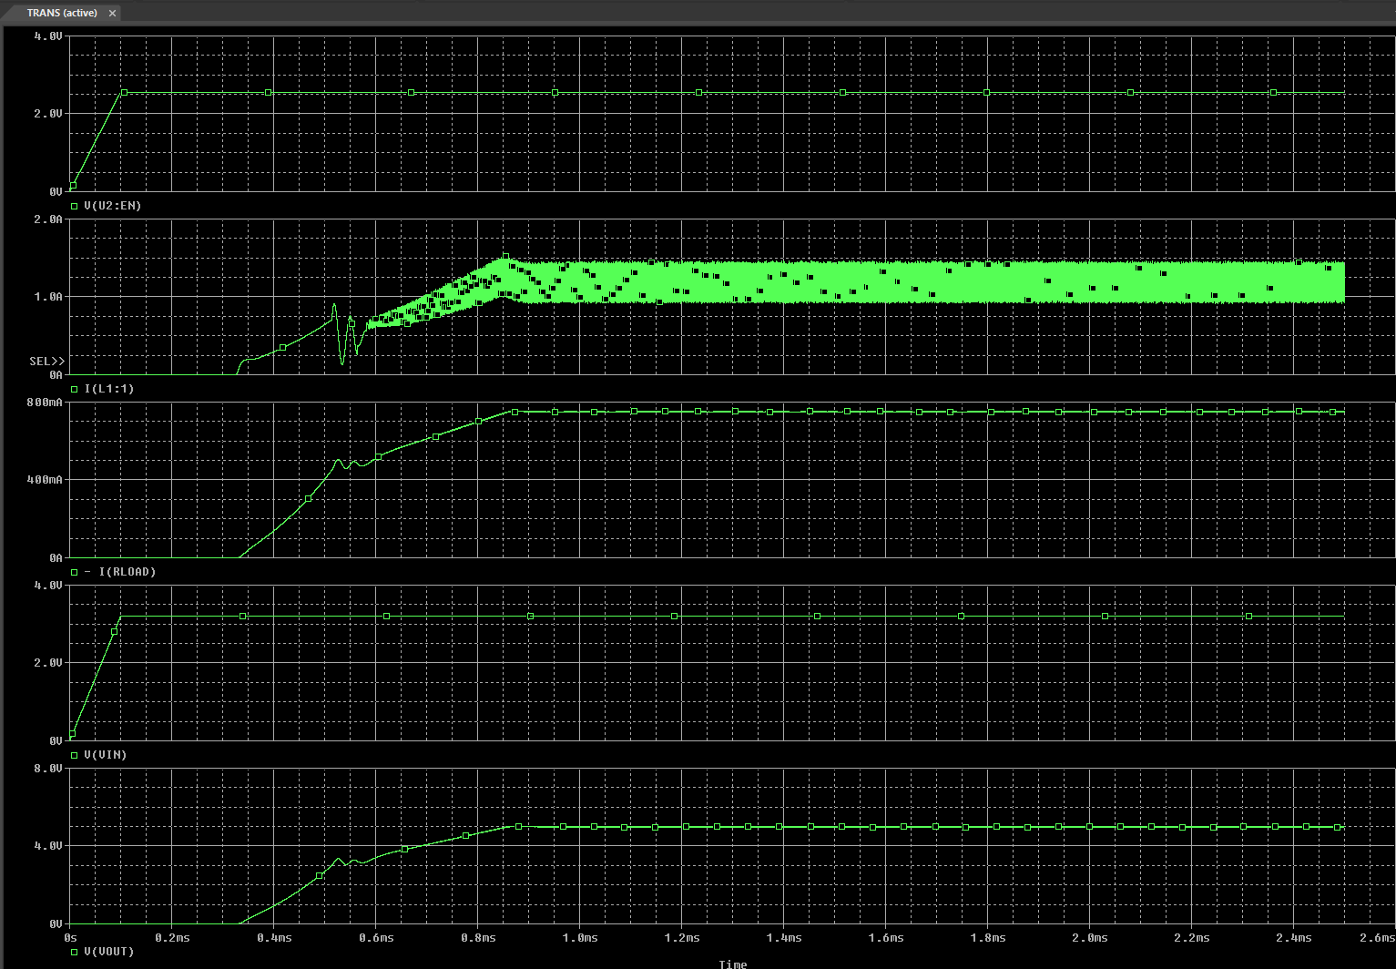

Test 2:-
Below is the Image of the TLV61070A Encrypted PSpice Model.

- Input Voltage : 1.5V
- Output Voltage : 5V
- Output Current : 0.750A

