Use TLV62569DBV to achieve 5V to 3.3V circuit：

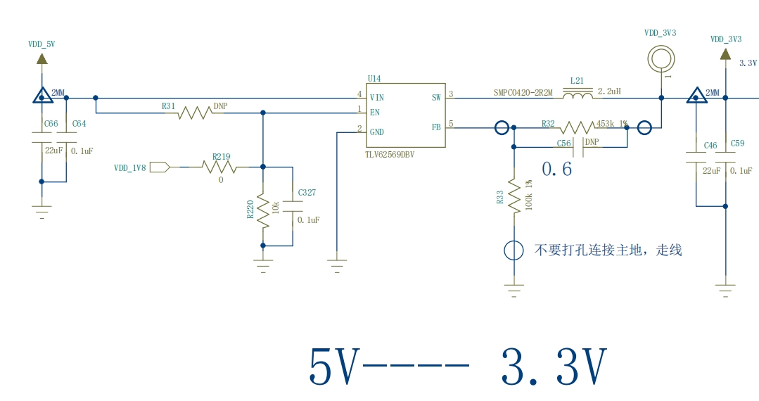

We use an embedded system. When the system is on standby and not running, 3.3V current is not consumed much. We used an oscilloscope to measure the SW pin of TLV62569DBV. The waveforms are as follows, with a large ring like signal, not a standard PWM waveform

As you can see from the datesheet card, at this point TLV62569DBV should be in light load Mode, entering Power Save Mode Operation

