TLV75101P Overload condition

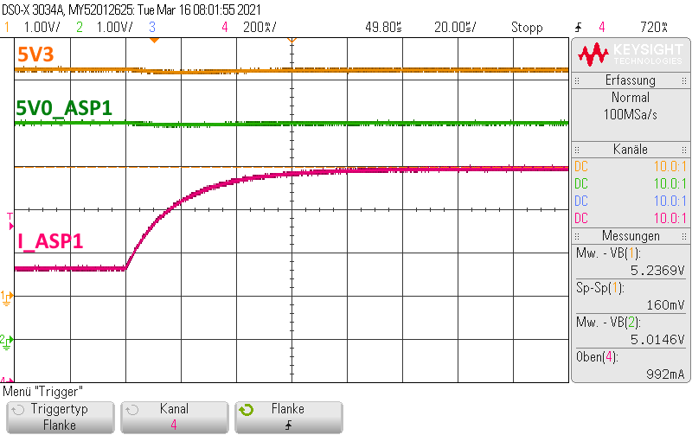

Figure 3‑23: 1 A overload: TC11_06_01_ASP1_Overload.png

According to the data sheet, the LDO should limit the current to a maximum of 865 mA (720 mA typ.). The LDO can deliver more current, in this test up to 1A, without limitation.

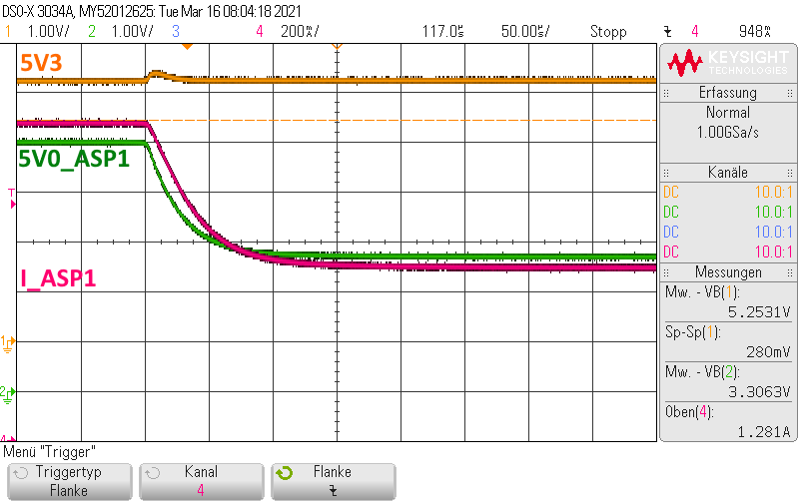

Figure 3‑24: Limiting at 1.28 A overload: TC11_06_03_ASP1_Overload.png

When the load current is slowly increased (by reducing the load resistor), the LDO switches to current limit mode at about 1.28 A and limits the output current to ~720 mA. Expected typical value in datasheet is 700 mA.

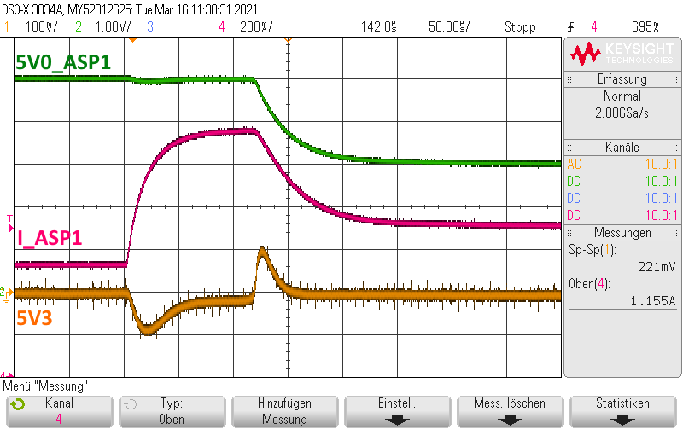

Figure 3‑25: 1.16 A overload and current limiting: TC11_06_07_ASP1_Overload .png

If ~650 mA is added to ~500 mA of LDO current, the LDO switches sometimes to limitation (~720 mA).