TLV75101P Overload condition

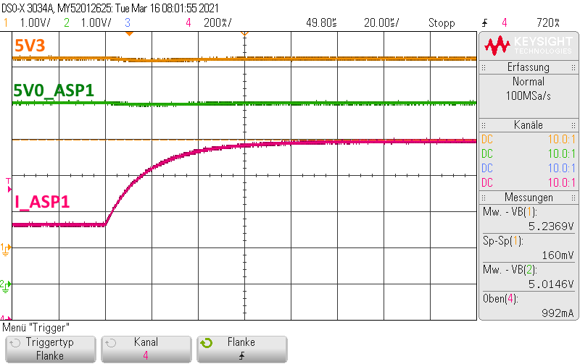



Figure 3‑23: 1 A overload: TC11_06_01_ASP1_Overload.png

According to the data sheet, the LDO should limit the current to a maximum of 865 mA (720 mA typ.). The LDO can deliver more current, in this test up to 1A, without limitation, forever.

*****Output capacitor may be reducing the step on the LDO

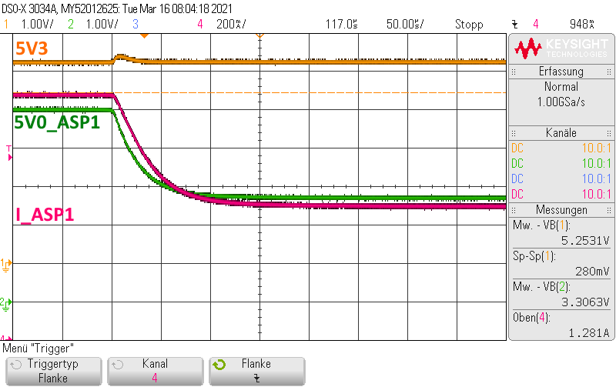

Figure 3‑24: Limiting at 1.28 A overload: TC11_06_03_ASP1_Overload.png

When the load current is slowly increased (by reducing the load resistor), the LDO switches to current limit mode at about 1.28 A and limits the output current to ~720 mA. Expected typical value in datasheet is 700 mA.

*********Current limit response time is typically 50-100us. If load is increased slowly while close to the threshold, it takes longer to engage current limit – this idea is called overdrive. Overdrive is defined by how much VDD deviates from the specified threshold. Threshold overdrive is calculated as a percent of the threshold in question. The amount of time required to engage current limit decreases as IOUT overdrive increases

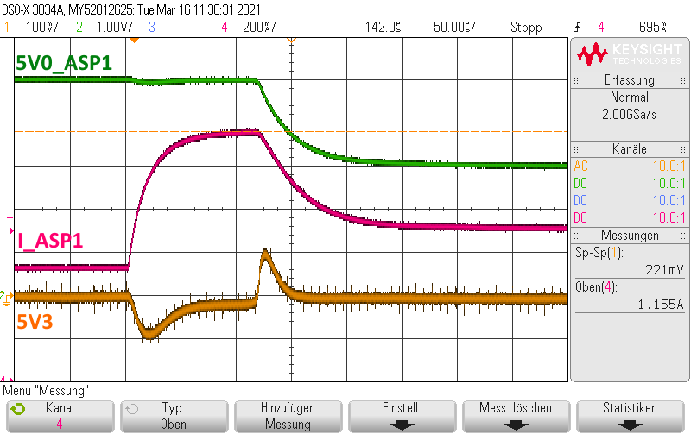

Figure 3‑25: 1.16 A overload and current limiting: TC11_06_07_ASP1_Overload .png

If ~650 mA is added to ~500 mA of LDO current, the LDO switches **sometimes** to limitation (~720 mA). With this test the LDO only goes to limitation for about 50% of all tests. Other 50% it continues to deliver 1150mA forever.

******* Because the current is being ramped up faster, the current limit is engaged faster.

Points of Action:

* Leave the Part at 1A for 200us to see if the current limit is engaged  
   Answer: 1A delivered forever, LDO never goes to limitation
* Step more quickly from lower load to higher load – does current limit engage sooner  
   Answer: with a short circuit test the limitation is engaged in less than 20µs

Our primary question is not about the time to engage limitation but why does the LDO deliver continuously up to about ~1250mA without entering limitation. This is the result of our tests increasing the load slowly.