TPS2121 OUTPUT VOLTAGE ANALYSIS
IN1 : 4.8 V -> external supply
IN2: 3.4 V -> external supply
Load: 1.2 A
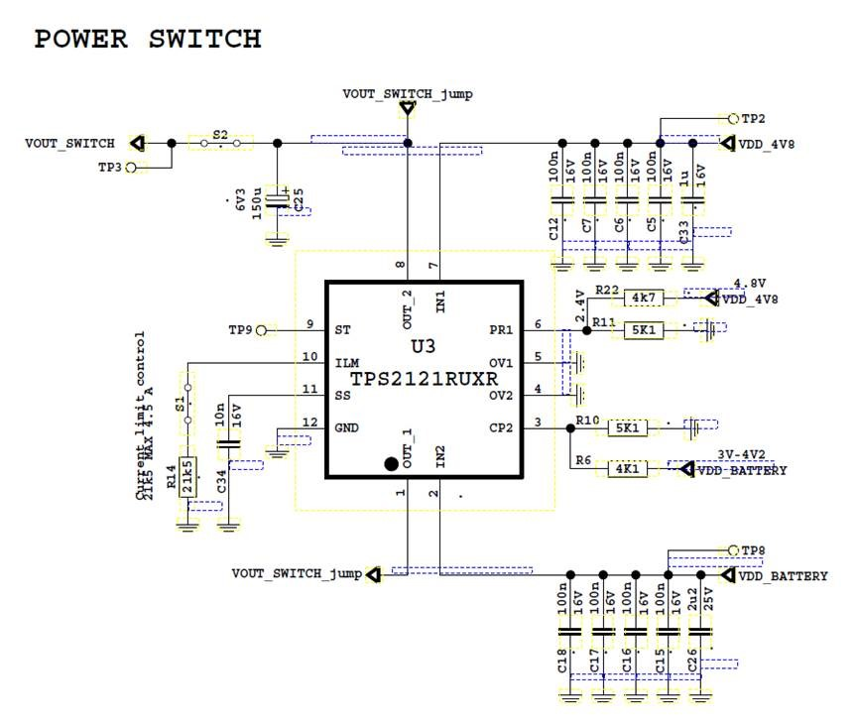
The Schematic
IN1 and IN2 are used from power supply.
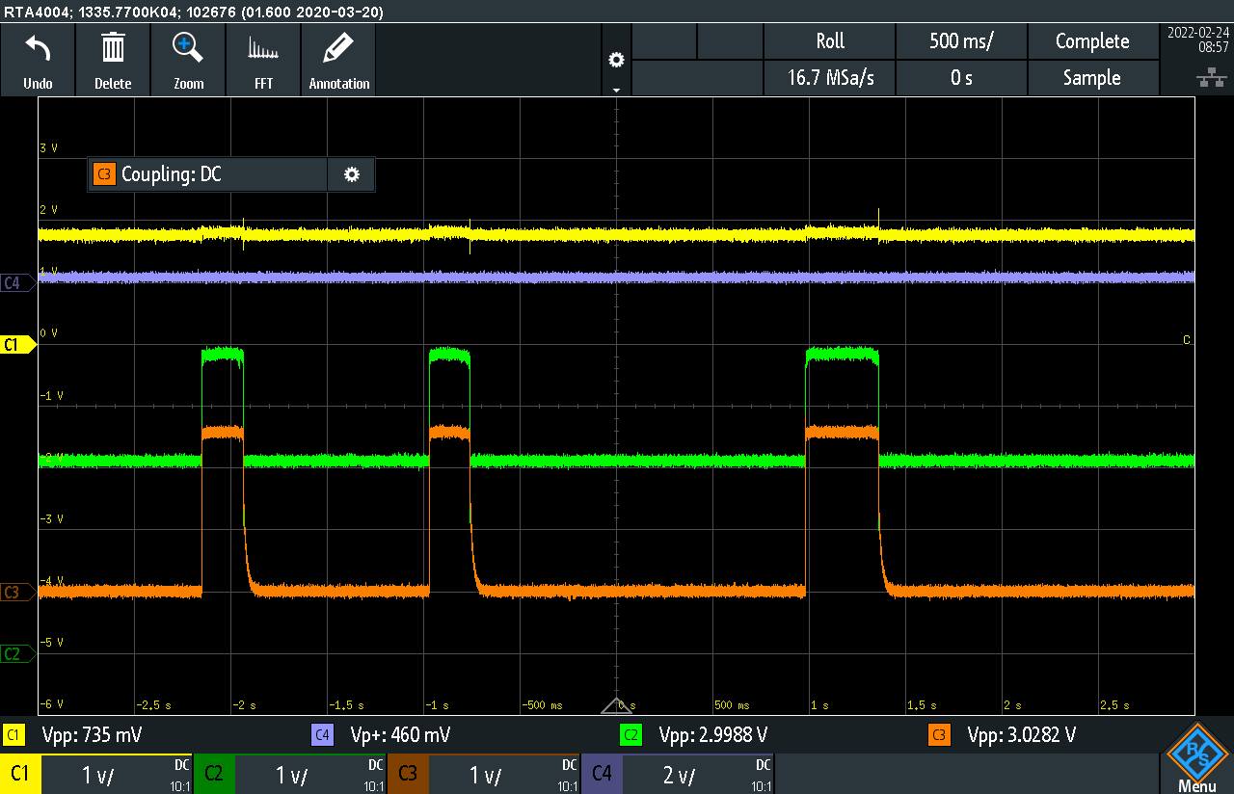
Output voltage dropped at 0 V and when IN1 is switched to IN2. The switching time from IN1 to IN2 is 2ms. Because of the situation, the system is shuted down.
CP2
PR1
OUT
ST
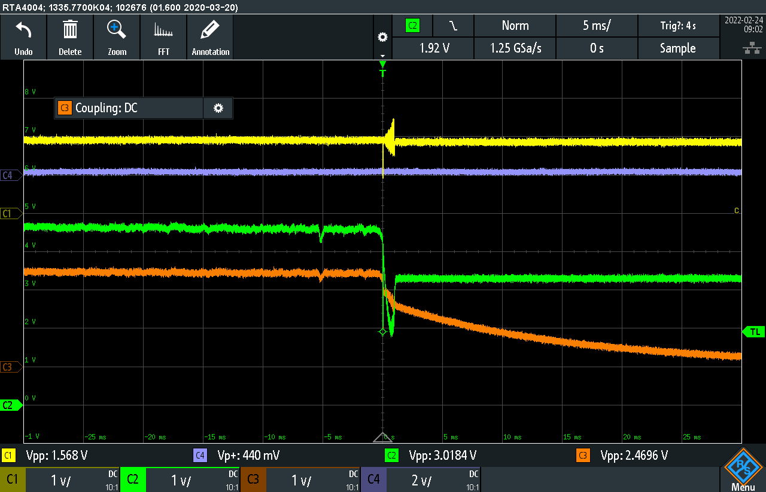
TRIGGER TEST
PR1
OUT
ST
Trigger result
Time : 500us
Trigger result
Time : 5ms
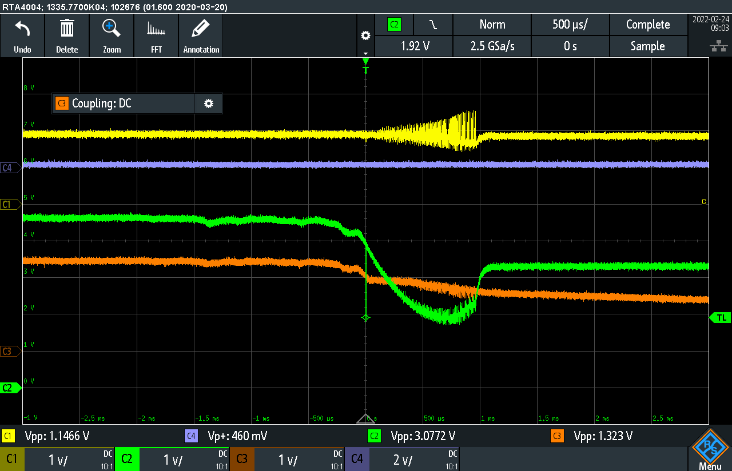
CP2
CP2
PR1
OUT
ST

