**Test configuration** :

* VBUS_PWR always present at 5V
* 3 Ohm load resistive load on MAIN_PWR (2A @6V)
* 450 uFelectrolitic capacitance on MAIN_PWR (not shown on schematics)
* EXT_PWR (12V) is rapidly switched ON and OFF to verify output drop
* CP2 is 3.3V derived from the main logic supply wich is derived from MAIN_PWR (as described in TIDA-01638)



**Successful Switchover** USB_PWR -> 6V_PWR-> USB_PWR

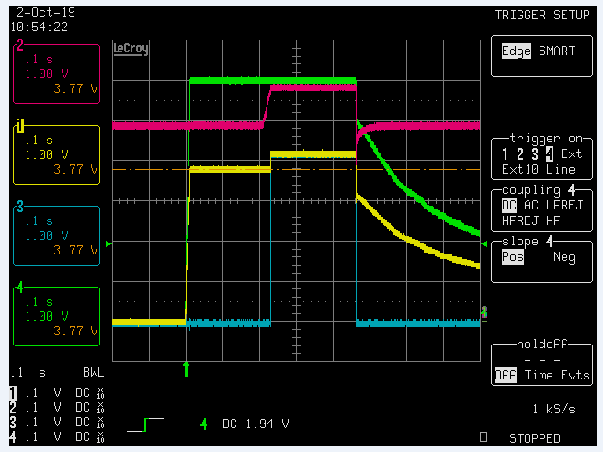

GREEN TRACE : 6V_PWR (VIN1 on TPS2121)

RED TRACE : MAIN_PWR (output from TPS2121)

YELLOW TRACE : PR1

BLUE TRACE : EXT_PWR_OK (ST on TPS2121)

Note that the step increase in PR1 is due to the positive feedback introduced by the resistor R101 from ST to PR1 required to avoid spurious switching when PR1 is at 3.3V.

**Failed Switchover** USB_PWR -> 6V_PWR-> USB_PWR

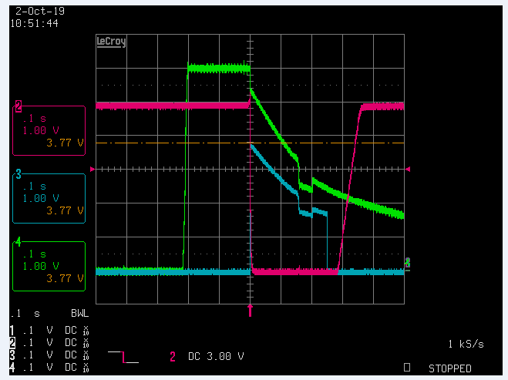

If the time interval in wihch 6V_PWR is present is reduced the above situation appears in which :

* Output do not switch to 6V
* The 5V (always present) is not restored at the output of the TPS2121 causing a reset of the device.

This configuration is representative of what happens when instable power supply.

If the presence of 6V_PWR is shorter than 200 msec the drop in MAIN_PWR do not happen.

It seems that this happen when the 6V_PWR is removed close to the ST rising edge.

Note also that the 6V_PWR show initially a sharp decrease due to the fact that the load is still connected to VIN1 and discharge the capacitors on 6V_PWR. When ST rises the slope in 6V_PWR decrerases meaning that the load is no more connected to VIN1

I also tried to use resistor R100 instead of R101 but the behaviour is the same

**Other tests of failed switchover**



GREEN TRACE : 6V_PWR (VIN1 on TPS2121)

RED TRACE : MAIN_PWR (output from TPS2121)

YELLOW TRACE : PR1

BLUE TRACE : CP2



GREEN TRACE : 6V_PWR (VIN1 on TPS2121)

RED TRACE : MAIN_PWR (output from TPS2121)

YELLOW TRACE : PR1

BLUE TRACE : CP2



GREEN TRACE : 6V_PWR (VIN1 on TPS2121)

RED TRACE : MAIN_PWR (output from TPS2121)

YELLOW TRACE : PR1

BLUE TRACE : ST