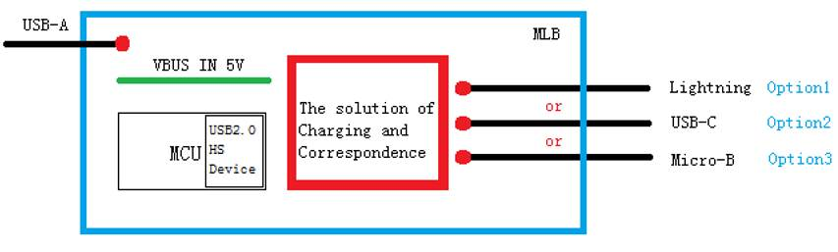

The device is getting 5V power input form USBA(only power), for the data transmission, it is as device.

The port lightning, USBC, Micro-B has D+/D- and connect with USB host, the power should be from this device to the data host, is this possible with TPS2546?

From my understanding, it usually data host provide the power, am I right?

In the application, the smartphone will act as USB data master to transmit data