TPS25750 I2C proceed

1、Read 0x03 MODE ：PTCH mode
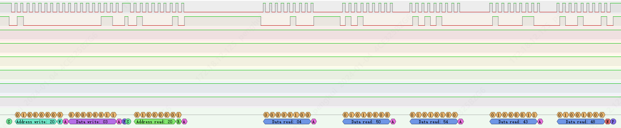
2 Read读0x2D BOOT_STATUS
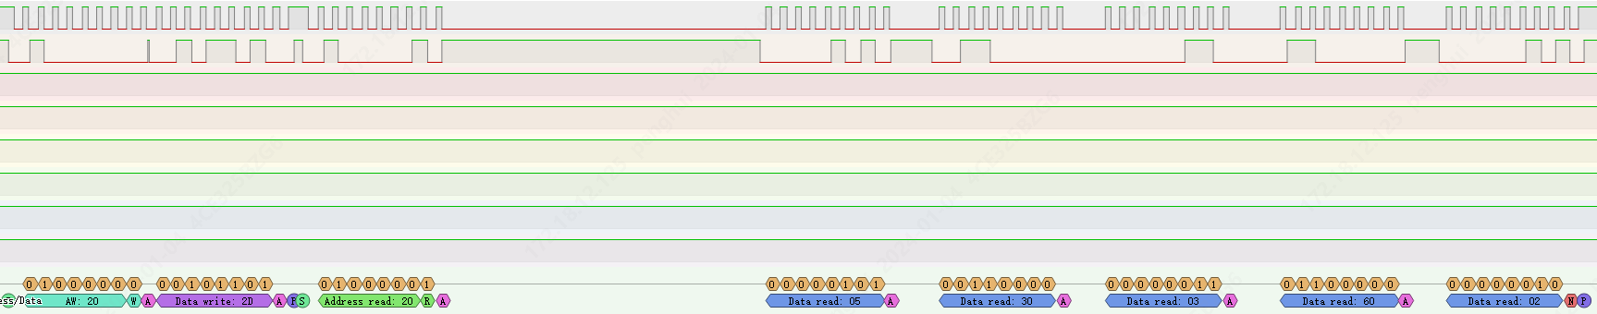
3、Write 0x09 DATA1
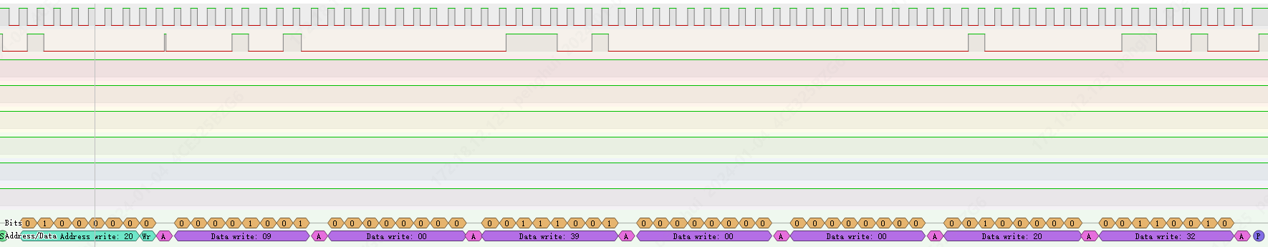
4、Write 0x08 CMD1：PBMs
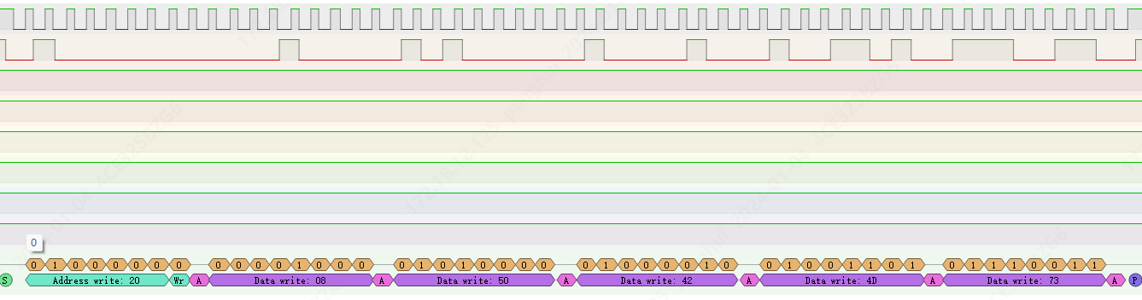
5、Read 0x08 CMD1 “!CMD”
