The circuit design of TPS25946 and TPS62130A is as follows, and the following problems exist in the circuit measurement, please help to analyze the causes. (All the following tests did not stimulate the full plate power consumption, only the board is powered on, no system program) :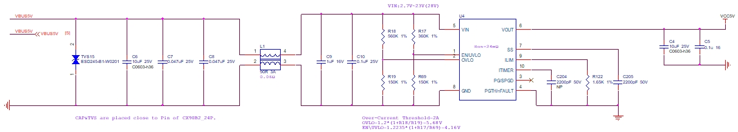
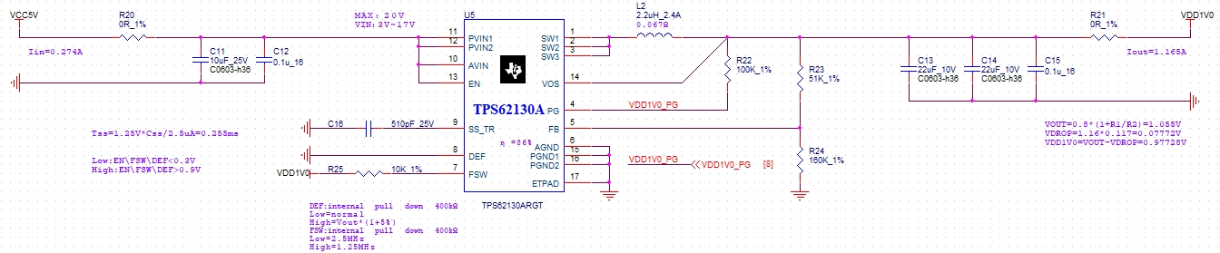
- a. VBUS5V (yellow line) will have voltage fluctuations about 5ms when powered on, see the waveform at the same position chip output VCC5V (green line) there are two voltage drops.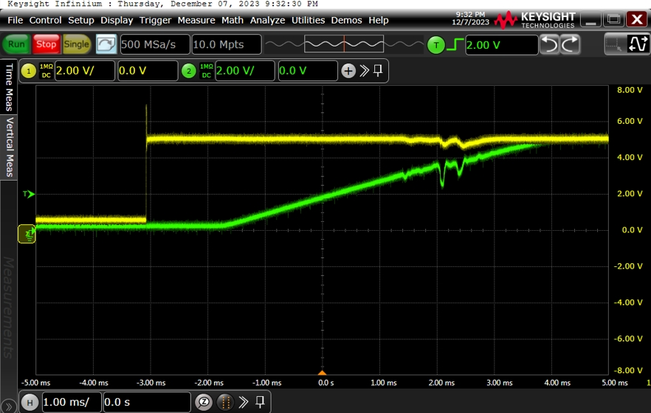
b. The low voltage at the first place will cause the power on the rear circuit to have a step affecting the power-on sequence (the blue line is the PG signal at the rear stage), as shown in the figure below:
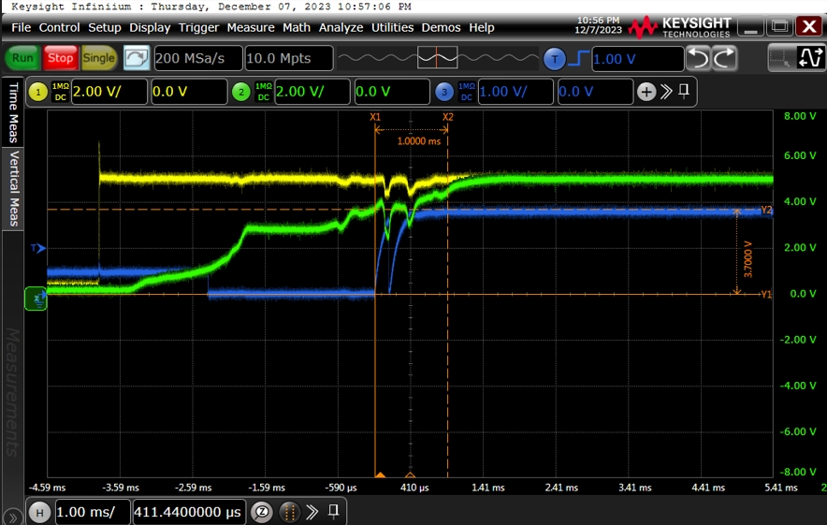
- If the SS capacitor is deleted, that is, the SS pin is suspended, the voltage drop still exists, but the PG signal drop disappears.( VBUS5V- Yellow line, VCC5V- Green line, VDD1V8PG- Blue line)
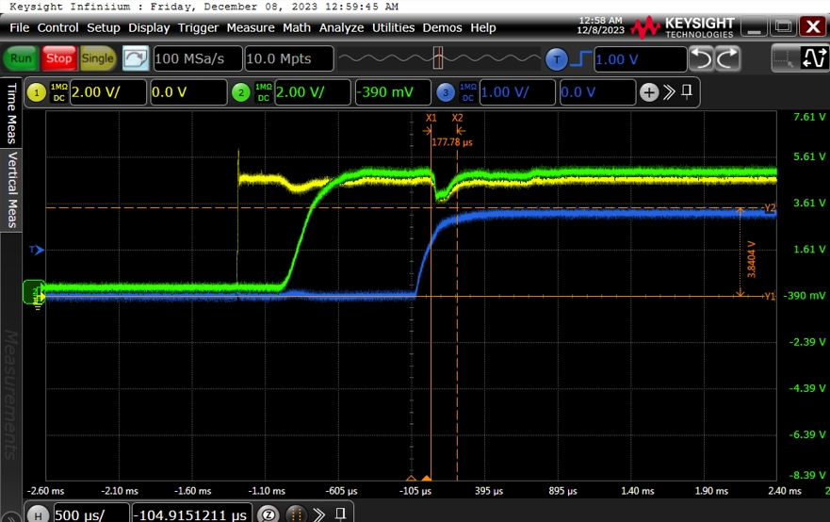

At this time, a new problem is introduced, and the first power supply after VCC5V has a large fluctuation (only the first power supply appears, and the rest of the power supply after the stage does not appear, all use VCC5V as input, but the power-on timing is controlled through each chip PC: VDD1V0>VDD1V8>VDD2V5).
VCC5V- red line, VDD1V0-yellow line, VDD1V8-green line, VDD2V5- Blue line, locally enlarged as shown in the figure below:
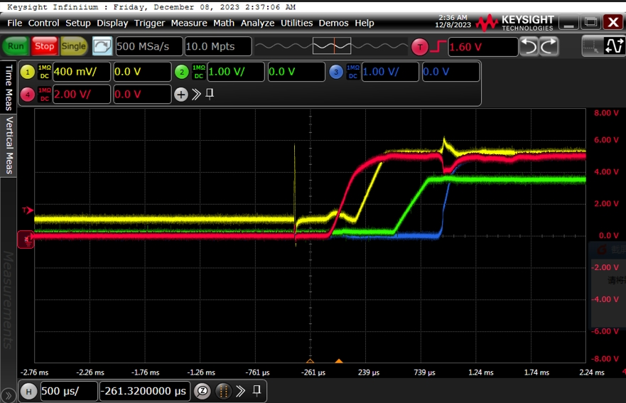
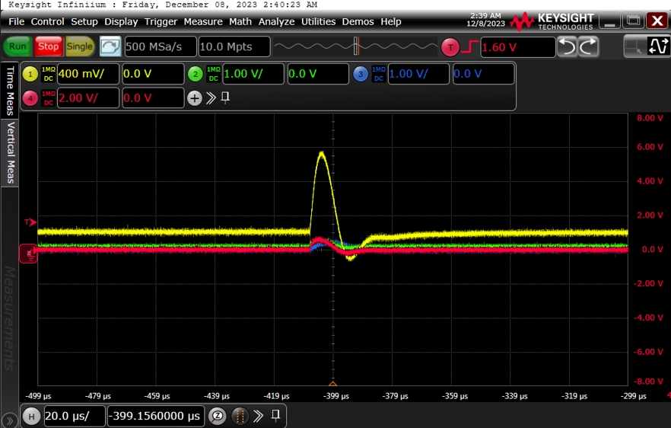
- I use another brand of chip SGM40666, there is no voltage drop phenomenon.
（VBUS5V- Yellow line, VCC5V- green line）
