## TPS2H160EVM conducted susceptibility problem

Measure are done on TPS2H160EVM:

* Power 24V
* Load 1K5
* Rcl 5k7
* signal injection on TPS2H160 output from generator (50 Ohm output) through 56 Ohm in serial with 330 pF.



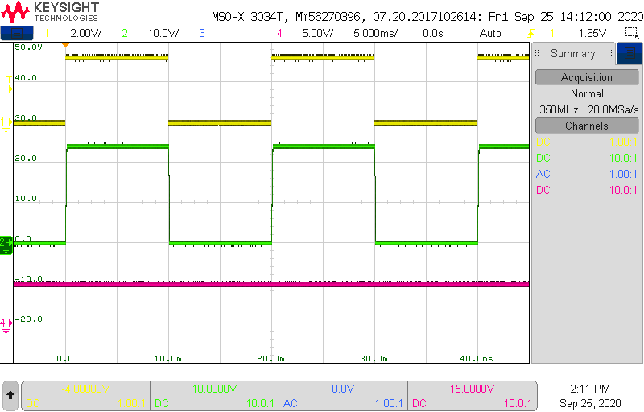

Figure 1: 50 Hz output toggling, no signal injection (yellow: IN; green: OUT; pink: fault)

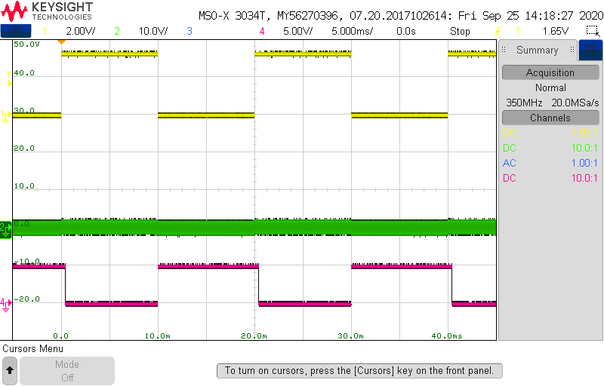

Figure 2: 50 Hz output toggling, 5.6 Vpp signal injection (yellow: IN; green: OUT; pink: fault)

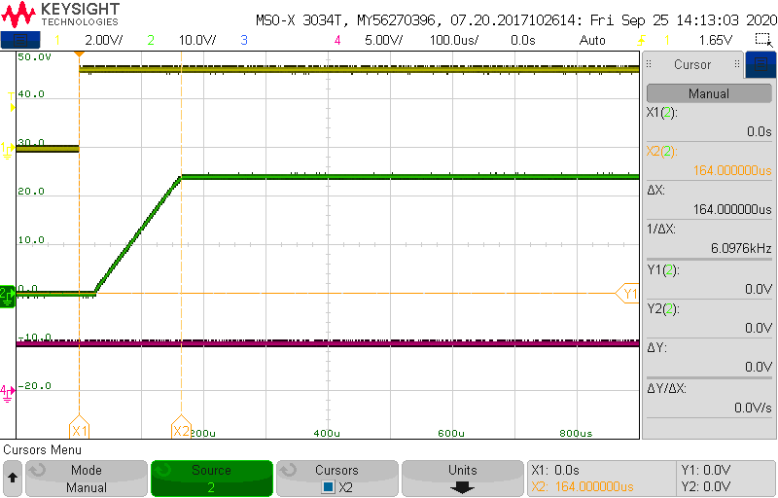

Figure 3: on transition, no signal injection (yellow: IN; green: OUT; pink: fault)

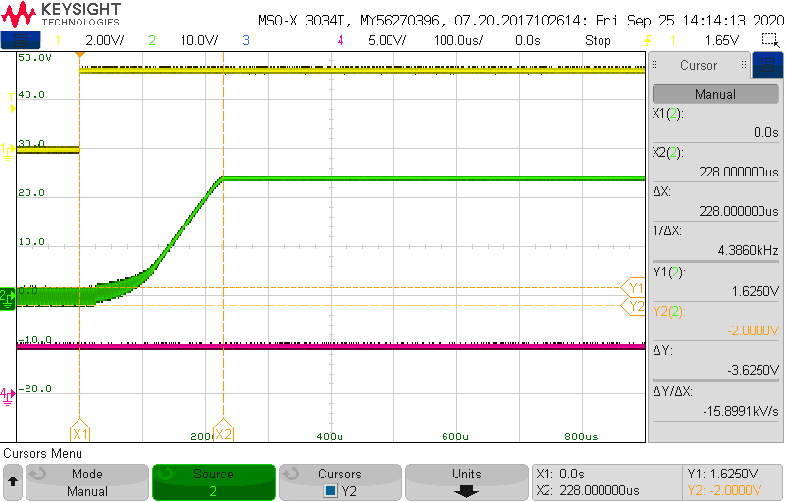

Figure 4: on transition, 5 Vpp signal injection (yellow: IN; green: OUT; pink: fault)

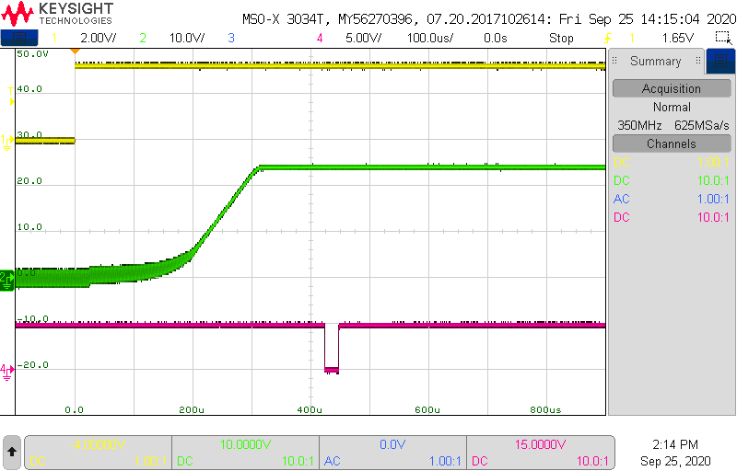

Figure 5: on transition, 5.4Vpp signal injection (yellow: IN; green: OUT; pink: fault)

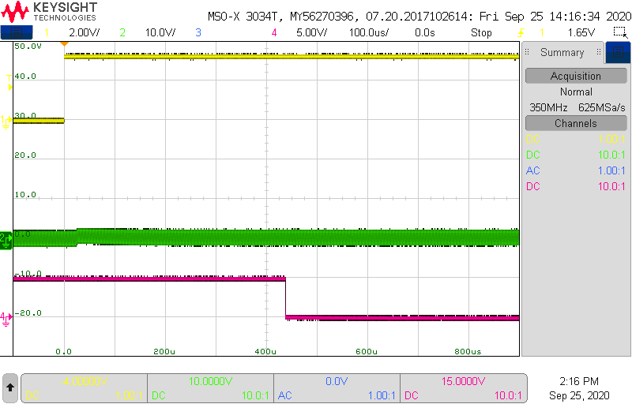

Figure 6: on transition, 5.6Vpp signal injection (yellow: IN; green: OUT; pink: fault)

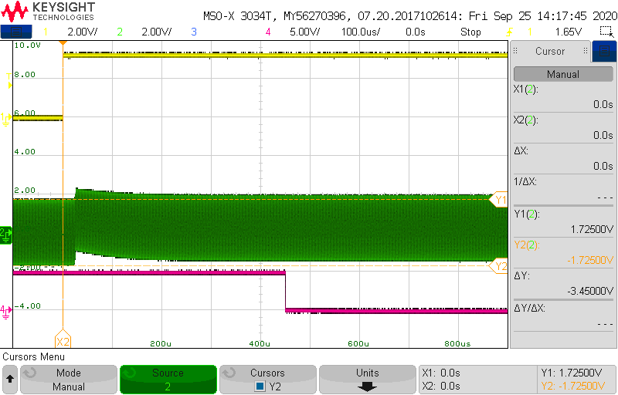

Figure 7: on transition, 5.6Vpp signal injection (yellow: IN; green: OUT; pink: fault)