**Issue description:**

My customer reported an issue that while the VDD drop and restored, the TPS40303 couldn’t provide normal output voltage.

The VDD provided by previous power module output which has the over current protection, if the load detected over setting which is less that TPS40303 OCP value, the VDD would pulled to less than 3V, and the PGOOD is pull to low. After the load removed, the VIN would be back to normal, but the output of TPS40303 couldn’t be restored.

**Schematic & PCB Layout:**

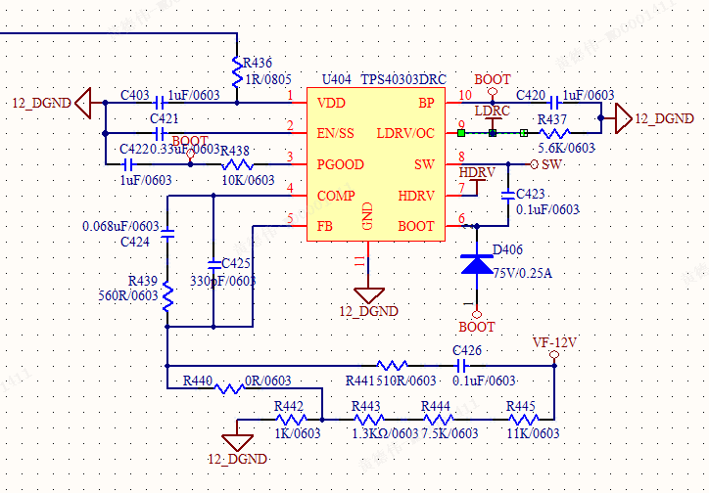

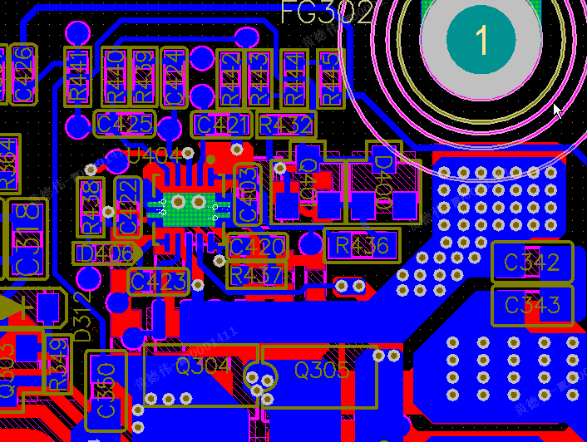

**Test Waveform:**

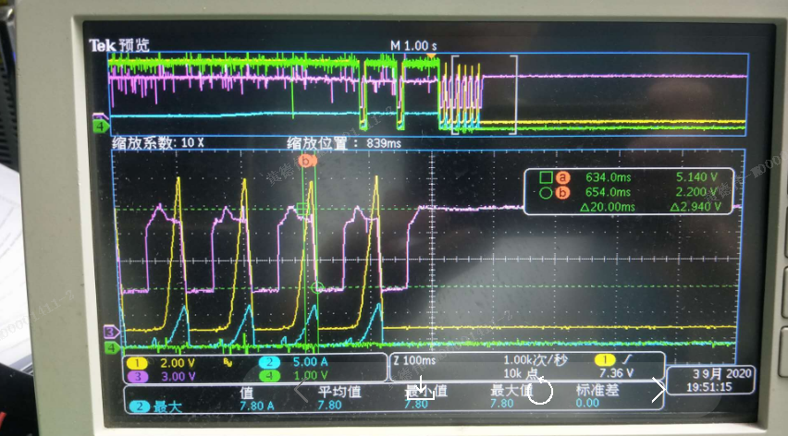

Figure 1: CH1:Vout   CH2:Iout   CH3:Vin    CH4:PGOOD

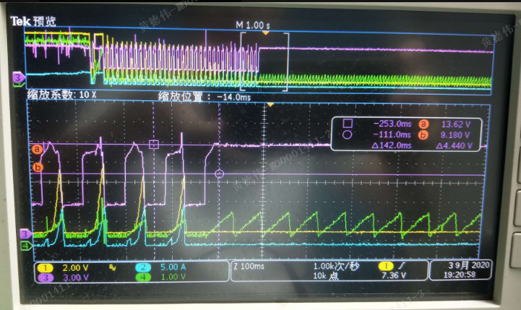

Figure 2: CH1:Vout   CH2:Iout   CH3:Vin    CH4:EN/SS

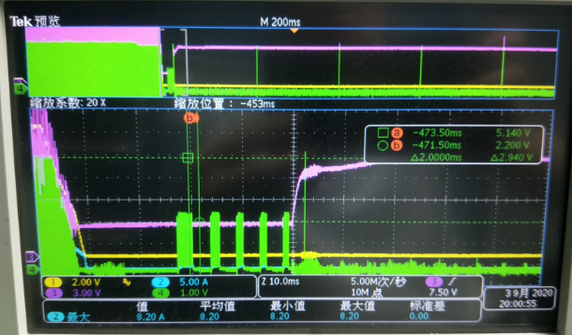

Figure 3: CH1:Vout   CH2:Iout   CH3:Vin    CH4:LDRV

**Support Needs:**

Could you kindly help on below items:

* While the input restored, and output load is empty and couldn’t trigger OCP, From previous test waveform,

why the PGOOD signal could be restored?

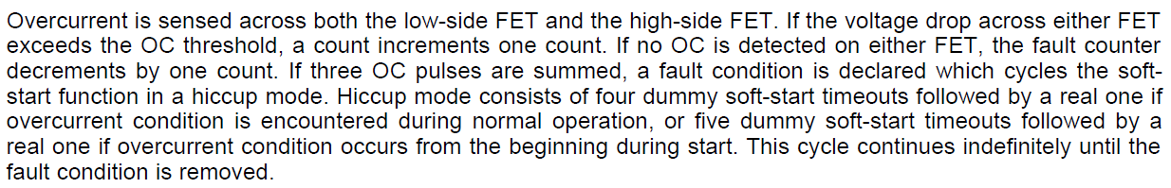

* How to fix this issue?