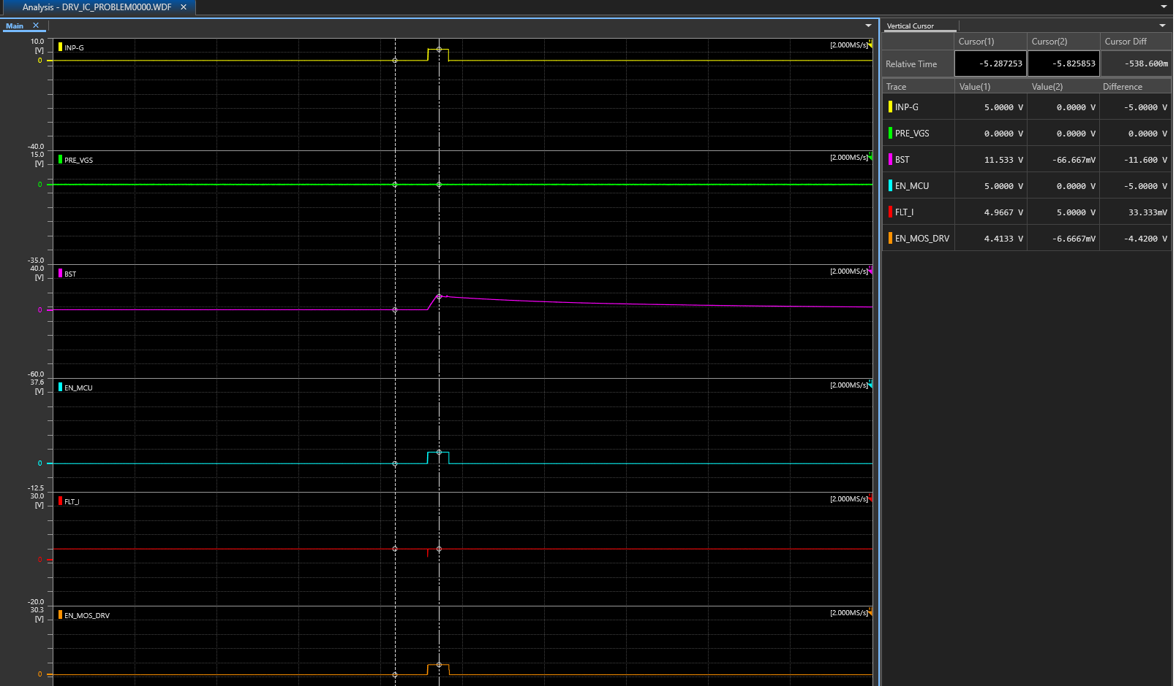

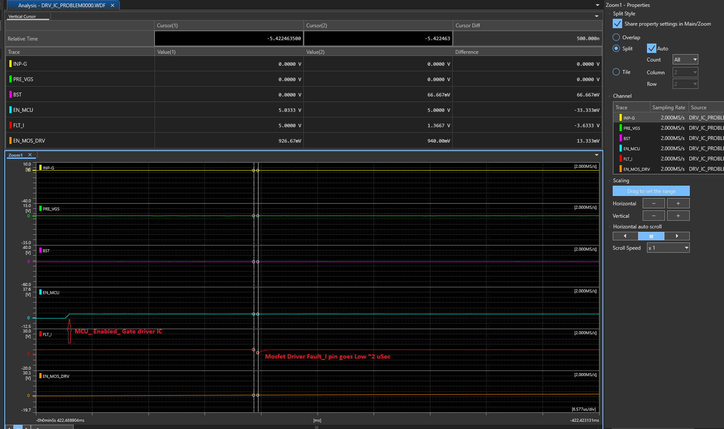

FLT_I go low for 2uSec. So Pre-charge Mosfet gate drive(G) is not getting high so no pre-charge takes place.

