Micron DDR3L Specs:

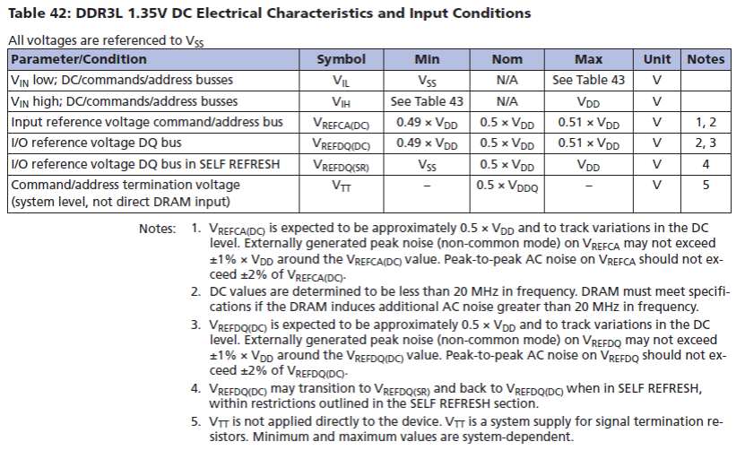

TPS51206 Specs:

