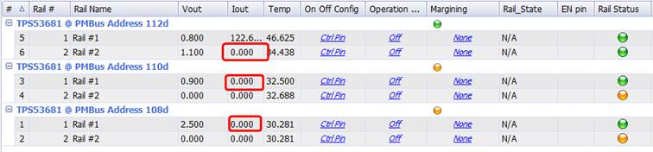
U19 OutB 1.1Vout 30A L153/L152 1uH(original is 150nH), L set LEST=1.65M+0.11M=1.76M
U19 OUTA 0.8Vout we can read value and work normal, that L11/L12/L9/L10/L7/L8.
May we know is there change will be impact TPS53681 read function?
